le Official Publication of ALOA—An International Association of Security Professionals

##*****'****#**3-DIGIT 303 S19 PI BRECK H. CAMP CML 12/31/2999 PO BOX 47070

ATLANTA GA 30362-0070

**IVIot to mention our 2002 Scholarship Winners,  
and more lock picking mysteries, safe openings  
auto transponders, business advice,  
legislative updates and locksmithing  
war stories than one issue can hold... so**

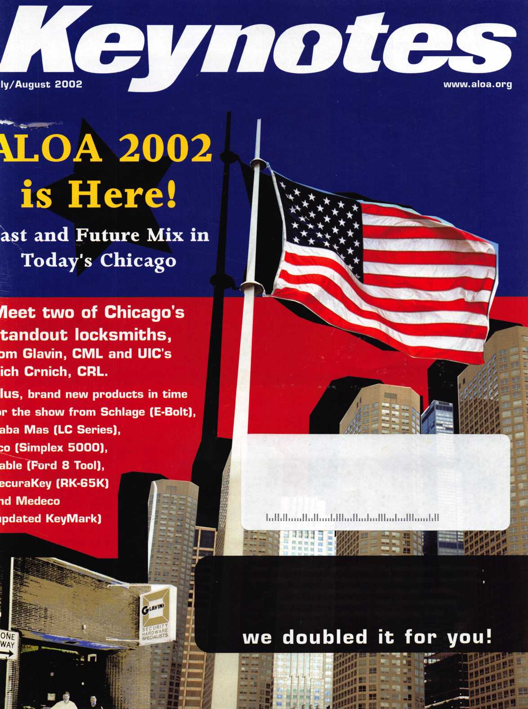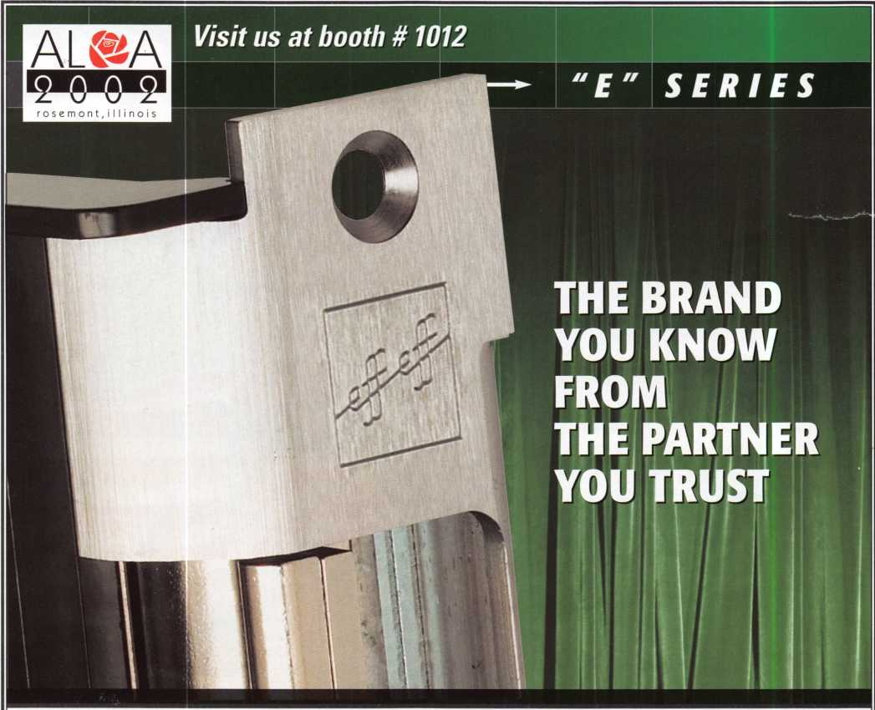

effeff electric strikes and locking products offer the highest level of security and convenience. With a wide range of dependable solutions to choose from, professionals are guaranteed reliable solutions to meet today's rigorous requirements for security.

Customers can now take advantage of the full line of effeff locking products offered by HES. This means new and exciting solutions such as the all-in-one PENTA, designed to easily satisfy all your system requirements. Quality, reliability, and support from a trusted partner in security.

Raising the Standard for Higher Security

[www.hesinnovations.com](http://www.hesinnovations.com) • 800-626-7590

HES is committed to  
raising security and life  
safety standards by  
providing high quality,  
innovative electric  
door locking products

to professional  
installers and

commercial  
end users.

An ASSA ABLOY Group company

**ASSA ABLOY**

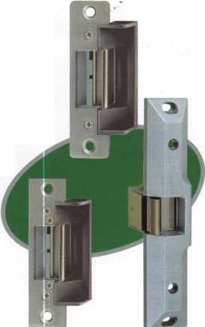

***And use Kreate-A-Key Software***.

Use Kreate-A-Key Code Software Stand Alone or Connected to a Key Machine:

Works with th& Ultracod*™ ilsy 3j£/jj/j3 pJus soma Sllcu, 3jjjsJ

Blacironlc Kay Machines

2d Mfith UltrilCOCfe J ftaadar, dacodaz pra-cus m$ cuts duplicate keys bush /j3jJ factory sp^cs

he Most Comprehensive in the Market:

pwfhr^ conunerctal Mid idanilal direct &

Jlay Munk date for all blank and DrigiVMlI automotive suppliers

■ Complete Auto Security Products Catalog

■ for uza with oil

popular punch machinate



Keyset To Quality And Locked Into Service

[www.kaba-ilco.com](http://www.kaba-ilco.com)



KARA

A Member of the KABA Group

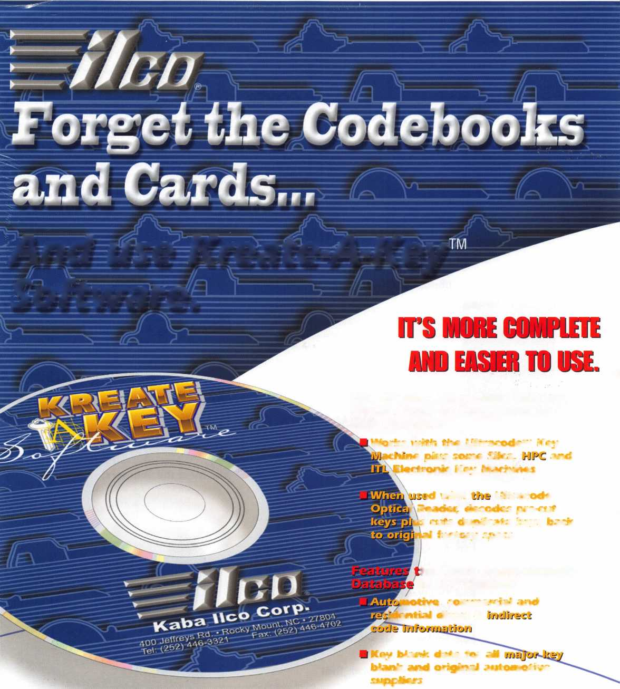

**features**

COVER

We are the Champions!

Interview of Tom Glavin, CML  
by *Keynotes* Editor, Jim DeSimone

Glavin's Security Hardware Specialists of Downtown Chicago shrugs off increasing industry pressures by sticking with sound lock­smith business principles.

INSTITUTIONAL



Walking the campus

of the University of

Illinois at Chicago by Rich Cmich, crl

fas told to *Keynotes* editor, Jim DeSimone)

For patented key control products, the expira­tion of the controlling patent is a significant event. Assa is just one example of a compa­ny that has upgraded their product line when the old line's patent expires. Here's how to complete some of Assa's most recent high security upgrades.

NEW PRODUCTS

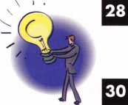

Average Joe Inventions —

Not just for the major manufacturers **ByMark Fuller, crl**

The Evolution of  
Medeco Key Mark

By Dale Bowman, CRL

Access Control — Simple Solutions for the Simplex 5000

The New LC Safe Series

from Kaba Mas By Jamie Taylor

Schlage's New E-Bolt By Sal Dulcamaro, CML

Locksmithing with that

"personal touch" By Frank Markiseh, CRL

Access Control — The 65,000 Key  
Lock from SecuraKey

BASIC

Lock Picking Mysteries, Part 2:

The Single Pin Method By sal Dulcamara, cml

SAFES

Safes: A Major Defeat *by* Greg Perry, *cml, cps*

AUTO

Inside the 1999 Lexus  
RX300 SUV

By Jeff Trepanier, RL

HISTORY

Opening Reflections: Living as a

**Public Servant** By CD. Lipscomb, CML, CPS

BUSINESS

Customer Service: Make or Break Your Business By Claim Cohen, CML

BONUS!

Meet the Winners!

Up Close with the 2002 ALOA ACE Scholarship Recipients

departments

Executive 3 Legislative

Update 70

Applicants 6

Classifieds 72

Calendar 8

Associate Members 74

Back Page ... 76

Visit

our we

bsite at [www.aloa.org](http://www.aloa.org)

Keynotes • July/August 2002

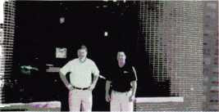

executive



Additional contact information for the ALOA Board and most Keynotes authors is available through "Locksmith Search'" on the ALOA Web site- [www.aloa.org](http://www.aloa.org) or by contacting the ALOA office at 3003 Live Oak Street; Dallas, TX 75204; (800)532-2562; FAX (214)827-1810; e-mail [aloa@aloa.org](mailto:aloa@aloa.org).

Editor

Jim DeSimone [editor@aloa.org](mailto:editor@aloa.org)

PRP/Education Manager

David Lowell, CML, CMST [david@aloa.org](mailto:david@aloa.org)

Technical Editor Operations/Membership Manager

David Lowell, CML, CMST [david@aloa.org](mailto:david@aloa.org) Mary May [mary@aloa.org](mailto:mary@aloa.org)

Editorial Advisor

John D. Cannon, CML [jdcannon@worldnet.att.net](mailto:jdcannon@worldnet.att.net)

Director of Information Technology

Randy McChristian [randy@aloa.org](mailto:randy@aloa.org)

Art Director Government Affairs Manager/

Betty Henderson [betty@aloa.org](mailto:betty@aloa.org) Chapters & Regional Associations Liaison

Tim McMullen [tim@aloa.org](mailto:tim@aloa.org)

Graphic Designer

Rose Ellen DeSimone Comptroller Kathy J. Romo

Advertising Sales

Kim Hammond voice: 817-645-6778

Fax: 817-645-7599 e-mail: [adsales@aloa.org](mailto:adsales@aloa.org)

Executive Director

Charles W. Gibson, Jr., CAE [charlie@aloa.org](mailto:charlie@aloa.org)

Convention & Meetings Manager

Kelly Carr, CMP [kelly@aloa.org](mailto:kelly@aloa.org)

Contributors

Jerome Andrews, CML Sal Dulcamaro, CML

Paul Chandler, CRL Billy Edwards, CML

Claire Cohen, CML Dan Graffeo, CRL,CMST

Brian Costley, CML, CMST A.J. Hoffman, CML Ray D'Adamo, CML Jeff Nunberg, CML, CMST

|  |  |  |
| --- | --- | --- |
| Network Specialist |  | Greg Jackson |
| Membership Coordinator |  | Shelly Jett |
| Convention & Meetings Assistant | | Karen Lyons |
| PRP/Education Coordinator |  | ...Ashley Manson |
| Accounting Coordinator |  | Kathy Green |
| Mail Room Coordinator |  | Kevin Wesley |
| Mike Oehlert, CPL, CPS  Randy Simpson, CML  Robert Stafford, CML  Dave Thielen, CML  Greg Perry, CML,CPS | Tom Seroogy  Charles Stephenson, CPS Dennis Watanabe, CML, CMST | |

Mission Statement: The Associated Locksmiths of America, Inc. is dedicated to enhancing the professionalism, education and ethics among locksmiths and those in related sectors of the physical security industry. With approximately 10,000 members in the United States, Canada and the freeworld, ALOA is poised to help members obtain the knowledge, the strength, and the confidence to perform their role in the physical security field with pride and dignity. But it is only through active involvement and participation that ALOA can fully achieve its potential—and can help members to achieve theirs.

Policies: Keynotes® is the official publication of the Associated Locksmiths of America, Inc. (ALOA). Keynotes® acts as a moderator without approving, disapproving, or guaranteeing the validity or accuracy of any data, claim, or opinion appearing under a byline or obtained or quoted from an acknowl­edged source. The opinions expressed by the authors do not necessarily reflect the official views of ALOA. Also, appearance of advertisements and new products or service information does not constitute an endorsement of products or services featured by the Association. The Association does not accept responsibility for the inaccuracy of any data, claim, or opinion appearing in this publication, due to typographical errors on the part of the authors, Association staff or its agents.

Editor's Note: This publication is designed to provide accurate and authoritative information in regard to the subject matter covered. It is provided and disseminated with the understanding that the publisher is not engaged in rendering legal or other professional services. If legal advice and other expert assistance is required, the services of a competent professional should be sought.

Authors' Payment: Payment for eligible submissions to Keynotes will be based on the following criteria: topic, time spent and past contributions. Authors who regularly submit to Keynotes® are generally paid a higher rate. The latter is especially true of authors who write to fit specific editorial needs and submit said copy by Keynotes® deadlines. As a general guideline: Average payment for a 750 word, business or 'light' technical article would be $200. Payment for a 1500 word article involving significantly higher time and research efforts would be $400.

Payment will not be offered for articles submitted by ALOA employees or members of the ALOA Board of Directors (unless material is of a technical nature), nor for articles submitted by a company that promote that company's products or services. ALOA reserves the right not to pay for articles sub­mitted by an individual(s) that promote a particular company's products or services.

Disclaimer: The Associated Locksmiths of America, Inc., (ALOA), reserves the right to refuse any article for any reason. Additionally, ALOA reserves the right to edit, amend or modify any article submitted for publication in order to preserve technical accuracy, clarity, fairness or grammatical cor­rectness. ALOA will make the best efforts to notify the author of any changes. The extent of ALOA's liability for any article or information contained therein will be a notice of correction or retraction in the next possible issue.

Keynotes® (ISSN 0277 0792) is published monthly except for the combined June/July issue by The Associated Locksmiths of America, Inc., 3003 Live Oak St., Dallas, TX 75204-6186. Telephone: (214) 827-1701; FAX (214) 827-1810; e-mail [aloa@aloa.org](mailto:aloa@aloa.org). Subscription rates for members—$15.00 per year. Second class postage paid at Dallas, Texas. POSTMASTER: Send address changes to: Keynotes, 3003 Live Oak St., Dallas, TX 75204-6186. © Copyright 1999, All rights reserved. No part of the contents may be reproduced or reprinted in any form without prior written permission of the publisher.

President

Randy Simpson, CML  
(713) 780-7026

[president@aloa.org](mailto:president@aloa.org)

Secretary

John D. Cannon, CML  
(703) 960-6413

[secretary@aloa.org](mailto:secretary@aloa.org)

Directors, Northeast

John C. Magee, Ilf  
(856) 845-3434  
nedirector@aloa .org

Peter Sarailian, CRL  
(973)890-9797  
[nedirector@aloa.org](mailto:nedirector@aloa.org)

William L. Young, CML  
(610] 647-5042  
nedirector@aloa .org

Directors, Southeast

Vincent Formon, CML, CPS  
(901) 324-2910  
sedirector@aloa .org

Donald E. Rule, CML  
(662) 324-2658  
sedirector@aloa .org

Directors, North Central

Mark E. Blum, CML, CPS  
(517) 482-5809  
[ncdirector@aloa.org](mailto:ncdirector@aloa.org)

John Soderland, CML, CMST  
(414) 327-5625  
ncdirector@aloa .org

Director, South Central

Randy L. Simpson, CML

1. 7807026 president@aloa .org

Directors, Southwest

Gordon R. Racine, CML  
(719) 384-4707  
swd i rector@a loa. org

Julie McCluney, CRL

1. 636-5652 [swdirector@aloa.org](mailto:swdirector@aloa.org)

Director, Northwest

Scott L. Henke, CRL, CPS  
(907) 248-3785  
[nwdirector@aloa.org](mailto:nwdirector@aloa.org)

Director, Associate Members

David F. Matthies  
(727) 541-5536  
asd irector@aloa. org

Trustees

[trustees@aloa.org](mailto:trustees@aloa.org)

JohnJ. Greenan, CML, CPS  
(773) 486.2030

Dalbs Brooks  
(334) 826-8990

David M. Lowell, CML, CMST  
(800) 532-2562

Edwin Toepfer, RL

Past Presidents

1999-2001 John Greenan, CML, CPS 1997-1999 Dallas C. Brooks 1995-1997 David Lowell, CML, CMST 1993-1995 Breck Camp, CML 1991-1993 Henry Printz, CML 1989-1991 Evelyn Wersonick, CML, CPS 1987-1989 Leonard Passarello, CPL 1985-1987 Joe Jackman, CML 1983-1985 Stanley Haney, CPL 1981-1983 Louis LaGreco, CPL 1979-1981 John Kerr, RL | 1977-1979 Clifford Cox, CML

1974-1977 Charles Hetherington 1972-1974 Gene Laughridge 1970-1972 William Dutcher, RL 1968-1970 Constant Maffey, RL 1966-1968 Harold Edelstein, RL 1964-1966 William Meacham 1962-1964 Robert Rackliffe, CPL 1960-1962 Edwin Toepfer, RL 1956-1960 Ernest Johannesen



Keynotes • July/August 2002

|  |  |  |  |
| --- | --- | --- | --- |
| • | J ~ | n 1 | 1 s |
| to  CD  Q_ | d e |
| j O U 1 | • n | e y | r |

Hello members,

Education, education, education. I just keep coming back to this conclusion every time people ask me about ALOA mem­bership and why it is so important to locksmiths today. It probably starts when you're staying abreast of the latest in our proud profession by reading our industry-leading Keynotes magazine - complete with second-to-none technical articles, business principles, legislative updates and the list just keeps going on and on every year. The information provided in each monthly edition of Keynotes helps professional locksmiths who care about getting ahead in the industry, get there with news, technical information and networking information.

But that's just the beginning. Too often, our busy members look at Keynotes as their only ALOA member benefit, because it's so much more visible and tangible than all of the other benefits. But how about our legislative advocacy for locksmiths at the local and national level? It represents a huge effort for our staff, in terms of time, money and any other resource they need to get the job done. Without ALOA's legislative efforts over the past 10 or 15 years, I am certain that lock­smiths would already be legislated out of existence in several states. Again, every professional locksmith with an inter­est in excellence, has a personal responsibility to stay alive as a locksmith, and ALOA membership and active legisla­tive participation is the only practical way to fight the ugly legislative battles.

And how about actual education? Nowhere else in the industry can you sit down in a classroom and learn more about locksmithing than through ALOA Continuing Education (ACE) courses. And this happens especially at the annual ALOA convention, where we provide the biggest and best learning opportunity to locksmiths all over the world each year. But beyond our annual show, we also provide year-round training to locksmiths all over the country through our numerous local chapters and affiliates. ALOA continues to be the choice for fashioning business-minded pros out of aspiring appren­tices. And membership in ALOA doesn't just open the door for you. Our ALOA Scholarship Foundation (ASF) awards thousands upon thousands of dollars in scholarships each year to those needy aspirants in our profession who have the will to excel, but not the means. Time and time again, ALOA rewards its members for caring about getting ahead. It's a symbiotic relationship that keeps us prospering every year, and so many of us have learned so much about the real nature of our profession as a direct result of our participation in ALOA as active members. I thank you for making all of this pos­sible this year, and in return, I offer you more education than you can shake a stick at.

I tell you - a guy could learn a thing or two from this association.

Randy Simpson, CML

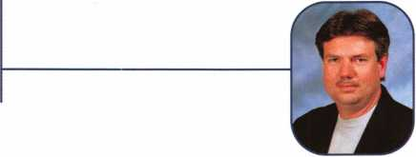

Keynotes • July/August 2002

IITECTURAL DOORS AND HARDVW

■nisi miuiMH wmi

Ruailable as single  
modules (one CD and  
guidebook) or the full  
set (three CDs and  
three guidebooks).

Seruer uersions are  
also auailable!

FUNDAMENTALS OF:

**Self-Study Course**

HLOR

**Conuention**

**SPECIAL**

**Get the award-winning  
Fundamentals of Hrchitecture  
Doors and Hardware Self-Study  
Course at a great price while  
attending HLOR 2002!**

The ultimate training tool for locksmiths... Now there is a complete in-house training

**program auailable! Order the** Fundamentals of architectural Doors and Hardware Self

**Study Course** three CD/guidebook series.

To order, call (800)532-2562 or uiuiiii.aloa.org

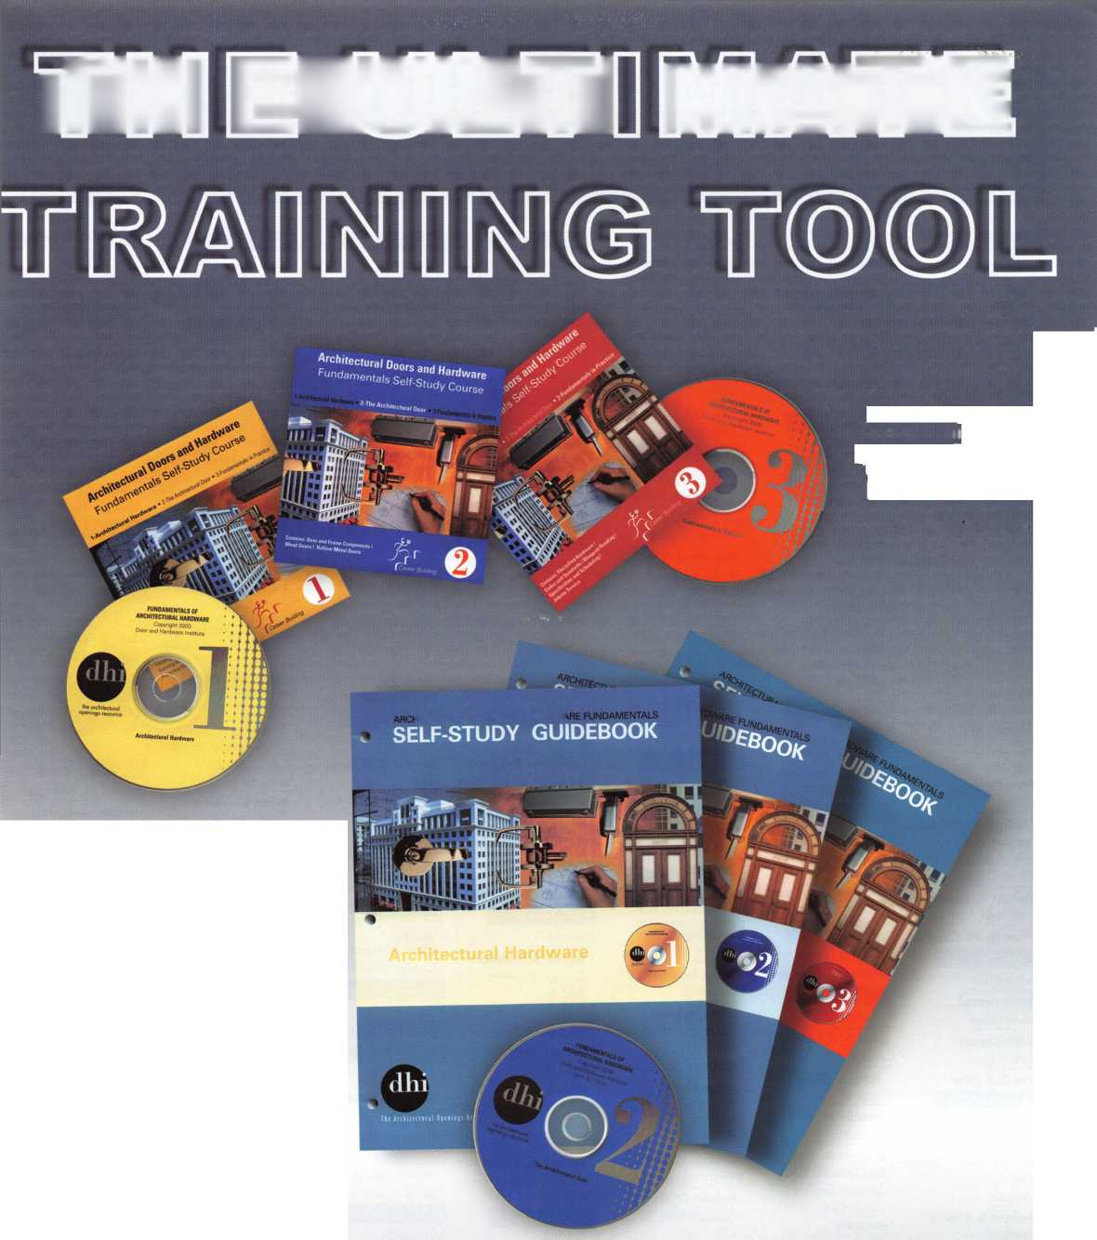

Anchorage

Gregory A. Wolfen- berger

Sponsor: Dale L. Rahn

Mulligan S. Gavin

Sponsor: Scott L. Henke CPL, CPS

Auburn  
Jeff L. Welch

Sponsor: John D. Brooks

Mobile

Jo Anne Cross

Greeley

Jennifer Crosby

Sponsor: Lynn B. Young

Bristol

Joseph B. Panella

Danbury

Christopher S. Seim

Sponsor: Larry W. Seim

Dolan Springs

Edward Huntzicker

Sponsor: Eugene R. Alto- bella Sr Glendale

Charles W. Copeland

Sponsor: William Lee Mesa

Bradenton

Brian Macquire

Sponsor: Curtis M.  
Mahoney CRL  
Coconut Creek

Antonio L Pol- erecky

Sponsor: Robert F. Car- roll CPL Gainesville

William R. Mikulski

Sponsor: Leonard P. Solt

**Jacksonville**

Bill McAllister

Juan M. Saenz

Sponsor: John A. Ilk CRL, Brunswick

CPS

Phoenix

Pete Holguin

Prescott Valley

Michael A. Robbins

Sponsor: Gregory L. Per-  
ry CM, CPS  
Queen Creek

Robert R. Howard

Scottsdale

Thomas N. Oberlin

Kerry J. Buchan

Lithonia

Brad Tyler

Wahiawa

Gary L Schwichten- berg

Sponsor: Louis R. Tascott CPL

Oak Park

Stephan Zaniolo

Sponsor: Kathy A. Zan­iolo CPL Park City

Noel M. Canlas Sponsor: Carl D. Norlin CPL Peoria Michael S. Rodriguez

Indianapolis

Wesley D. Freeman Lafayette Aaron Beeler Ron Niccum Sr Brian Greene Cheryl Wetli Shelby

Michael Myers

Louisville

James W. Frazier

Sponsor: Robert L. Strange

Colfax

Terris Murphy

Boston

Ryan Krakowsky Uxbridge

Brian D. Farrar

Cedar Glen

Scott Dentel

Los Angeles

Sam Cohen

Northridge

Eric B. Krebs

Broomfield

Paul E. Poglajen

Sponsor: John L. Shandy CML

Edwards

Robert S. Riddle

Frederick

Robert M. Harper

Sponsor: John L. Shandy CML

Carroll

Phillip D. Squibb

Calumet City

Bret D. Krist

Carbondale

John L Graig

Chicago

Rosalie M. Schultz

Evanston

Shawn A.  
McCormick CML

Sponsor: Thomas G.  
Glavin CML  
Kewanee

John Puskar

Lawrenceville

Michael Baker

Cambridge

Patrick A. Sarracco CRL

Sponsor: Norman Nel­son CPL Plymouth

Grant Laitala

Independence

Jason T. Smith Kansas City

James Willett Oleatha A. New- land

Bridgewater

Edward J. Colline

Irvington

Angelo Espinoza

Sponsor: Peter Sarailian CRL

Long Branch

Drew Carroll

Brooklyn

John P. Blacie  
Moses Gates

Sponsor: Philip A.  
Rovenolt CPL

Daniel Loperena

Sponsor: Joseph R. De  
Arce  
Freeport

Heidi Kinhackl

Sponsor: Peter Sarailian  
CRL

Merrick  
Keith Gerold

Sponsor: Wayne J. Nor-  
ris Jr  
Nyack

Adam R. Peel

Patchogue

John Flanagan

Sponsor: Peter Sarailian  
CRL

Peeksville

Lance D. Whitson

Oak Ridge

Christopher Peter-

Albuquerque

Adrienne Seaborn

Sponsor: Calvin E. Lauer CML

Leonard T. Adams

Sponsor: Debra S. Cole­man

Deming

David L Ransone

Brighton

Terry Tschirret

Dowagiac

Gary Pontius

Sponsor: Michael Marsh CPL

Macomb Dave Kaiser

Sponsor: Larry W. Williams RL, CPP Sturgis

Claude L Fish

Wyoming

Robert C. Van Ee

Sponsor: Peter Sarailian CRL

Henderson  
Jeff A. Schreiman

Sponsor: Eugene R. Alto-  
bella Sr  
Las Vegas

Michael L Sparks

Sponsor: Eugene R. Alto-  
bella Sr

Max L Allen

Sponsor: Eugene R. Alto-  
bella Sr

North Las Vegas

Joseph C. Balangan

Sponsor: Eugene R. Alto- bella Sr

Cincinnati

Steven D. Woods CRL

Sponsor: Charles L Woods Fayetteville

Mike Rzesutock

Monroeville

Andrew M. Betschman

Sylvan ia

John A. Pandi III

Sponsor: Steven R. Long

Ada

David D. Taylor

Lititz

Daniel J. Rossi Jr

Philadelphia

Thomas Kline

Thorndale Dale K. Mast

Sponsor: Keith S. Smith

Mapleville

Bruce Wattendorf

Sponsor: Stephen R. Blanding

Blanco

Loren G. Marshall

Sponsor: James L. Han-  
cock CRL  
Dallas

William S. Reed

Sponsor: Randy L Simp-  
son CML  
Kemp

James A. Moye

Sponsor: Clifford D. Lip-  
scomb CML, CPS  
San Angelo

Frank G. Ramirez

San Elizario

Paul A. Castillo

Sponsor: Rick H. Milliorn CRL

Robert D. Hendrick- sen CRL

Sponsor: John P. McKen­na CPL

West Bend  
Terry Vrana

Sponsor: Todd B. Lore  
CML

Cheyenne

Norman Devilbiss

Saint Thomas

Francis LeCuyer II

Sponsor: Francis J. LeCuyer RL

Dupont

Jonathan Clemens

W. Richland

New Westminister

James Carbonneau

Sponsor: Peter Boddy

Richmond

Wayne Duggan

Alexandria

Anthony A. Ortiz

Sponsor: Peter Sarailian  
CRL

Arlington

Brian Blystone

Sponsor: Michael B.  
Groves

Michael Palmer

Sponsor: Michael B.  
Groves  
Culpeper

Kent D. Piesbergen

Sponsor: Gary D. Quick  
CRL

Falls Church

Steven Kane

Lorton

Michael J. Mester

William J. Thorpe

Salem

Samuel A. Wilson

Hang Zhou Zhejiang Sun Jin Qiang

Sponsor: Kwok-kei Leung Taipei

Hsieh Chung-Hsing

Sponsor: Kwok-kei Leung

Ebetsu-City Hokkaid  
Tadaharu Katou

Sponsor: Takashi Kuwana CRL Himeji-City Hyogo

Yoshie Mori

Sponsor: Takashi Kuwana CRL Nagoya City Aichi

Oota Masanori

Sponsor: Yuriko Yanai Sapporo Hokkaido

Sadao Watanabe

Sponsor: Tomoo Hisano

Bimingham

Richard Bunn

Sponsor: Ken Dale Essex

Sean Waterfall

Hereford

Robert Collins

Surrey

Paul Stewart

Sponsor: Joe J. Lee CRL

These applicants are scheduled for clearance as members of ALOA. The names are published for member review and comment within 30 days of this  
Keynotes issue date, respectively, to ensure applicants meet standards of ALOA's Code of Ethics. Protests, if any, should be addressed to the Membership  
Department and must be signed. Active Membership applicants (a) have worked in the industry two or more years. Allied Membership (AL) applicants are not  
locksmiths, but work in a security-related field. Apprentice Membership (AP) applicants have worked in the industry less than two years.

Keynotes • July/August 2002

**Magnetic Locking Systems with**

**■» More Than Fasteners**

**for Support.**

**When you select a DynaLock elec tromagnetic lock or accessory product, you get more than fasteners for sup­port. You receive the full complement of product support and engineering ser­vices that only DynaLock offers... from technical and application assistance to system design and specification work.**

**DynaLock UL Listed high security products are manufactured in our modern, 18,000 square foot facility by computerized machining centers and robotics for superior quality, tight control and timely delivery. Each product is fully tested before shipment, with a 10 year warranty on all magnetic locks. And our full, internal production capacity ensures that lead time on standard products is measured in days... not weeks.**

**Standard maglocks, Passive Infrared, Delayed Egress and Low Profile DynaLock systems offer holding forces from 650 to 1500 lbs. Accessory products include UL listed power supplies, keypad systems, keyswitches, exit controls,**

**timers, monitor stations and custom consoles.**

DynaLock Corporation

705 Emmett Street, P.O. Box 2728 Bristol, CT 06011-2728 Fax: 860/585-0338 i nfo@dynalock. com

Don’t settle for just a lock... Get more than maglocks with DynaLock.

Call today:

**877-DYNALOCK** (877-396-2562) or visit: **dynalock.com**

**See us at ALOA show booth #832 and DHI Convention Booth #720**

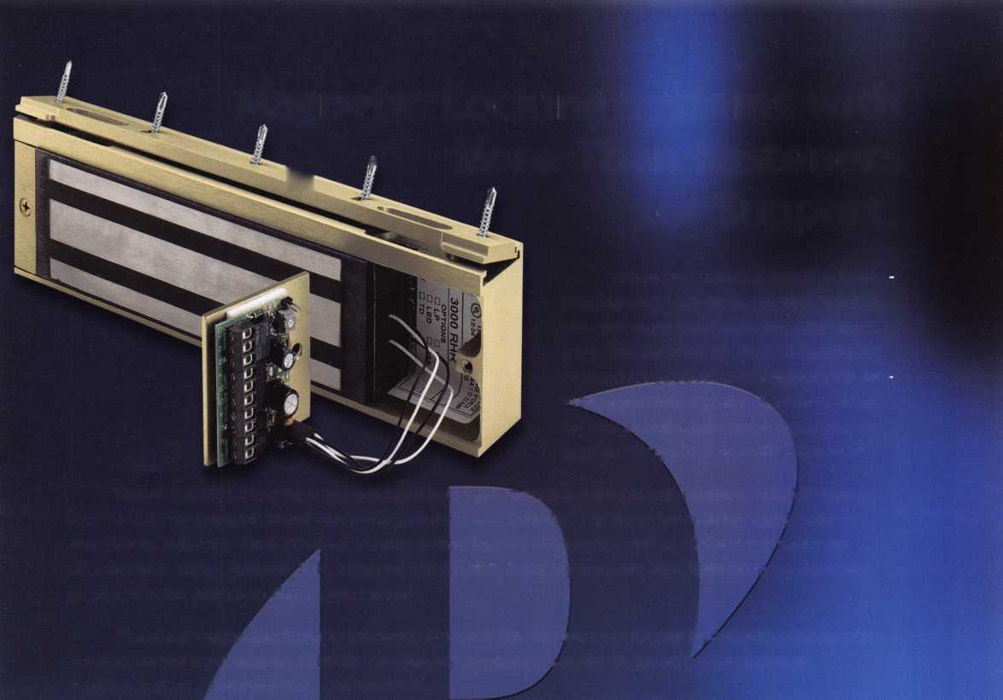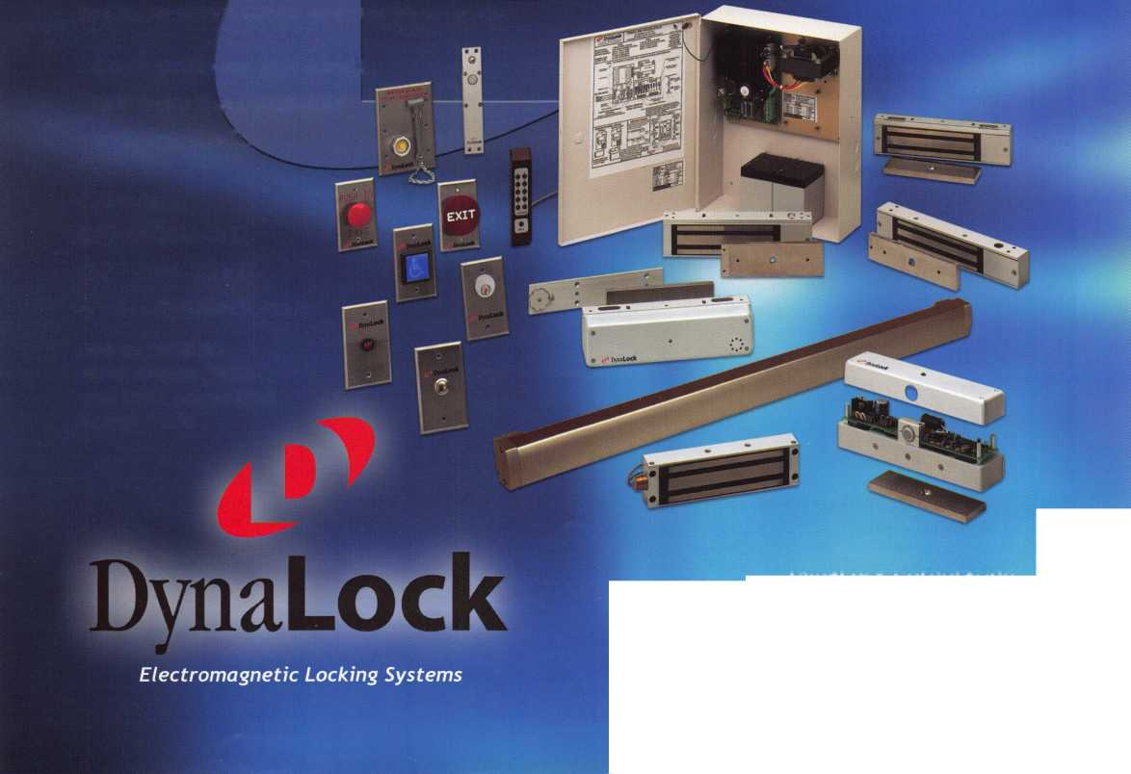

DEC I NOV I OCT I SEPT I AUGUST I JULY

upcoming

3 Minnesota Chapter of ALOA Membership Meeting [www.locksmithnews.com](http://www.locksmithnews.com)

22-28 ALOA 2002 (800) 532-2562 [www.aloa.org](http://www.aloa.org)

13-14 DHI Convention and Expo, Chicago, Illinois [www.dhi.org](http://www.dhi.org)

22-28 South Carolina Locksmith Assn. Meeting (803) 432-9008

Central Florida Locksmith Assn. 18 Membership Meeting (386) 775-3641

Pacific Locksmith Association Membership Meeting 6:30pm (360) 835-1191 [www.pla-pro.org](http://www.pla-pro.org)

17

24

Florida West Coast Locksmith Association (FWCLA)

General Meeting (727) 849-1812

7

Minnesota Chapter of ALOA Membership Meeting [www.locksmithnews.com](http://www.locksmithnews.com)

CENTRAL FLORIDA LOCKSMITH ASSOCIATE

Membership Meeting  
Contact: Janet Boyer

7:3'

386-775-3641

11 Fox Valley Chapter of ALOA 14-16 ISC EXPO/East 1 Oth Anniversary Orlando, Florida

Foxy Lady Cruise siaonline.org

(715) 355-5397

28 Pacific Locksmith Association Membership Meeting 6:30pm Dan Cunningham (360) 835-1191 [www.pla-pro.org](http://www.pla-pro.org)

16 Central & Southern Colorado Locksmith Assn (303) 688-4104

|  |  |
| --- | --- |
| 4 Minnesota Chapter of ALO  Membership Meeting  Basic Impressioning [www.locksmithnews.com](http://www.locksmithnews.com) | A 14 Greater Houston Locksmith 18 CENTRAL FLORIDA 19 Florida West Coast Locksmith  Assn. • Auto Opening with LOCKSMITH ASSOCIATION Association (FWCLA)  Steve Young • (979) 323-9919 Membership Meeting 7:30pm General Meeting  [orditels@fbtc.net](mailto:orditels@fbtc.net) Contact: Janet Boyer (727) 849-1812  <http://ghla>. 1 cis.com/index.htm 386-775-3641 |
| 27-29 Jo-Van Distributors Inc. 2002 Annual Security Sho and Educational Conferenc 416/752-2238 or 888/752-7210 | V  e |
| 7 Minnesota Chapter of ALOA 1-5 Pacific Locksmith Association 3 Oregon Professional Locksmith 14-19 ACE Six-Day  Membership Meeting Annual Convention Day Banquet • Pacific Locksmith Basic Locksmithing Course  Basic Lock Cylinder Rekeying Portland, OR Conference* Featured guest: Fox Valley Technical College  [www.locksmithnews.com](http://www.locksmithnews.com) 541/741-6902 Tim McMullen Appleton, Wl  [www.pla-pro.orgwww.pla-pro.org](http://www.pla-pro.orgwww.pla-pro.org) | |

25-26 South Carolina

Locksmith Assn. Meeting (803) 432-9009

Minnesota Chapter of ALOA Membership Meeting [www.locksmithnews.com](http://www.locksmithnews.com)

6-10 Yankee Security Conference Sturbridge, MA [www.yankeesecurity.org](http://www.yankeesecurity.org)



20 CENTRAL FLORIDA

LOCKSMITH ASSOCIATION Membership Meeting 7:30pm Contact: Janet Boyer 386-775-3641

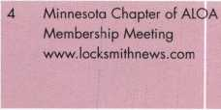

18 CENTRAL FLORIDA

LOCKSMITH ASSOCIATION Membership Meeting 7:30pm Contact: Janet Boyer 386-775-3641

n t

19 Central & Southern Colorado Locksmith Assn (303) 688-4104

18 Locksmith Golf Open

Minnesota Chapter of ALOA [www.locksmithnews.net](http://www.locksmithnews.net)

19

1**11**!

HI

Professional Locksmith Assn, of  
Alberta 25th Annual Convention  
and Tradeshow

[www.plaa.org](http://www.plaa.org)



I

25 Pacific Locksmith Association Membership Meeting 6:30pm Dan Cunningham (360) 835-1191 [www.pla-pro.org](http://www.pla-pro.org)

25-29 SERLAC Trade Show Orlando, FL (800) 845-529 [www.serlac.com](http://www.serlac.com) ACE

16 CENTRAL FLORIDA

LOCKSMITH ASSOCIATION Membership Meeting 7:30pm Contact: Janet Boyer 386-775-3641

23-27 Greater Philadelphia Locksmith Association (G-PLA) Convention



UPCOMING PRP SITTINGS

July 12 ALOA • Dallas, TX • Ashley Manson: 800/532-2562, ext. 30

July 26 ALOA • Rosemont, IL* Ashley Manson: 800/532-2562, ext. 30

Aug. 9 ALOA • Dallas, TX • Ashley Manson: 800/532-2562, ext. 30

Aug. 18 Clark Security Products • Elicott, MD • Joan Emrick: 619/718-7308

Sept. 13 ALOA • Dallas, TX • Ashley Manson: 800/532-2562, ext. 30

Sept. 22 Clark Security Products • Anaheim, CA • Joan Emrick: 619/718-7308

Oct. 11 ALOA • Dallas, TX • Ashley Manson: 800/532-2562, ext. 30

Nov. 8 ALOA • Dallas, TX • Ashley Manson: 800/532-2562, ext. 30

Nov. 11 Crand Canyon Chapter of ALOA • Phoenix, AZ John Ilk, CRL, CPS: 602-420-2174

Dec. 13 ALOA • Dallas, TX • Ashley Manson: 800/532-2562, ext. 30

UPCOMING ACE CLASSES

July 21-28 ALOA 2002 Convention • Rosemont, IL • Ashley Manson: 800/532-2562, ext. 30

Aug. 23-25 Central NY Locksmith Association • Syracuse, NY Ronald Smith, CRL: 315/658-2368

Sept. 11-13 Nutmeg Chapter of ALOA • Nutmeg, CT Dale Hobbs, CRL: 203/237-4602

Sept. 21-22 Central NY Locksmith Association • Ronald Smith, CRL: 315/658-2368

Sept. 25-27 SERLAC • Orlando, FL • Michael Belden, CRL, CPS: 904/396-2022

Oct. 14-19 Fox Valley Technical College • Appleton, Wl • Jerry Antoon: 920/735-2406 • [www.fvtc.edu](http://www.fvtc.edu)



SAFE CORPORATION

MANUFACTURES OF QUALITY DEPOSITORY SAFES AND CHESTS

DISTRIBUTING FROM

WAREHOUSES IN

* LOS ANGLES, CA
* CHICAGO; IL
* GLASSBORO, NJ

A & B is now a stocking distributor

for Mutual Safes

featuring

AB-43035 AB-9 FL WS 10-2

Chose from over 75 models in stock

We ship your order within

24 hours

See us

*ot [www.o-bsofecorp.com](http://www.o-bsofecorp.com)*800-253-1267  
Fox 856-863-1208

CALL FOR YOUR  
CATALOG TODAY

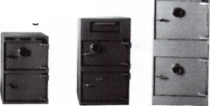

core

Letters to the Editor

The Battle of Access Control

Legislative issues cross my mind each and every day. They haunt me by the hour. Whether I am meeting a customer, selling or installing a product, I am always wondering when lawmakers are going to be paid enough money to suddenly strip me of the ability to serve and sell to my customers. Or maybe they'll include access control and CCTV in the burglar alarm industry's list of services and exclude us. They have already attempted this in a few states - is your state next?

Like most of you, I have been very successful in CCTV and access control. I follow electrical codes, take great pride in my installations and treat every job as if I were performing it on my own building. Why do we have to worry about law­makers and the alarm industry? Because this is already hap­pening in other states. Ohio House Bill 452 is an alarm licensing bill that includes access control and CCTV.

I do not want to install burglar or fire alarms; they are not my cup of tea. And the alarm industry guys do not want to unlock vehicles or change safe combinations. Yet we both install AC and CCTV, and are both in the security industry. Why not include these two services exclusively to both lock­smiths and alarm installers? This way, satellite, car audio and other installers not involved with security won't be able to install these systems - only licensed security professionals. What about our existing clients who have systems we have already installed? Will we tell them to call an alarm compa­ny because we aren't qualified to work on their security sys­tems? I can see it now... "I'm sorry, but we no longer offer those services."

We all need to get involved with this issue. Maybe you think you're too busy to do so, and you're going to let the other locksmiths worry about these issues. But if some of these alarm bills pass, you'll have more time and less money, and it will be too late to get involved. Contribute to your lock­smith lobbyists. We do so annually here. Stay involved with these legislative issues. Encourage other locksmiths to join ALOA - the only organization that exists to protect and pro­mote locksmiths - so they can get legislative updates in Keynotes each month. Write the politicians in your state and let them know how strongly you feel. Stop things before they get started. Get involved today while there is an opportunity to do so. Let's stand united on this matter.

—-James White

Editor's Note: See page 70 for legislative updates.

ALOA's Direction

Where is ALOA heading? Are the rumors true that at the next convention, the designation will be changed to "ATOA"? I see more help wanted ads for technicians than for locksmiths. I have conducted an informal poll at a side­walk coffee plaza and asked approximately 100 people what they think when they hear the words "locksmith" and "technician." The reply to "locksmith" was overwhelmingly, "Oh, he opens cars and houses, repairs keys, repairs locks, etc." The overwhelming response to "technician" was, "Gee,

I don't know - you mean a computer whiz or a dental techni­cian, automotive, TV repairman, etc.?" No one ever linked technicians with locksmiths.

A couple of years back, I was filling in part time for a local shop and I would always hear the dispatcher say, "I'll send my technician out" and I informed her - in non-delicate words - that I was NOT a tech, but that I have been working for 39 years to become a better "locksmith."

Next spring, I will be a working locksmith and an ALOA member of 40 years - and darned proud of it.

Well, I got a load off my chest and mind. I will continue to serve the public to the best of my ability.

Easy pickins,

Maurice Hatfield, CRL Brunswick, GA

Editor's Note: No, those "ATOA" rumors are not true. Keep the faith...

Let Us Know!

If you have an opinion to offer on ALOA, the state of the industry, or life in general, we want to know about it! Submissions to the "Mailbox" section of Keynotes are printed on a space-available basis. Write to: "Letters to the Editor"; ALOA; 3003 Live Oak Street; Dallas, TX, 75240; FAX 214/827-1810; e-mail: [editor@aloa.org](mailto:editor@aloa.org).

Need Help?

At ALOA, we want to make sure you are getting as much bang for your membership dues buck as we are able to give you. If you have had problems getting membership services, or have a question regarding member services, please con­tact Bill Gibson, executive director, at 800/532-2562, or e- mail: [charlie@aloa.org](mailto:charlie@aloa.org).

^23 Keynotes • July/August 2002

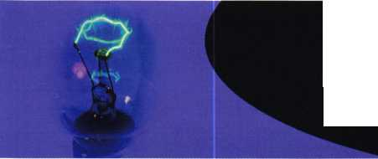

Skip Saves the Day

SAVTA President Skip Eckert, CML,  
recently rescued a baby who was acci-  
dentally locked inside a bank vault  
where his mother worked in

Williamsburg, PA. Skip, in his own  
words, tells us now what happened:

"Diebold called me about 6:30 p.m.

and told me to go to Williamsburg, PA. An 1 8-month-old boy  
had been locked in a bank vault. His mother worked in the  
bank and the boy was playing and hiding in the vault when  
it was closed. The time lock was set to keep it locked until  
the next morning.

"No one was sure what kind of vault it was, so I took off not knowing what kind of vault. I wouldn't usually do this, but time was important. At this point, no one knew if the kid was going to be able to breathe for very long. On the way, I called a friend and he dug through his library until he found something that matched the info we had about the vault. It turned out to be a Skilcraft. I also called Ron Snively, CPS, because I thought he had drilled the Skilcraft and then I called Ron Jewell, because I thought he owed me money. Just kidding. I knew he had drilled Skilcraft vaults before; I had not. Considering the high stakes, I wanted every bit of info I could get my hands on.

"I arrived a little after midnight. The whole block had been closed off with yellow police tape. Upon entering the bank, I saw about two dozen people just staring at the vault. There were police, firemen, paramedics, bank people, Diebold people and the family of the little boy. The pressure was so thick you could cut it with a knife! (I've always wanted to say that.) It really wasn't that bad. I put a mark on the door using the measurements I had gotten from Phil and the two Rons. I drilled a hole using the Strongarm lever rig. It took about 20 minutes to put a hole through the door (about 10 inches to the time lock). It took about five more minutes to get a probe from the van and push down on the blocking bar and open the door. When I opened the door, the little boy was still stuffing hundred dollar bills into his diaper. Just kidding — I just said that to see if you were still paying attention.

"If there are any heroes in this story, they are Phil and the two Ron's! I just did what they told me to do and collected obscene amounts of money for drilling a little hole. If you want to be a hero, too, give me your best jobs with all the info I need and I'll try and make you look good, too.

"As I got into my van to leave, a few camera crews came up and knocked on my window, asking for an interview. As my pepper spray wasn't where I could reach it, I agreed and they shot some video of me sitting in my van." —Skip Eckert, CML, SAVTA President

ATTENTION ALOA CHAPTERS, AFFILIATES AND LOCAL LOCKSMITH ASSOCIATIONS!!!

Bring your membership card to the ALOA Convention and win prizes!!

In an effort to promote this year's ALOA Convention, in Rosemont, Illinois, July 22 - 28, ALOA is offering its Chapters, Affiliates, and local locksmith associations the following reasons to join us!

* Have your Monthly Chapter/Association meeting during the Convention - we'll give you the space to hold it!
* Each one of your members who attend will receive an extra raffle ticket for the NEW VAN DRAWING;
* For Chapters, Affiliates, and local locksmith associations that register at least 20 members, the organization

will receive LAB's great Schlage/Kwikset Combination pin kit;

* For Chapters, Affiliates, and local locksmith associations that register the most members, will receive a 7-day Registration Package at the 2003 Convention in Las Vegas (approx. $900 value)!!

ATTENTION UNITED KINGDOM ALOA MEMBERS

The Board of Inland Revenue has approved The Associated Locksmiths of America, Inc.under Section 201 of the Income & Corporation Taxes Act of 1 988 for income tax relief in respect of annual membership subscriptions retro-active from April 6, 2001. ALOA's name will appear on the list of approved bodies, which is due later this year. Inspectors of Taxes will not receive notification of ALOA's approved status until then, so if you wish to obtain a deduction for your annu­al subscription before the new list is updated, you should explain when contacting your local Tax Inspector that ALOA has only recently been approved and quote the following Head Office reference number: SAPP/T1644/1 1 /2002/JEM.

More information may be found at: <http://www.inlandrevenue.gov.uk>

New Certifications

CRLs

Marilyn Brown Cheney, WA

DeWayne Heidemann Decatur, IL

Keynotes • July/August 2002



MEMBERSHIP MILESTONES:

2002 ALOA Anniversary List

Each year, ALOA recognizes those members who are celebrating membership anniversaries. The follow­ing list represents this year's list of milestone members, whose years and years of service and participa­tion in their profession set a great example for those in subsequent generations.

ms

Edwin F. Toepfer

1956

Ewell W. Bradburn James L. Britt RL Herman B. Brust Jr, RL Edwin Dietzel John Dziuba RL Harold Gort William C. Kenton James F. Love Philip A. Macy Arthur E. McGinnis William D. Mclnerney RL, AHC, CPP Roman G. Moncur Carl W. Moyer Jay Nelson RL Arthur R. Paholke RL Roger J. Paradise RL Ernest J. Ricciuto Don J. Spenard Sr, RL Carl A. Stapel RL Herbert Stein SJ Sussina RL James L. Taylor RL George E. Walters

1957

Stanley C. Haney CPL Harry J. Kroll Joseph T. Smith Sr

1958

Lawrence P. Buchanan RL Charles M. Cooper RL Harold Edelstein RL William J. Greenberg RL Edgar L. Jones Jr, RL Fredrick R Leimbach RL

Richard M. Lockman RL Robert C. McCown RL George A. Petrie Edward A. Pfeil CML Louis Weberman RL

1959

Joseph S. Anmuth RL Sam Charm RL Donald G. Dobs RL Aaron Max Fish Gordon J. Grengs Walter H. Stiering RL Kenneth J. Troy RL Joseph A. Veniero

19^0

James C. Ard Sr Joseph A. Dube CML Robert H. Easter Sr, RL John R. Malinowski CML,CMS Gerard E. Mangione David M. Williams Sr

**iq6i**

Raymond E. Beggs CML Robert W. Freed RL Warren G. Heaton RL U.W. Hunt John McManus William A. Meacham Ramon F. Merlin RL Jerry C. Shaffer Robert E. Sontag RL Charles W. Thomas CML Leonard E. Whitford Sr

1062

Dan C. Ellis CPL

Timothy G. Griffing Jr, RL

Louis N. LaGreco CPL

1963

Maurice W. Hatfield RL Eugene Haywood RL Alfred C. McAfee CML Jerry Meilan RL Arthur C. Miller RL Walter L. Miller Thomas E. Minick Lew F. Noyes Jr, CML Alexander W. Rose RL Harvey W. Sass George J. Trouland RL Karl C. Wentz RL Gene S. Winne RL Milton F. Wolferseder RL

1064

Charles M. Angelroth RL John H. Berg RL James C. Condil Edward J. Delphia, RL Morris H. Fleischman George F. Frey Robert G. Henke CRL Yehuda M. Hersh Ernest Jones T C. Mickley CML Edwin L. Phillips RL George Pinson Alan P Stelzer

1965

Eugene R. Anderson RL, CPP, AHC

Edward R. Crossman CRL George I. Esthus RL George A. Iffrig

Paul H. Jamieson RL John N. Keefe RL Walter W. Lascar RL Sandy D. Roseborough William G. Schultz

1066

Garvis E. Crider John DeCosta Jr, CML Carl A. Fowler RL Patsy Gunkel RL Stuart W. Johnson Edward Kotler RL David E. Leeper RL James Mozisek CML Charles E. Skobrak Sr, RL John W. Walter CPP Marion J. Walters CRL

1067

Lewis A. Alessandrini RL Edward R. Attkisson RL Lawrence I. Barrett Sr, RL B.W. Cook

Michael F. Cutler CML Arthur M. Frost RL Richard E. Fullmer Jr, CPL R Alan Haga Ronald E. Hutchison John E. Jackson RL David J. Killip CML Roger D. Kline RL Raymond P Knecht Larry B. Ralston RL John L. Shandy CML Paul C. Taormina RL Walter R. Wasilenko RL Arby R. Watkins Ronald W. Weaver Harold J. Wills

**2**

Keynotes • July/August 2002



**mOBILE CODE m A C H I n E**

q Q| Qp ||2 ^2

cam caam©  
amaaas

mmmmmm

**Codes Codes Codes**

most Domestic, Japanese, and  
Korean Car Codes are now built in.

* Windows™ interface for built  
  in masterkey system printing  
  and sauing
* Domestic car codes included
* Both 12 uolt and 120 uolt  
  usage standard
* One cutter emulates all flat  
  widths
* Four line display with menus  
  RS232 communication port
* Repeatable accuracy +/-.002
* 1 year parts and labor war-  
  ranty
* Ouer 500 maufacturers depths  
  and spaces built in
* Finds, loads and cuts a car key  
  in 15 seconds

Intralock Tools Ltd

TheneW m g5l

most cost

mIrh'Ue cod(

Machine ever'

Phone: (888)264-6627 A 1 / 2639-B Progressive Ulay

(604) 852-8904 || | ] Abbotsford, B.C.

Fax:1604852-8938 TOOLS LIMITED U2T6H8

uiupui. intralocktools.com

Seruing industry with superior key machines since 1985.

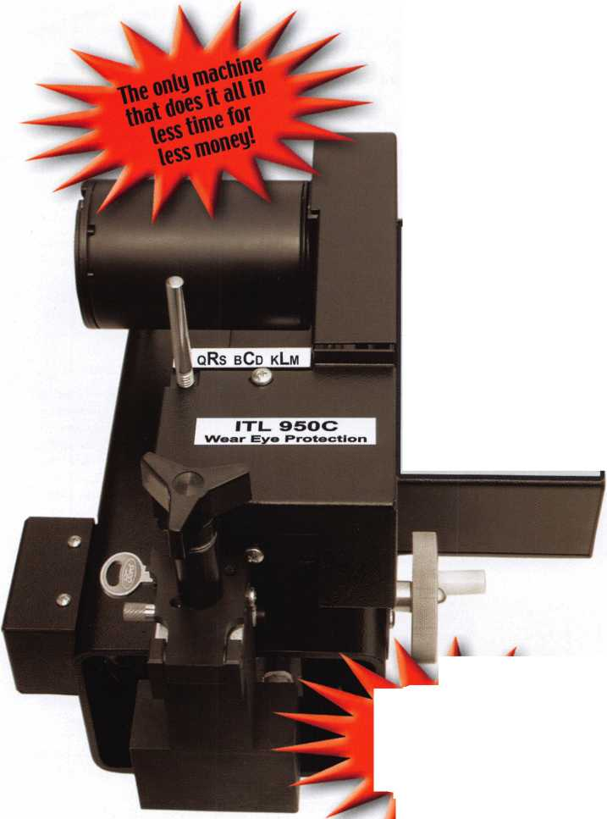

STATE OF THE ASSOCIATION

In this tough economy, ALOA continues to offer you more for your money

by working smarter for you

When I became President last year, a member came up to wish me good luck, and then threw me a curve ball: "What is ALOA doing for me?" The purpose of ALOA is the prosperity and success of its members, so I answered him readily with generali­ties about what Keynotes, Education and Legislation is doing for him. In a year's time, I have been in the fortunate position to work with the Bill Gibson, CAE, the Executive Director and the talented ALOA staff on the numerous things that ALOA does for its members, and have come to a more specific answer, "ALOA offers our members more for the price by working smarter on you behalf, and here's why..."

An educated membership that is prepared for the future

An educated member is able to work smarter too. So, one of the goals of the associ­ation is to promote our members to the consumer and our industry partners as highly skilled certified professionals. Its mission is to also provide a highly qualified market for advertisers and exhibitors. We accomplish this through our outstanding Education Department, and its Manager, David Lowell, CML, CMST. Last year alone, the ALOA Continuing Education (ACE) program conducted 174 full day and 44 half­day ACE classes & seminars at 19 locations. Ninety-three of these full day classes were conducted away from the convention at sites that ranged from Seoul, Korea to Sturbridge, MA.

It is also important for ALOA to develop a skilled service network of members for each area of specialization. To that end, last year we conducted training in Automotive (37 ciasses/563 students); Electronic Security (41 classes/652 students); Safe and Vault Servicing (38 classes/504 students); Mechanical Security (82 class­es/1391 students); Business Management (20 classes/225 students).

Another goal is to grow our membership because of consumer and industry demand for highly skilled ALOA certified locksmiths. We have administered the PRP at 40 sit­tings with 556 participants. There were 43 ACE classes that provided after class PRP exams. There were 258 students that chose the option to take the after-class PRP for that class. The pass rate for these exams is 87%. Currently there are 693 CML's, 629 CPL's, 2722 CRL's and RL's (646 grand fathered RL's). This represents 56% of the total ALOA membership, and one of the highest ratios of trade association voluntary certification in the country.

We will be conducting more ACE classes this next year, including conducting a five- day basic locksmithing training course at the ALOA headquarters on a quarterly or semi-annual basis. We are also working with some large locksmith companies and distributors to provide regular ACE classes at their sites and their shows.

We are currently updating and revising the PRP categories as well as adding addi­tional elective categories. The Education Manager is looking at developing addition­al locksmith certifications in specialized areas such as: Certified Automotive Locksmith (CAL); Certified Electronic Locksmith (CEL); Certified Institutional Locksmith (CIL).

Using the latest technology to bring you the latest information

Giving locksmiths the right tools, helps them work smarter. The PRP, developed in 1985, had not had a professional review for some time. The Scholarship Foundation had a complete Psychometric review of the PRP conducted by North Texas State University. This will allow the PRP to be delivered electronically in the future and updated more timely. We now update both the PRP and the ACE schedule on the web site calendar as well as FAX on Demand so that members and others can have access to daily changes in the schedule. This assists in helping to promote locally sponsored events in a more timely fashion.

In an effort to provide additional assistance for members wanting to advance their knowledge and/or prepare for the PRP, we have created the ALOA Bookstore where we offer books, videos and CD ROM's. In addition to the books that we publish, we are offering those published by National Locksmith, Tech Train, Locksmith Publishing Corp., DHI, HPC and others. We are now able to offer the current Life Safety Code Manuals and National Fire Protection Association (NFPA) publications at a special member rate, usually 10 - 15% off the list price.

We are continuing to look at alternate means of delivering ACE classes and the PRP such as videotape, CD ROM and Internet interactive instruction. ALOA is also devel­oping a correspondence course that will provide a learning tool for apprentices as well as a study/reference guide for the CRL exam.

We have also begun working on the website to make it more user friendly in the "Find A Locksmith" section. Soon, consumers will be able to have a multitude of options when looking for a security professional.

By Randy L. Simpson, CML, President

ALOA membership is recognized as security professionals by related industry groups

A locksmith that has the support of related industries is able to work smarter for their customers. It is important to me that those outside of the association recognize that our members are the best security professionals, especially in this day of heightened security. In the course of soliciting advertising and booth sales we repeatedly inform manufacturers and distributors of the quality of our members and the association. The interaction between these companies and our members at convention and similar events serves to acquaint companies with our membership. Several members of the manufacturing community have served on the ALOA Board, and SHDA has adopted a policy of attempting to place one of its members on the ALOA Board as the "Associate Region" director. ALOA participates in the SIA, DHI, ILA, ASIS, SHDA and NBFAA Board meetings and chairs the Electronic Systems Alliance that includes 12 associations with a common interest in protecting the low-voltage industry.

ALOA has developed and registered an "apprentice program" with the Department of Labor, and we have worked with states to implement some part of this program. ALOA maintains with the Department of Commerce a unique North American Industrial Code System (NAICS) code. This code, 561622, is used to gather informa­tion about the profession. It also serves as recognition by the federal government that locksmithing is a separate, identifiable profession. We have worked with the Institutional Locksmiths Association to accomplish this End.

ALOA has worked with various locksmith associations for "Locksmith Day" proclama­tions. We were successful with Wisconsin, South Carolina and Oregon in bringing awareness of our profession to the general public.

ALOA recently contracted with a vendor who will be selling business forms to mem­bers that feature the ALOA logo and have the Code of Ethics printed on the reverse. This will help to publicize the code to the public.

A positive legislative environment for ALOA members

A locksmith who knows what is happening to laws that effect them, will make them a smarter business person. ALOA effectively represented members' interests opposing bills that would impede locksmiths right to do their work in Connecticut, Indiana, Maryland, Mississippi, Oregon and Texas. We were successful in getting these bills either killed or amended. ALOA actively worked on passing a locksmith-licensing bill in North Carolina and locksmith registration bills in South Carolina and Texas. We worked closely with the Texas Locksmith Association and their lobbyist on the defeat of an alarm amendment to the current law that would have brought in all types of access control under the alarm regulatory board. We are working closely with NBFAA on updating the International Association of Security and Investigative Regulators (IASIR) model law on licensing electronic security systems to make it more favorable to locksmiths.

Last year, our Government Affairs Manager, Tim McMullen, monitored over 500 bills related to the security industry, focusing on 15 of them in 13 states that directly affected locksmithing. The Legislative Report page on the ALOA website is updated constantly on these bills to give members up-to-the-minute information on legislative activities in their state. We've developed an "Action Alert" page where members may look at specific bills, their status, and write a letter to the appropriate legislator. The Legislative Action Network continues to inform and energize members about leg­islative matters. The total number of LAN members has risen to 321 in 44 states donating over $9,000 to the Legislative Fund. We are also working at the Federal level on legislation that would require car manufacturers to provide locksmiths impor­tant information so they may fully serve their customers.

Keynotes continues to provide the very best in Locksmithing technical information

Members access to industry experts at all appropriate levels is best displayed in the numerous technical articles written by these experts every month in Keynotes. Last year we had well over 500 pages of technical articles covering every topic under the sun. The "new and improved" Keynotes also includes monthly features in 5 major dis­ciplines: mechanical locksmithing, access control, automotive, safes and institutional.

So now you know, what I've learned: In this tough economy, ALOA continues to offer you more for your money.

**14**

Keynotes • July/August 2002

**Navi**

**TO THE**

**IN SAFETE**

**GATE**

**Future**

**CHNOLOGY**

**THE SAFE AND VAULT T**

I

**CONVENTION**

**MARCH**

**BAHIA RESORT HOTEL •**

**I**

**JCHNICIANS ASSOCIATION**

**5** **TRADE SHOW**

**24-29**

**j SAN DIEGO, CALIFORNIA**



FINANCIAL REPORT

The Associated Locksmiths, Inc. engaged the firm of Sutton Frost Cary, LLP to conduct the annual audit of the association's financial records for 2001.

The audit was completed and a report made to the Board of Directors on February 20, 2002. Part of this report, the Statement of Financial Position (Balan Sheet) and the Statement of Activities (Profit and Loss), are included with this report to the membership. The auditing firm was of the opinion that the financ records present fairly, in all material respects, the financial position of the Associated Locksmiths of America, Inc.

The purpose of the Associated Locksmiths is not to make a profit; rather it is to provide the member services specified by the Board of Directors. These service include education, access to technical information and legislative action. It is not always possible to provide these services and produce a profit. Such was the case in 2001. For the year, the income of ALOA decreased by 8.9% and expenses increased by 6.3% creating a loss.

So far 2002 is doing well. Dues revenue, normally about 45% of ALOA's total income already exceeds last year's total. Convention income, the other majo component of total income, is doing well so far. Changes have been made to reduce expenses this year. We expect 2002 to be profitable.

ALOA remains financially capable of providing the services expected by its membership.

ASSETS

|  |  |  |
| --- | --- | --- |
|  | 2001 | 2000 |
| Current assets: |  |  |
| Cash | $312,274 | $375,026 |
| Certificate of deposit | 62,515 | 59,375 |
| Accounts receivable | 225,299 | 302,095 |
| Inventory | 29,400 | 30,118 |
| Prepaid expenses | 115,213 | 76,004 |
| Dues from affiliate | 2,852 |  |
| Current portion of notes |  |  |
| receivable from affiliates | 21,882 | 25,040 |
| Total current assets | 769,435 | 867,658 |
| Property and equipment: |  |  |
| Land | 79,836 | 79,836 |
| Building and improvements | 302,516 | 302,516 |
| Furniture and equipment | 476,616 | 445,810 |
|  | 858,968 | 828,162 |
| Less accumulated depreciation | (641,567) | (599,202) |
| Property and equipment, net | 217,401 | 228.960 |
| Note receivable from affiliate, |  |  |
| less current portion | 182.627 | 145.080 |
| $1 | ,169,463 | $1,241,698 |
| LIABILITIES AND NET ASSETS | | |
|  | 2001 | 2000 |
| Current liabilities: |  |  |
| Accounts payable | $82,911 | $39,264 |
| Accrued expenses | 40,948 | 31,770 |
| Current maturities of long-term debt 11,062 | | 10,711 |
| Current maturities of |  |  |
| capital lease obligation | 3,616 | 3,455 |
| Prepaid dues | 578,372 | 442,402 |
| Prepaid exhibit fees | 422,400 | 459,260 |
| Total current |  |  |
| liabilities 1 | ,139,309 | 986,862 |
| Long-term debt, less current maturities |  | 11,318 |
| Capital lease obligation, less current maturities | | 3,308 |
| Total long-term liabilites | | 14,626 |
| Total liabilities 1 | ,139,309 | 1,001,488 |
| Net assets- unrestricted | 30,154 | 240,210 |
| $1,169,463 | | $1,241,698 |

STATEMENT OF ACTIVITIES

|  |  |  |
| --- | --- | --- |
|  | 2001 | 2000 |
| Revenues | | |
| Membership dues and services | $933,362 | $970,158 |
| Convention | 752,724 | 872,973 |
| Management fee | 92,400 | 110,400 |
| Advertising | 63,696 | 100,141 |
| Promotional programs | 28,363 | 37,158 |
| Interest | 38,803 | 41,850 |
| Educational programs | 111,974 | 82,817 |
| Miscellaneous | 10,860 | 14,632 |
| Total revenues | 2,032,182 | 2,230,129 |
| Expenses | | |
| Administrative | 1,258,409 | 1,123,495 |
| Convention | 460,552 | 467,296 |
| Keynotes magazine | 204,558 | 241,883 |
| Building operations | 72,633 | 53,104 |
| Member services | 39,169 | 32,953 |
| Depreciation | 42,365 | 40,956 |
| Promotional programs | 20,291 | 26,623 |
| Educational programs | 140,339 | 120,871 |
| Committee | 3,922 | 1,745 |
| Total expense | 2,242,238 | 2,108,926 |
| Increase (decrease) | | |
| in net assets | (210,056) | 121,203 |
| Net assets at beginning of year | 240,210 | 119,007 |
| Net assets | | |
| at end of year | $30,154 | $240,210 |



Keynotes • July/August 2002

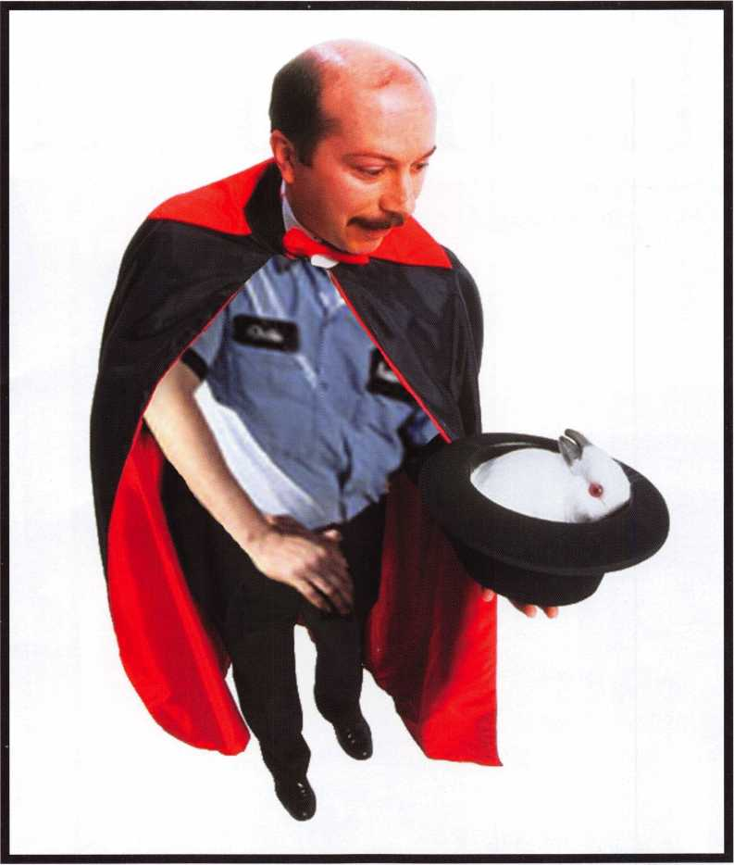

Keep Your Day Job

Come to Las Vegas and invest in your future.

Discover classes, workshops, and exhibits that will keep you competitive in today’s marketplace.

The only gamble is staying home.

LAS VEGAS, NEVADA

ALOA 2003

♦ . » i

Las Vegas Hilton/Las Vegas Convention Center • July 14-20, 2003

We Are the

Champions!



HU

Glavin Security Hardware Specialists of Downtown Chicago Shrugs Off Increasing Industry Pressures by Sticking with Sound Locksmith Business Principles

Interview of Tom Glavin, CML, owner of Glavin’s by Keynotes editor, Jim DeSimone

**8**

Keynotes • July/August 2002

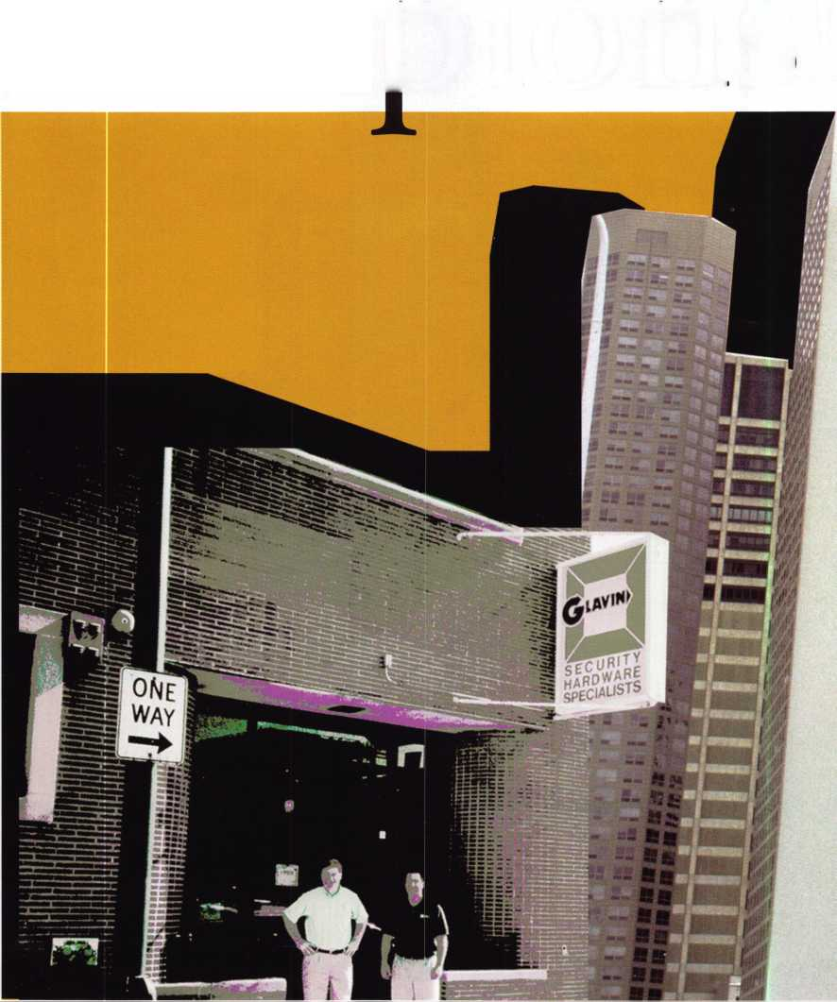

Hi Tom, thanks for taking the time to talk with us.

Thank you for considering our company for Keynotes magazine; we are honored.

Our pleasure. Tell us, what’s your favorite place in Chicago?

I really enjoy all of the lakefront parks.

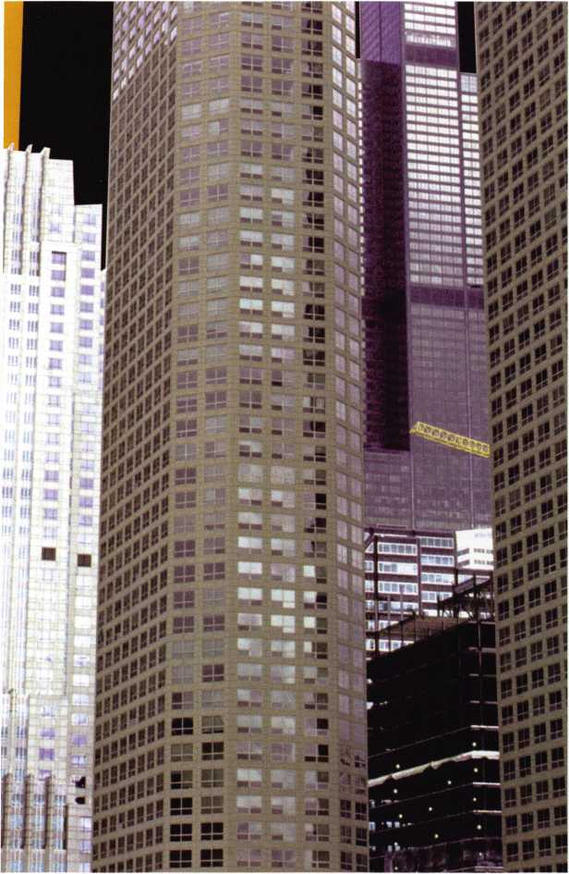

Why?

They’re open to everyone so therefore a great place for  
people watching. It’s one of the things that makes  
Chicago really unique.

Tell us about the rich locksmithing tradition in  
Chicago.

Many manufacturing companies started in Chicago and  
one of the nation’s largest distributors of locksmith tools  
and hardware, H. Hoffman, started here as well. As I  
understand it, many locksmiths from Chicago have their  
names on the ALOA Charter, including my Uncle Tom  
Glavin and his partner Sol Kaye. In addition, there are  
several locksmith companies, including ours, that are  
family owned and have been in business for more than  
50 years.

Lots of locksmithing history in this region, no doubt  
about it. Tell us how you got into locksmithing in  
Chicago.

My father owned his own locksmith company, M.J.  
Glavin Locksmith, and two of my uncles had businesses  
as well. My sister, cousins, nieces and nephews are all in  
the industry. I guess it was in our blood. My only job  
before becoming a locksmith was paperboy!

Really? Those family-owned businesses really give  
you the chance to hit the ground running. Tell us

what changes you’ve seen in technology applications in town  
over the years? How have you adapted over time?

Electronic locks and systems are becoming more mainstream and much more affordable to both business owners and homeowners. Customers are extremely interested in hearing about the latest elec­tronic products. Electronic products are our fastest vehicle of growth, not unlike most other companies in our industry.



Keynotes • July/August 2002

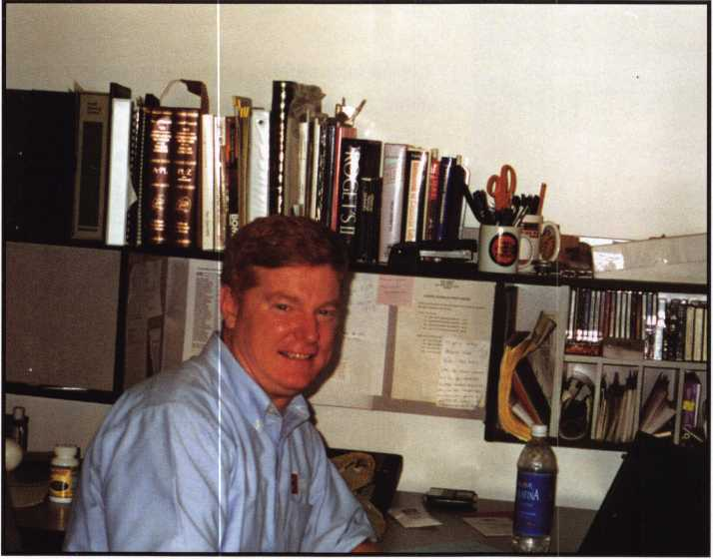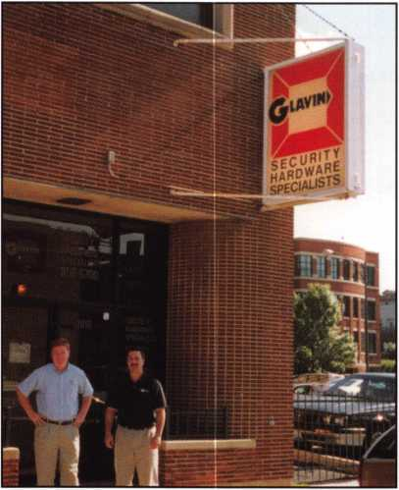

3 Keynotes • July/August 2002

Tell us how shops work together on referrals and workflow?

Do Chicago shops send certain customers over to specialists, or is it more cutthroat than that?

Fortunately, most professional shops are helpful to each other.

It might have something to do with the previous generations working together. We actually get a lot of referrals from other locksmith com­panies that don’t want to service the downtown area, and likewise, we refer business to them. We’re in a competitive market, but it hasn’t come to being “cutthroat.” I know in many other cities competing locksmiths don’t even talk to one another. Thank goodness that’s not the way it is here.

We were wondering how you get along with the local law enforce­ment guys? (From what we understand, there actually has been a decent effort from the police side to educate their people and to get locksmiths to participate in outreach programs in the Chicago area.)

We get along great and find that the Chicago Police are very good  
at referring citizens to locksmiths, although they are not allowed to  
encourage someone to use a specific shop. We’re an active member of  
our local CAPS (Chicago Alternative Policing Strategy) program and  
are a resource to the Chicago Police Department when they need

product displays for their  
crime seminars.

Good to hear. Harmony  
between local police and  
businesses that can help them  
isn’t exactly common every-  
where. But tell us, how do you  
reconcile the old and new -  
securing antique doors and  
doorways, etc., with new lock-  
ing systems (AC, High-  
Security, CCTV, etc...)

At Glavin, we consider this one  
of our specialties. In this area  
we are frequently called in when  
other locksmith and security  
companies have been unable to  
solve problems. We often have  
products specially manufactured  
to fit customers’ needs.

How do you stay abreast of new products and locksmithing tech­niques, so that you can keep delivering added value to customers?

The manufacturers representatives in our area do a great job of keep­ing us up to date with new products. In addition we have a very com­prehensive training program, which include OJT, classroom, job simu­lation and job debriefing. We try to make learning in our company a way of life...not an event. We are striving to give our team an environ­ment that is conducive to learning, that includes trying to give them the tools and information they need when they need it.

How territorial are the neighborhoods in Chicago?

I think this is becoming less prevalent; more shops are differentiating themselves by their products and services or the market segments they service, not geographic areas.

Future of locksmithing — where are we going?

I think locksmith companies are in a fine position to grow, as long as we aggressively pursue opportunities and continue to see our business as more than mechanical locks. I also see more and more women becoming technicians in our industry, in fact I wouldn’t be surprised if one day our industry is led and dominated by women. I think it’s a perfect situation for a woman who would like to work with her hands as well as her brain. Locksmithing is as much customer service as it is a trade. It’s not backbreaking work; it obviously requires communica­tion skills, but also a great deal of empathy and problem solving skills. In addition, it’s not shift-work; the hours are flexible, making it perfect for a single parent.

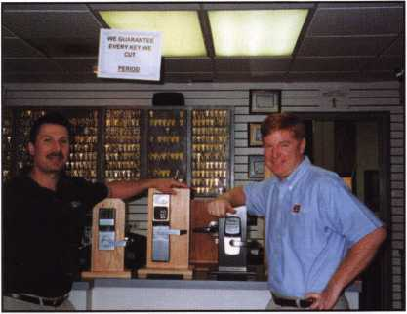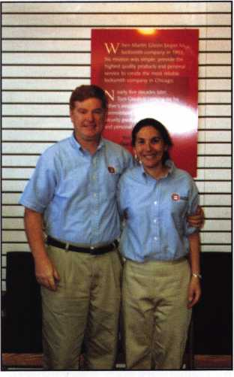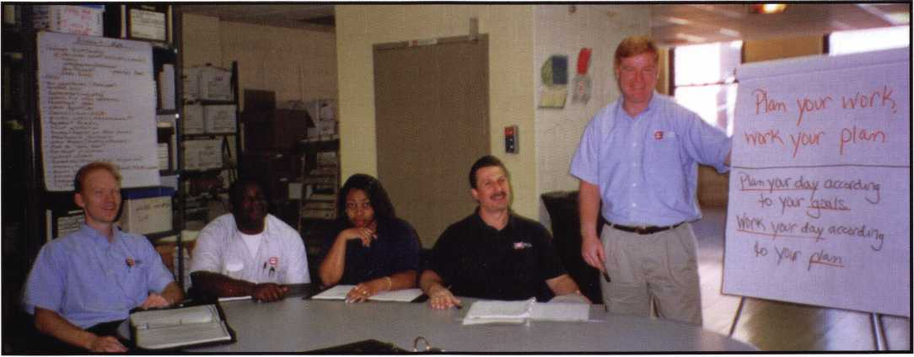

Keynotes • July/August 2002

Name a few things locksmith business owners should be doing (but maybe aren’t) to help their businesses prosper and grow.

WE ARE THE CHAMPIONS! - While watching a tennis match on television a while back, I heard a commentator say something very profound. He said, losers hit a wide variety of shots, but CHAMPIONS hit the same old boring winners! Here are a few “old boring winners” you may consider.

* Produce a quality product.
* Treat people so they recommend your company to others.
* Make a profit.

IF JOHNNY JUMPED OFF A CLIFF, WOULD YOU?

I remember my mother asking me that question whenever she thought I was following someone blindly and not using my own judgment. Don’t get too caught up worrying about what your competitors are doing; chances are their “crystal ball” is no clearer than yours.

IS THE WORLD PASSING YOU BY? If you are having too many days like the “Maytag Repairman” (waiting for the phone to ring)... start aggressively implementing a sales plan.

CONTROL YOUR EGO. - Almost all the business owners I know have a pretty sizable ego, but over the years, I’ve seen uncontrolled egos get a lot of business owners into trouble (including myself!). Your business decisions should be giving you a Return on Equity (ROE), not a Return on Ego (ROE). Be realistic. There is a fine line between Vision and Hallucination.

GOT CASH? Someone once told me that there are three rules for staying in business.

1. Don’t run out of cash!
2. Don’t run out of cash!
3. Don’t run out of cash!

It may sound oversimplified, but it is true. Forecast and man­age your cash during good times and bad.

WHO IS A CUSTOMER? One conclusion many experienced shop owners have come to at some point is this; If you per­form work for an individual or a company and they don’t pay you, they are not a customer. They are an expense and you

should STOP WORKING FOR THEM. This is a lot harder than it seems because it is tough to walk away from a sale.

Name three unusual things (locksmith tools, personal charac­teristics, anything) that a locksmith has got to have to make it in Chicago.

* Patience in Chicago traffic.
* Problem solving skills, because of the older homes, build­ings and different applications.
* Fortitude to work outside in our ever-changing weather.

Give us your biggest Chicago locksmithing horror story - toughest job, or one in which you learned a big lesson.

The biggest lesson I’ve had over the years is that it takes a lot of courage to walk away from a big job that isn’t profitable. There is a reason they’re called “killer deals.”

Name one thing in your shop office or van that says the most about you.

I keep lots of pictures and personal items of my family in my

office. Work is fun, but my family

fulfills my emotional needs, not my business.

What is the best part of being a locksmith in Chicago today?

Chicago is diverse, not dependent on one industry. When one revenue-stream dries up it’s not that difficult to find another. Perseverance and hard work still matter in Chicago.

Explain the rewards of being an active participant in the profession as a whole, as opposed to someone just spinning their wheels trying to make ends meet at the shop?

The best friends I have in the industry I have met through networking events. I think it’s important to have peers that you can call for advice and opinions. Our industry has many intelligent and creative people in it, so why reinvent the wheel? Q

**22**

Keynotes • July/August 2002

ALUA Locksmiths Secure America

Membership.  
You're a Pro

Pick **Up Some Players!**

ALOA

Prove

Attention Current Members! As the best security pros in the world, you play a vital role in making ALOA what it ' is. You make our industry hym, and we're going to prove it this year by offering you more benefits than ever. For the entire calendar year of 2002, those who recruit new members will receive special gifts from ALOA. We're asking you to prove you're a pro by sup­porting the only professional organization that exists to help educate, protect and promote security profession­als in America and beyond. Here are some of the v details of our campaign:

**For New Members!**

All newly recruited members receive a useful ALOA 11-piece pick set from LAB, plus our stirring "ALOA Locksmiths Secure America" decal for the shop or van.

**For Current Members Who Recruit!**

1 new member: The useful ALOA 11-piece pick set from LAB.

5 new members: A handsome ALOA Polo Shirt (w/ stitched logo)

10 new members: LAB's great Schlage/Kwikset Combination pin kit -- plus membership in the ALOA President's Club, with your choice of a dazzling ALOA ring or a classic ALOA blazer (plus a periodic listing in Keynotes).

**For Chapters and «Ae**'',ers**

**Affiliates Who  
Recruit!**

If your chapter gets 15  
new members: ALOA will  
send instructors out to  
your site for two free days  
of ACE classes FREE OF  
CHARGE! Plus, the chap-  
ter or affiliate that recruits  
the most new members  
gets three free convention  
packages for our blowout  
show in sparkling Las  
Vegas in July of 2003!

Don't pass up this fantas­tic chance for these qraat free giveaways, an ~ expanded group of peers with whom to learn and grow, and the same fantastic education, protection and promotion ALOA has been providing for our great profession for almost 50 years! Call us today at 800/532-ALOA (2562) for more informa­tion, or visit us on the web at [www.aloa.org](http://www.aloa.org).

c,„w «•«» nten>.

*e M and Receive«

°oi **Gift'.**

C.

KflHBniai

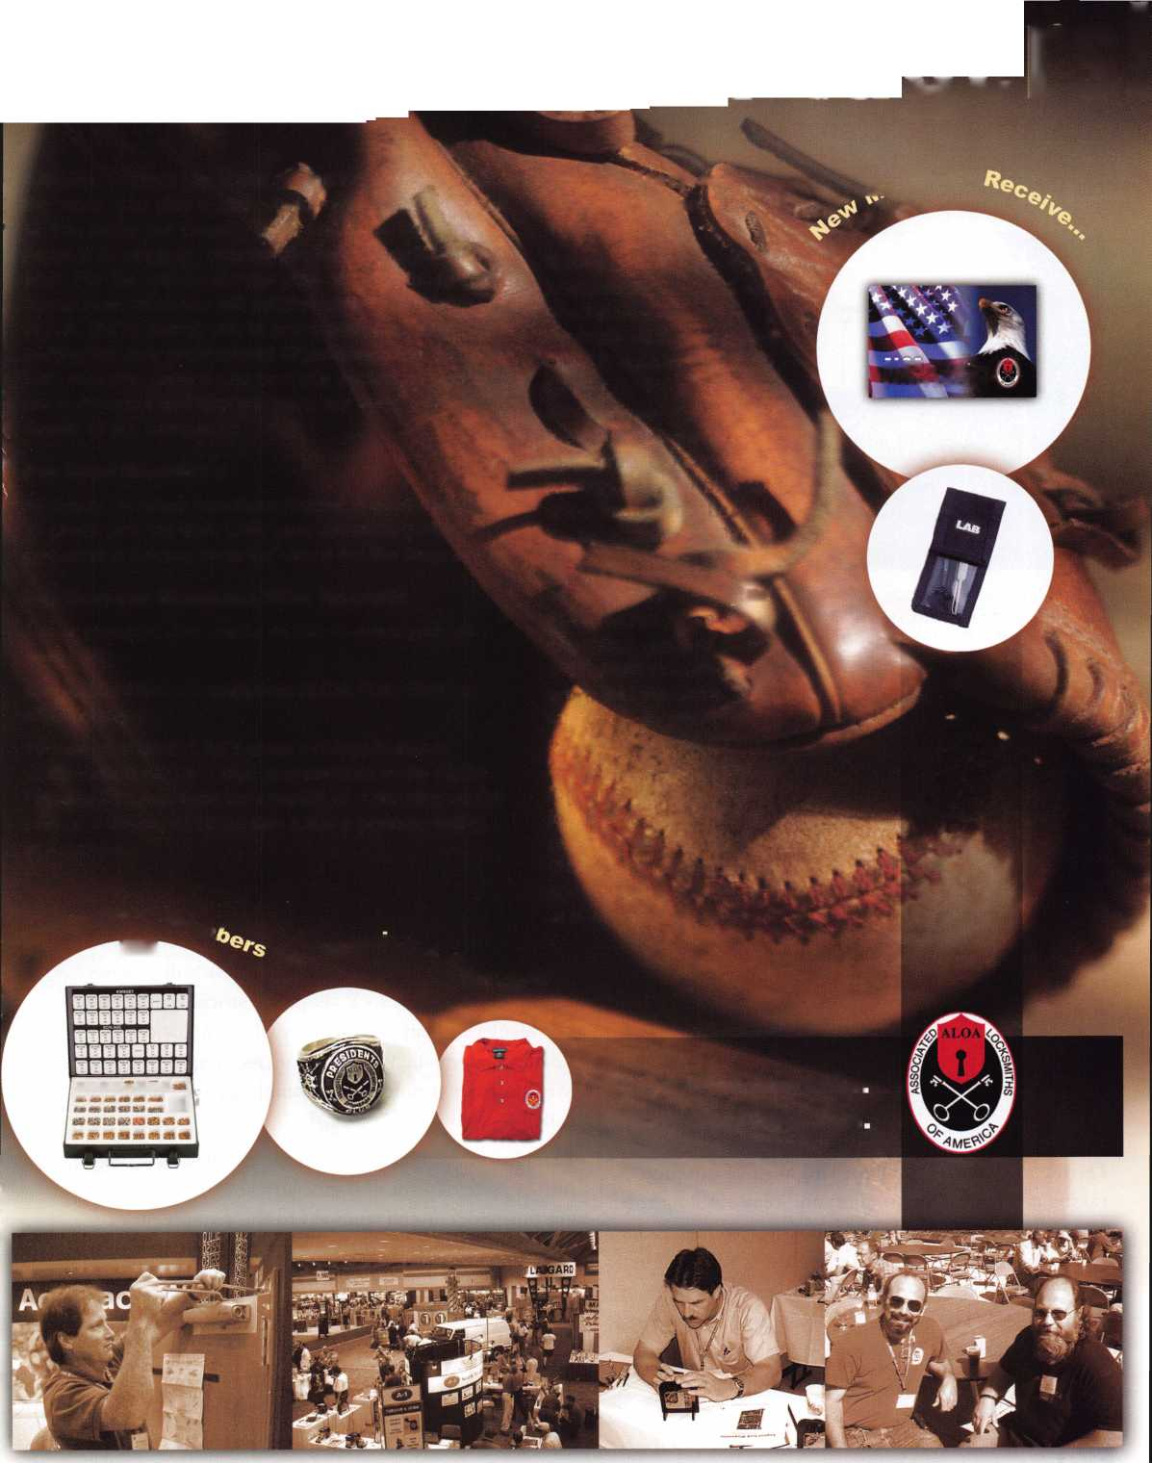

Institutional:

Walking the Campus of the University of Illinois at Chicago

By Rich Crnich (as told to Keynotes editor, Jim DeSimone)

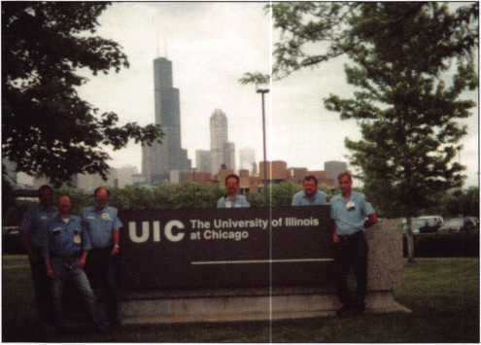

Photo 1: The University of Illinois at Chicago is maintained by six full-time locksmiths who work together as a team. (From left to right:

Mike Oswald, Rich Crnich, Dave Pratl, Conrad Pomykala, Mike Powell and Jim Lindquist.)

Rich Crnich, in his own words:

Downtown Chicago is my favorite part of town, because there you’ll find restaurants, entertainment, theater, museums, nightlife and special festivities throughout the year. There is always something to do in this great city, in which I live, work, play, have fun and just generally call “home.”

It’s a very big city with many great cultural neighbor­hoods. Chicago also has a large number of outlying surrounding suburban communities, with both old and new buildings, which lends to the diversity of locksmithing. Safe and vault work is also demanding. Chicago is a very mobile society, with severe weather conditions, which cause lots of lock problems.

During my youth, I would spend most of my time taking mechanical items apart and reassembling them just to see how they worked. I’d also make necessary repairs or improvements to make them function bet­ter. I have been a locksmith for a total of 23 years, 13 years at UIC. The other 10 years began in residential, then moved up to commercial, industrial and archi­

tectural hardware before getting hired for employ­ment at UIC, which is an exciting challenge.

There have been new construction and remodeling projects going on all over the city to keep up with new trends, as well as with city codes. The efforts have been to make the city a safe and better place to live and prosper. Chicago is progressing into the future with updated technology.

The UIC lock shop work orders are divided thusly:

* 30 percent departmental
* 10 percent key requests
* 20 percent remodel projects
* 10 percent new construction
* 30 percent maintenance and repairs

Departmental: Departments on campus call our routing office when they need us. Like for the instances when somebody locks their purse in a desk or when a key gets broken in an emergency situation. If the department requests that a lock be changed, The work orders are paid by the department request­ing the work, so budgeting is a big concern.

Key Requests: Key certification cards are filled out by departments and submitted to the Key Clerk’s office here at UIC. Then the Key Clerk will process the requests for the lock shop. We stock 632 different key blanks and cut 60,000 keys (that’s 60,000 door openings) annually for a total of no campus buildings. We also have 51 non-campus buildings, which are called “leased space.”

In addition, we make or cut desk, cabinet, case, auto­motive, safe deposit and specialty keys. When keys are finished, cut and stamped to the request order, the keys will then be returned to the Key Clerk’s office for final key distribution. Each year, our func­tional locking hardware grows by 1,000 to 2,000 pieces. The whole show takes place on approximately



Keynotes • July/August 2002

I3,5i5?°3^ square feet of total campus space. UIC is like a city within a city

Remodel Projects: We work with coordinators to assure the proper hardware gets specified for each job, as well as the lock cylinders getting keyed up to the correct depart­ment keying schedule. Plus, the architect gets a blueprint or CAD drawing cut with the correct door and/or room num­bers. Then we tell the sign shop the code-standardized sig­nage needed for the job. Obviously, the keys won’t work if this is handled incorrectly, as it happened here at UIC once.

New Construction: These are different, but similar to remodel projects - it’s a bigger picture with a new building. Working with architects and outside contractors sometimes may or may not make a job go smoothly. There are changes in hardware specifications and keying schedules, the wrong lock trim or function may be encountered, etc. When it’s all completed, it’s our job to correct any oversights.

Maintenance and Repairs: Obviously, we get most of our repair and maintenance work from the doors that see the highest traffic (lots of building entry doors, common spaces, etc.) We do all the closers in addition to all locking devices. When doors are secured and locked most of the time there is a great wear factor, even on the better Grade i hardware.

Most of our panic devices are on the west side of campus, and we use Von Duprin - all models, as well as electrified bars. We also use Foger-Adams electric strikes in conjunction with our card reader systems. Corbin/Russwin, Lockwood, Yale, Sargent, Medeco, Best SFIC. On some of our leased buildings, we had to furnish and maintain the large format Schlage IC. We maintain the Simplex Cylindrical 1000, Liooo and the new 8100 series, which accommodate the large format Medeco IC cylinder key override.

The older campus (west) has dorms secured with Best SFIC and older Corbin/Russwin full mortise locksets. The newer dorms to the east are secured mostly with Best SFIC. UIC will soon have another 700-room dorm to be completed next Spring. We’ll use Schlage L9000 with Medeco Biaxial Mortise cylinders in that building.

Access Control

Our Access Control system is tied indirectly to the local police station through the main entryway of our buildings, as is the CCTV. So at the shop, we have to make sure everything is functioning properly, so the police can monitor the campus.

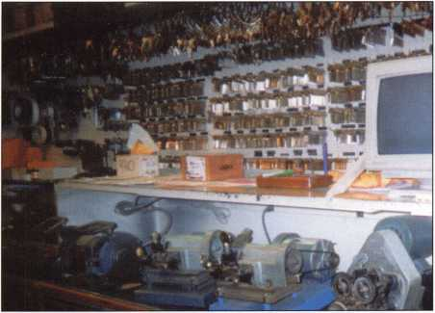

Photo 2: This is UlCs East Campus lock shop, which is the main shop or "home base." This is where the central computer holds all the information on UlC's key and lock inventory of both the East and West campuses. The information is also doc­umented and catalogued in written form, and gets updated regularly as changes are made.

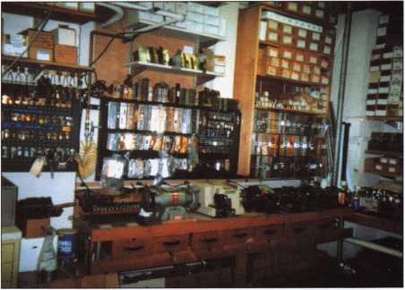

Photo 3: The West Campus lock shop, which houses all locks and repair parts and cabinet key blank inventory. All door lock keys requested come out of the East Campus, as do departmental lock changes. Any lock cylinders being keyed are done at the East Campus shop. "We cut cabinet keys requested and dour our service for the west side of the campus out of this shop," said Rich Crnich.

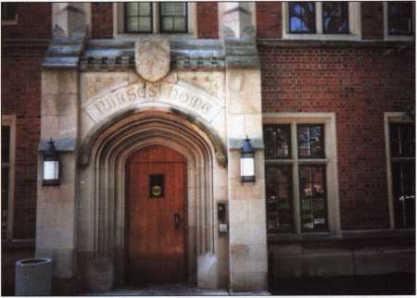

Photo 4: The west side of the UIC campus is the oldest of the two. Most of the older buildings were built in the early 1900s. Rich says, "We still have the old Yale bit keys and locks still



Keynotes • July/August 2002

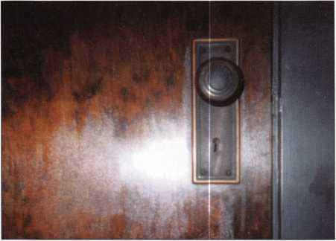

Photo 5: A Yale bit of history.

Photo 6: UlCs Molecular Biology Research building, dedicated Feb. 8, 1996. The interior doors of this building are secured with the Yale 8700FL series (full mortise locksets with Carmel CR-lever handle XCO, escutcheon trim XUS 26D and Best small format 1C and mortise cylinders XUS26AD.

Photo 7: Rich: "We just recently were called by a department to open a Herring-Hall-Marvin walk-in vault door. An employee left the department with the combination many years ago; they never locked the door, they just closed it each day. Then one day, someone turned the handle that controls the bolt mechanism and also turned the S&G safe dial. The department was locked out of the vault. We tried manipula­tion, but didn't succeed, so we drilled it open and made the necessary repairs."

History

UIC’s older west campus was built in the early 1900s, and the younger east campus was started in i960 and fin­ished in 1965. The academic staff and students moved there from a nearby Navy Pier, where they were housed before the East Campus Project. Most buildings on the east side have Russwin full mortise sets with Russwin System 65 cylinders.

The West Campus is part of the State of Illinois Medical District, with construction starting in the early 1900s and continuing through the years. UIC is joined by VA Veteran’s Administration Hospital, Cook County Hospital, Rush Presbyterian, St. Luke’s Medical Center as one BIG medical district. There is also a new College of Medicine building that will have 900 door openings, projected to be completed in two years. Its lock and hardware specification are the Yale 8700 FL series sets with Medeco mortise cylinders on the interior doors. We will also have close to 100 Von Duprin panic devices with Medeco rim cylinders and Foger Adam 310-4 and 712 electric strikes tied in with UIC’s access con­trol I-card reader system.

There are approximately 25,000 students attending UIC,

65 percent undergraduate study and 35 percent graduate and professional degree studies. The campus is supported by 12,000 full-time faculty and staff. Our shop is part of the carpenter shop, which is part of the Building Trades Department. This department belongs to the Facilities Management Department, which services UIC.

UIC consists of many new and old buildings. The mainte­nance on some of the locking systems on the older buildings is very time consuming. These locks are gradually changed over with updated sets, even though we are always trying to maintain the original hardware.

Education

I stay abreast of new technology and product changes by attending factory seminars and association seminars (such as ALOA, which I’ve been a member of for 15 years).

ALOA offers more than any locksmith can ask for. You get Keynotes, which is the number one magazine in our field.

So don’t delay - join today! Also, the Institutional Locksmiths Association (ILA) is another great association to which I belong. DHI is another. All of the above have been great programs and learning benefits.

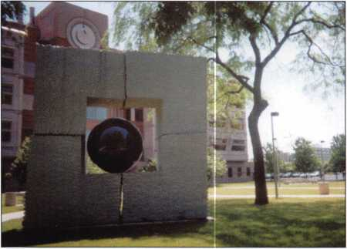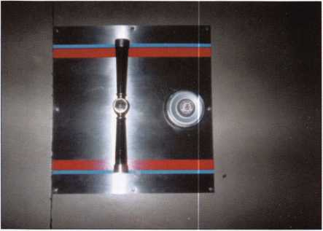

Keynotes • July/August 2002

Challenges

Every lock job at UIC is a challenging one.

I remember one experience when someone put dental impressioning material, which dentists use to make models of their patients’ teeth, in quite a few lock cylinders at the College of Dentistry What a nasty job, removing all of that white, chalky sub­stance form those locks.

Future of Locksmithing

I ask myself this question from time to time. I see more and more electronic computer chip, loaded memory-stored locks on the market today. With electronic computerized locks, you cannot visually see the breach in security unless you electronically interrogate or investigate the lock’s system. There are computer hackers out there with palm or laptop computers who could gain entry if they know the system. On the other hand, mechanical show visible signs of having been breached. Electronic locks emphasize more on electronics than the mechanical strength of the lock itself. It’s a decision each lock­smith usually has to develop with the user (or cus­tomer). But I do strongly suggest that when you order electronic locksets, order them with mechanical key override. That way, if the electrical chips or boards burn out or go bad, you still have the mechanical to fall back on. Even the mechanical push-button locks should be ordered with mechanical key override.

ADA Compliance

All remodel and new construction jobs must comply with the Americans with Disabilities Act, along with electrical assisted operators and door closers with cor­rect height push pads and lever locksets. We comply with all national and local safety and fire codes. Staying abreast of the ever-changing electronic and computerized locking hardware, panic devices, elec­tric strikes, locks, etc.

Needs of a UIC Locksmith

You need a good pair of walking shoes. I may cover anywhere from two to seven or better miles per day walking from job to job. If the elevators are down, it’s hiking up and down stairs, plus hauling all of your tools and material.

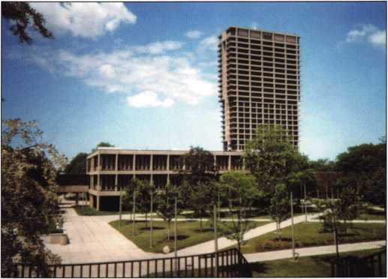

Photo 8: The University Hall Building is UlCs tallest, and consists of 28 floors whose doors have Russwin full mortise locksets secured with Russwin master ring mortise cylinders. This building stands tall on the east side of campus.

Ask your supervisor to provide you with a two- or four-wheeled cart or truck to facilitate moving tools and material from job to job on campus. We are a unionized institutional lock shop. Being an institu­tional locksmith does define the job limits for our locksmiths. Our tradesmen locksmiths work in coor­dination with the unionized carpenter workshop.

Last, but not least, and most important, is your appearance, positive attitude and professional com­mon courtesy, which goes a long way.

Final Thoughts

Being an institutional locksmith here at UIC is an adventurous and challenging learning experience every day. There are new experiences every single day.

I think that even though book knowledge is respect­ed, having common sense and experience — in any profession — is the best knowledge to have. The computer - the so-called Information Superhighway - is the best technology that could have been invented.

By the way...

I’m a big White Sox fan. I’m a southsider of Chicago. That is the difference - GO WHITE SOX GO!! The northsiders are Cubs fans - BOO!! BOO!! I’m sorry, that’s not always true - only another Chicago tradition and everybody has their own personal preference. Q

Keynotes • July/August 2002

**2**

‘Average Joe” New Products:

Not Just for the Major Manufacturers

By Mark Fuller, CRL

When I approached Keynotes editor,  
Jim DeSimone, with the idea for this  
article, he was intrigued. My suggestion?  
That we sound the drums of invention  
so that ALOA members will know that

they have the chance to publish their ideas in Keynotes.  
We want members to know that they can present and  
promote their own ideas about how to create the best  
new locking mechanisms right here in Keynotes.

Will the response be strong enough to produce  
enough material to feature a different article in our  
magazine each month? Time will tell, but here’s why  
I think it will:

In the process of presenting my own new lock

ideas to manufacturers, I have discovered  
that many people responsible for the  
products that ultimately wind up on  
our local distributor’s shelves are not  
what we’d call “lock guys” at all. Can  
you believe that? In many cases, they  
may not know what we, as locksmiths,  
frequently see a need for in real-world  
applications. This is why there will always  
be an opportunity for the small guys out  
there.

Until Keynotes green-lighted my idea, it was my experi-  
ence that trade magazines won’t do features on new  
ideas until the new product is packaged and ready for  
sale. It reminds me of someone asking the bank for a  
$10,000 loan, and they’re told that in order to qualify,  
they’ll need $10,000 in an account to borrow against it.  
“Well if I had $10 grand...”

I’m not suggesting we write stories about the guy who,  
by improvising, overcame a bank vault door with a mod-  
ified Slim Jim, or any other “How He Did It” features.  
This “Locksmith/Inventor” series would also not be for

explaining, in detail, the latest method of defeating  
some state-of-the-art locking device. Useful yes, but  
those articles have a way of bugging me sometimes.  
Lastly, it is not for some conglomerate to promote their  
latest innovation with “What’s New in the Industry”  
every issue. No; this space is for you, “Full-time Joe  
Locksmith and Inventor/Dreamer.”

Now, I don’t recommend publishing your ideas here if  
you’re thinking about patenting them. With that said,

I would not recommend pursuing a patent for a lock  
unless you own a lock manufacturing company. But if  
you are a locksmith who has invested a great deal of  
energy in what you believe is the best device for a par-  
ticular application, submit your ideas to Keynotes so

that your idea can be heard (for a change).

Your intuition should tell you that by pre-  
senting your idea to the members of  
ALOA, you are somehow going to bene-  
fit from it, see your idea live and  
breathe, participate in your profession  
rather than just working in a vacuum, and  
so on. Now we are offering you a vehicle  
to do all those things — and more.

I am betting there are many locksmiths who are  
working on great ideas for new locks and tools. Or, per-  
haps there are some who have let these ideas go by the  
wayside because they didn’t have the resources to bring  
them to the market. Either way, if you want to tell your  
peers about it, now’s your chance.

Jim DeSimone, editor of Keynotes, can be reached via e-mail at [editor@aloa.org](mailto:editor@aloa.org), or by phone toll free at 800/532-2562, ext. 19. My e-mail address is [etonkeysystems@yahoo.com](mailto:etonkeysystems@yahoo.com). Send me your thoughts, or you can mail me some general information about what you’d like to share with the industry. My address is: Mark W. Fuller, CRL • P.O. Box 3702 Houston, TX 77253 • Phone: 713/862-7674 Q



\ > *



**28**

BH Keynotes • July/August 2002

**&** “Quick-Out” Emergency Trunk Release

Prevent Tragedy - Install a “Quick-Out” Device Today

, Fits Virtually All Model Autos

^ Easy to Install

A Child Can Easily Release the Trunk Latch from  
Inside of the Trunk to Escape

Federal Law in new vehicles. A must for all others.

In packs of 10 FREE Window Poster

QUICK-OUT INSTALLED $11.00 ea + $3 S&H

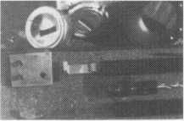

The Innovator

1998 and up GM in-dash ignition removal kit.

Patent 5,454,245 1

Removes plastic ring and chrome cap in seconds; makes access hole to pick side bar; turns cylinder to ACC position. Removes lock in less than five minutes with no damage to lock. Your first job will more than pay for the kit.

Introductory price: $70.00 + $4 S&H

1996 and up 8-Waffer Ford Ignition  
Removal Kit and Side Bar Breaker Tool

Patent 5,701,773

Turn ignition to “ON” position in less than 60 seconds for fast removal or use kit to

push side bar in, then turn cylinder to “ON” position without any damage. Fit key, replace same lock. Or use the force tool to  
turn to “ON” position for fast removal in 60 seconds; no damage to waffers. $9U.0U + $4 S&H

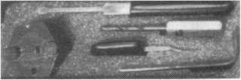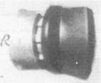

FINISHED CYLINDER

1994 and up 9-Waffer GM Ignition Removal Tool Kit

Patent 5,454,245

A new system for the future. These locks have side bars longer than the old type and must be in  
the “ON” position to remove the cylinder. My tool will do this. Best of all, you will not damage

the cylinder. You can repair, fit key and replace the same cylinder. Do only one job and you will have the price of the kit paid for. A  
replacement cylinder costs about $22.00, VATS $45 our cost. Order one today at my special introductory price, and be prepared for  
these new locks. $60.00 + $4 S&H. ***Upgrade it for ’95 Blazers, Suburbans, S-10 Pickups, etc. $20.00 + $4 S&H***

No-Nonsense Squeeze Lock  
Plug Remover

Patent 5,165,158

Now you can remove all squeeze lock plugs in 15 seconds  
or less, from all GM, Ford, Chrysler, AMC, Jeep, no more  
fumbling, gadgets, cut fingers, broken tabs, need for 3  
hands for removal of lock. It’s so easy you can do it in the  
dark, while it’s still in the glove box. $50.00 + 4 S&H

The GM Persuader

This unique tool will open virtually all GM trunks and doors, through the current year, where tool fits into the cylinder  
in less than 50 seconds. No drilling, pulling, picking, special tools, or electric needed. When customer’s key does not o]  
because: Problem 1: spring retainer popped up into outer shell; Problem 2: one side of side bar sprung off side bar  
does not retract; Problem 3: key or cylinder worn side bar does not retract; Problem 4: key jammed in lock in  
“turned” position, etc. With The Persuader you will open these locks in less than 50 seconds. No damage to lock, just  
repair and replace, nothing to wear out. Yes, if needed, it will open with no key.

Note: because of The Persuader’s capabilities, it will be sold to locksmiths only. $45.00 + $4 S&H

Ford Disc-Out Kit

Patent #4,682,398

A tool kit to remove those stubborn Ford pin ignition locks from 1976 through the current year. These locks incorporate 2 locking  
devices and a hard steel disc across the shear line. They must be in the “ON” position, to release both locking devices, so as not to  
damage the housing. I guarantee the job to take 5 minutes with my kit. Complete Kit $60.00 + $4 S&H

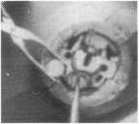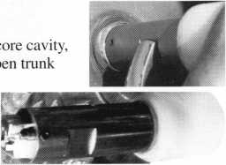

irT11111

**ipiii.-** -4



Ford “Quick On”

Patent 5,454,245

Now turn all 10 cut ignition cylinders to the “ON” position for fast removal - in less than 60 seconds. Sable, Taurus, all styles, even with airbags. No damage to housing.

**$65.00** + $4 S&H

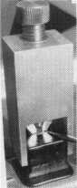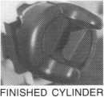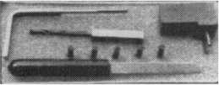

Aable Locksmiths • 86-19 97th Avenue • Ozone Park, NY 11417 • 718.847.1377 • Fax 718.847.0991  
Frank Markisello guarantees all of his products to do as stated or your money back!

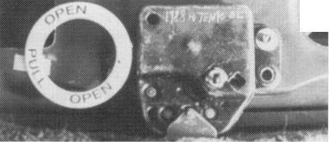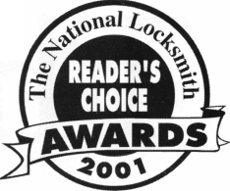

The Evolution

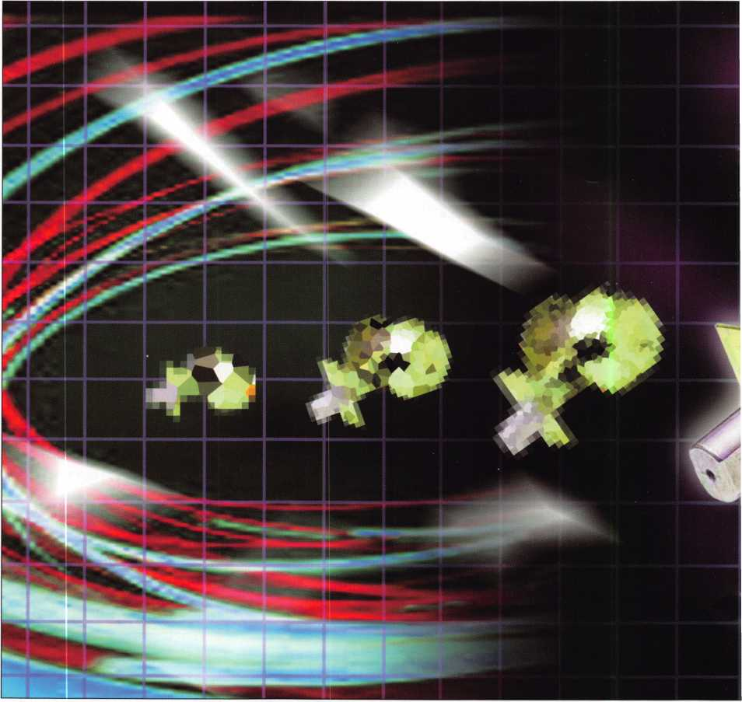

of Medeco®

**3**

Keynotes • July/August 2002



\ > .

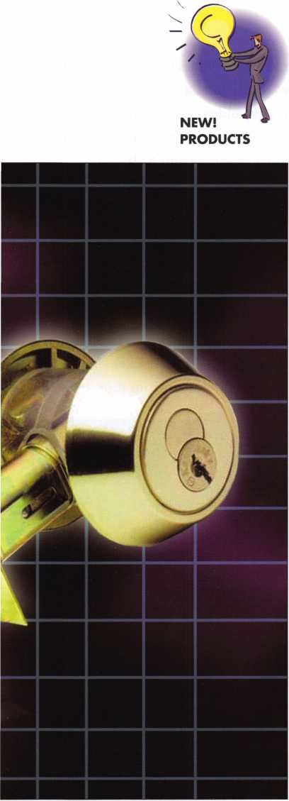

The concept of the interchangeable core lock was introduced in 1921  
by Best Lock Company". The introduction of a cylinder or core that  
could easily be replaced, changed-out, or re-keyed without disassem-  
bling the door hardware, quickly became an industry standard and a  
favorite for many end-users for many decades to follow In 1995,  
Medeco" introduced KeyMarka patent-protected, key control  
small format interchangeable core (SFIC). Medeco’s goal was to  
offer institutional users an economically priced, key control alterna-  
tive to other Best-style cores to meet their needs while achieving the  
utmost control over the duplication of keys.

Soon after KeyMark was released in a small format interchangeable  
core design, Medeco realized that it should not limit itself to just  
the SFIC market. Knowing that end-users usually have a wide vari-  
ety of different type cylinders throughout their facility, Medeco  
developed conventional rim/mortise, key-in-knob/key-in-lever cylin-  
ders, deadbolts, and padlocks to compliment the KeyMark SFIC  
cylinder. The same features and benefits incorporated in the  
KeyMark SFIC are also included in the conventional line of  
KeyMark cylinders. KeyMark, like other hi-security key systems,  
require only the single key to be used to operate the entire KeyMark  
product line. There is no need to carry two or three different keys to  
access various doors or locks throughout the system. The KeyMark  
product line also incorporates an extensive line of retrofit key-in-  
knob/key-in-lever cylinders designed to fit into many manufacturers’  
locksets.

Pinning/Keying Specifications

All KeyMark cores and cylinders utilize A-2 keying specification  
with a .0125” pinning increment.

KeyMark®

by Dale L. Bowman, CRL

The spacing and cut depths are read from tip to bow and the cylin-  
ders and cores are pinned from back to front. There are ten possible  
depths, zero (shallowest) through nine (deepest), that can be used in  
each position. KeyMark has no MACS (Maximum Adjacent Cut

Keynotes • July/August 2002

Specification) losses so all theoretical bittings obtained from the key bitting array could be used; however, there are certain undesirable bittings that should be left out. KeyMark SFIC’s incorporate a 23- pin stack height in each pin chamber (same as Best or Best-style cores) while KeyMark conventional cylin­ders use a 19 pin stack height in each pin chamber. The different pin stack heights allow both the KeyMark SFIC and conventional cylinders to work together in the same system.

KeyMark Keys & Pins

There are three distinct characteristics or sections involved in the shape of the KeyMark key: the upper portion, the ledge, and the security leg. The first sec­tion, the upper portion of the key, is used for the pri­mary bittings and is where the cutter wheel of the key machine will make the cut for the appropriate depth. The second section, the ledge, is used as a reference

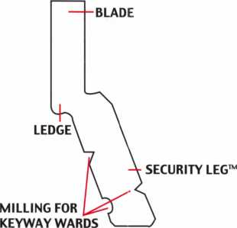

possible keyways. The security leg also enhances pick resistance and helps to prevent interchange between other keyways.

KeyMark uses nickel silver key blanks to provide one of the strongest keys in the industry. Two different stops, a tip stop and a shoulder stop, are used on KeyMark keys (Figure 1). The tip stop and shoulder stop allow conventional cylinders and SFIC’s to be used in the same system. The KeyMark SFIC utilizes the tip stop while the convention rim/mortise and key-in-knob/key-in-lever cylinders utilize the shoulder stop.

Nickel silver bottom pins are used to help limit the wear that may occur on the pins from the nickel silver key. The top pins (drivers) and master pins are made of brass since they do not contact the nickel silver key. Spooled top pins and spooled bottom pins are

|  |  |  |
| --- | --- | --- |
| II | II II II II II II II _ _ | |
| — | — •• at II II II II II l| | |
| u | o u U U U l | 1 11 II (1 |
| Figure 2 | | |

Figure 1

point for the depth of each cut. The ledge is also used as a locating surface for key cutting equipment. Furthermore, due to the point at which the ledge is located, it provides a limited area for the insertion of picking tools increasing the pick resistance. The final­ly section of the KeyMark key involves the security leg. This security leg can be positioned or offset between 5 to 85 degrees from center. The security leg contains millings for keyway wards that work in con­junction with the different degree of angle of the security leg to produce an extraordinary number of

also used to provide pick resistance (Figure 2).

KeyMark keys are not decoded in the same manner as standard pin tumbler keys. The root depth on stan­dard pin tumbler keys is measured from the bottom of cut to the bottom of the blade on the key. The cut depth on KeyMark keys is measured from the ledge of the key and not the bottom of the blade or security leg. Since the security leg can be offset and is not cen­tered with the upper portion of the keyblank, the depth of the cut cannot be obtained in the traditional manner. A special key decoder that measures the dis­tance between the ledge and the bottom of the cut is required to decode KeyMark keys (Figure 3).

Keynotes • July/August 2002

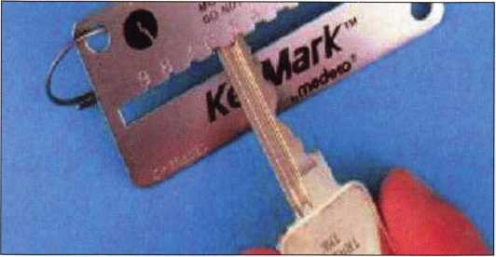

Figure 3

Applications

KeyMark rim/mortise cylinders are available in a 6 or 7 pin version and can be ordered in different lengths for retrofitting different applications.

Also, the cam on the mortise cylinder and the tailpiece on the rim cylinder can quickly and easily be changed and replaced to meet the requirements of the application (Figure 4). Medeco provides over 30 different cams to meet the requirements of almost all applications.

For a list of cams and tailpieces for required for a specific manufacturer’s product, please call the Medeco factory. Medeco also offers retrofitting capabilities for various Key-In-Knob/Key-In-Lever Cylinders, Interchangeable Cores, SFIC Rim/Mortise Housings, Padlocks , Deadbolts , Tubular Deadlatch, Knobs and Levers.

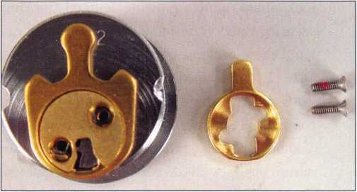

Figure 4

Some common applications for KeyMark mortise cylinders include the following:

* Mortise locksets manufactured by: Arrow®, Marks®, PDQ®, Baldwin®, Best®, Sargent®, Corbin Russwin®, Schlage®, Falcon®
* Adams Rite® Swinging & Sliding Door Hardware
* Mortise exit devices/panic bar
* Deadbolts
* Easy Removable/Changeable Cam Design

Some common applications for KeyMark rim cylinders including the following:

* Adams Rite®, Detex®, American Device®, Jackson®, Arrow®, Von Duprin®, Corbin Russwin®, Yale®, Segal® Dropbolts, Medeco SteelGuard®

Conclusion

As you can surely see, KeyMark has grown significant­ly since its inception in 1995. KeyMark SFIC, LFIC, conventional rim/mortise and key-in-knob/key-in­lever cylinders, and door hardware products are designed to provide you or your customer with a patent-protected, key control core or cylinder at an economical price to meet their security needs. Since KeyMark has an extensive line of retrofit capabilities, a KeyMark core or cylinder can be provided for virtu­ally any door without the need to replace hardware.

If you have any questions or would like more informa­tion regarding Medeco KeyMark or how Medeco can meet your security needs, please feel free to contact your local Medeco Sales Representative or the Medeco factory at 1-800-548-8472. You can also find plenty of information on these products at the ALOA show, July 22-28 in Rosemont, IL, or by contacting Medeco on the web at [www.medeco.com](http://www.medeco.com). Q

Keynotes • July/August 2002

NEW!

PRODUCTS

Kaba Ilco has just unveiled the newest addition  
to its lineup of pushbutton combination locks,  
the fully mechanical Simplex 5000. With its new  
clutch-free design and cast stainless steel internal  
drive parts, the Simplex 5000 aims to offer

greater strength and durability than ever before.  
In addition, the new lockset is built for easy  
installation, with its non-handed design, while  
end-users should appreciate the lock’s one-hand-  
ed operation, thousands of easy combination  
changes, and two-year warranty

Access Control: Simple Solutions for the Simplex 5000

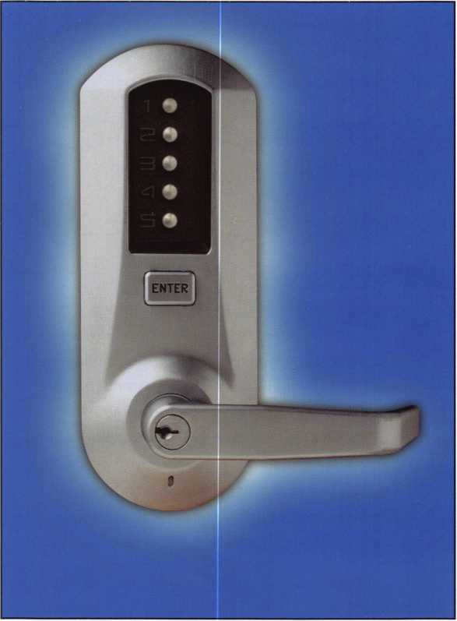

‘At a time when security is an increasing con-  
cern, the strength and simplicity of the new  
Simplex 5000 is a welcome addition to our array  
of mechanical pushbutton offerings,” said Jawa  
Thomas, product manager at Kaba Ilco. “It is as  
secure or more secure than keyed access but  
without the keys, the magnetic cards, the wiring,  
the computer-driven lock programming, or the  
batteries.”

The Simplex 5000 is an all-purpose pushbutton  
lock aimed to meet growing demands for simple  
security. Entry is designed to be easy; with one  
hand the user depresses his combination, presses  
“ENTER” and turns the ADA-compliant lever.

To familiarize users, the lock comes with a sur-  
round card offering operating instructions.

When employees, tenants or guests leave, combi-  
nation changes take seconds without removing  
the lock from the door. The key override feature  
provides convenient access for emergency, securi-  
ty or maintenance personnel. The lock also  
accepts 15 major industry standard key-in-knob  
cylinders allowing facility managers to maintain  
a master-keyed security system.



Keynotes • July/August 2002



Let’s take a further look at the Simplex 5000.

CONSTRUCTION

* Extra heavy-duty cylindrical lock housing; solid cast housings; solid cast zinc levers, stainless steel cylindrical drive components

CERTIFICATIONS

* ANSI/ BHMA A 156.2, Grade 1 Certified COMPLIANCE
* Three-hour U.L./ U.L.C. Fire Door Rating
* ADA (Americans with Disabilities Act)

KEY OVERRIDE

* Conventional key-in-lever cylinder with Kaba llco 15395 cylinder included.
* Schlage C keyway, keyed different. Tailpieces included for compatibility with the following cylinders:
* Abloy 5277 Abloy 5477 Arrow C 100
* ASSA 65611 ASSA 65691 Australian
* Corbin Russwin 2000-03 Kaba llco 1599 Kaba llco 15395
* Marks Medeco 20W200H1 Sargent 10 Line
* Schlage 23-001 Schlage Primus 20-760

STRIKE

ASA strike plate

BACKSET 2 3/4 " (70 mm)

DOOR THICKNESS

* **13/8"** (35 mm) to 2 1/4" (57mm). Preassembled to accommodate doors, 15/8 " to 2" (41 to 51 mm).

INSTALLATION

* Easily installs on wood or metal doors. ASA 161 door preparation with two (2) additional through bore holes. Retrofits cylindrical and tubular locksets with a 2 3.4 " (70mm) backset.

DOOR HANDING

* Non-handed lock, preassembled for left-hand door installa- tions-can be easily changed in the field.

ITEMS SUPPLIED

* Complete lock, latch, ASA strike, Installation Manual, tem­plate, Kaba llco 15395 cylinder, two nickel plated brass keys, five tailpieces, spare cylinder retainer, spare inside lever set screw, lever release combination change tool, hardware required for installation, and hardware required for thin

and thick door installations.

WEIGHT

* 8.0 lb (3.65 Kg)

CONSTRUCTION

* Extra Heavy-Duty Primary Locks FEATURES
* Mechanical pushbutton strength and reliability.
* Keyless convenience. Eliminates problems and costs associated with issuing, controlling, and collecting keys and magnetic cards.
* Combination can be quickly and easily changed to ensure continued maximum security once employees, tenants, or guests leave.
* Thousands of possible combinations.
* Easy to install: Installs easily on wood or metal doors.

No electrical wiring or computers required for programming. Fully contained front and rear housing assemblies install in minutes.

* Non-handed: One lock for both left-and right-hand door applications.
* Easy to maintain: No batteries, and fewer parts to maintain during life of lock.
* User friendly: One-hand operation. Short lever travel distance with an ergonomically correct design. Latch retracts when lever is turned in either direction.
* Mechanical key override: Used to override the lock combina­tion and gain access using a key. Permits facilities to initiate or maintain their master-keyed security system.
* Direct drive: Eliminates potential breakage in critical internal links.
* Rugged and weather-resistant: Lock is wear tested for intensive use.
* Two-year warranty.

APPLICATION

* The Simplex 5000 lock provides fully mechanical pushbutton access control without any wiring, electronics or batteries. Exterior access is by combination. Egress is by interior lever and is free at all times. Lock is ADA (Americans with Disabilities Act) compliant.
* The Simplex 5000 is ideal for controlling access to high-traf­fic, security-sensitive areas in commercial, industrial, educa­tional, governmental, lodging, and multi-unit residential set­tings. Perfect for locations with a high user turnover rate such as data processing centers, employee entrances, R&D labs, apartments, dormitories, and restricted areas in hospitals and airports.

You can check out the all new Simplex 5000 up close and in person at the llco booth at ALOA 2002 in Chicago. See you there!



Keynotes • July/August 2002

\ >

The New LC Series from Kaba Mas

By Jamie Taylor

NEW!

PRODUCTS

Since it’s start in 1989, Kaba Mas Corporation has been the industry leader in container locking technology With the breakthrough design of the X-07 and its PowerStar(tm) energy generating system, the market has seen product design and engineering rise to new levels.

©@©

®©(D

@®(f>

CLEAR (O) ft

***kaba***

Our large engineering staff, consisting of mechanical, electrical and software

engineers, leads the way with innovative products like our new “LC” low  
current battery operated safe locks. These locks accept multiple users,  
install simply and feature our PowerSaver(tm) power management system.  
Our Power Saver circuitry allows the 9 volt battery that powers our LC  
Series to last virtually for the shelf life of the battery.

Here is why Kaba Mas will make the Kaba LC Series of locks your BRAND

of choice.

Fast Installation

The LC Series locks can be installed in just a few minutes, using the existing dial ring  
and lock mounting holes. The spindle-free operation of our LC Series Slide Bolt lock  
saves you installation time eliminating the need to cut spindles or shafts in the field.

The Kaba Mas Slide Bolt lock body is the only lock of this type that UL will allow to be  
mounted directly over the existing spindle hole in the traditional Right Hand, Left  
Hand, Vertical Up, or Vertical Down positions. In each of the four traditional positions,  
our slide bolt lock body can be flipped over, changing the direction the slide bolt nose

faces. The Slide Bolt Lock Case has a total of eight different mounting positions.

With our Slide Bolt Relock Adapter Plate mounted to the case, you can attach the

existing external re-locker device that was previously attached to a 3-wheel  
mechanical lock, making retrofit a breeze!

Easy Operation

All the safe user has to do is simply enter the 6-digit code and turn the safe’s  
handle to open. When the safe door is closed, just turn the handle and the safe  
is locked automatically. The automatic locking feature will help protect against  
“day locking”, where the user only has the safe door closed but not fully secured.

User 1 and/or User 2 can change their own combination at any time with simple

commands at the lock’s keypad. Just press Enter i(for user 1) or Enter 2 (for user 2)

plus the existing combination and then enter the new combination twice for confirma-  
tion. Locksmiths save time and money while providing their customers with a simple,  
user-friendly product.

Keynotes • July/August 2002

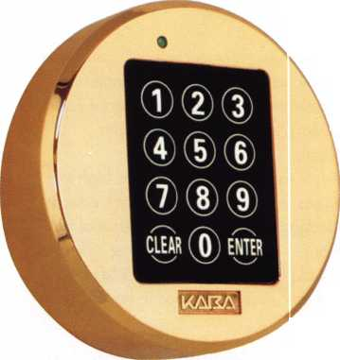

Control Code

It’s not a bird, it’s not a plane, it’s SUPER MASTER control! We offer a super master code that the lock­smith can set and attach to the sales order. When the customer either loses the combination or gets the lock programmed incorrectly, the locksmith can pro­vide the super master code, allowing the customer to reset the lock back to the factory default status. The super master functionality can turn a locksmith into a super hero by preventing the costly drilling of the safe! If the customer does not want the super master functionality, it can be permanently disabled at the lock. Once the Super Master code has been programmed, it will remain in the lock forever. Changing the combination prior to programming a Super Master code will permanently disable the Super Master.

Battery Power

LC series stands for Low Current. While powered only by a single 9-volt battery, managed by Power Saver Circuitry, the LC series will out-perform all competitors. Once the battery has reached “low power”, the lock will signal the need for a new bat­tery. SEVERAL THOUSAND openings remain before it must be replaced. On the LCLX Lexan housing, a #2 flat blade screwdriver is pushed into the slot at 5 o’clock, which will release the front housing in order to replace the battery. On the new LCMX metal housing, a button on the housing can be pressed, which will release the front housing for battery replacement.

The Kaba LC Series has 2 operation modes to choose from:

MANAGER CONTROL MODE

The manager {User 1} can add, delete, enable, or dis­able User #2 combination at any time without know­ing the opening combination. When an employee leaves without notice, their combination can be delet­ed and the User #2 code can be added for a new employee. The new employee can then set his or her own new private opening combination. The LC Series Slide Bolt locks come from the factory in the Manager Control Mode with user #1 combination set to 50-25-50. User #2 must be added to the lock by the Manager (User #1).

DUAL CONTROL MODE

With the LC Series lock programmed for Dual Mode, both User #1 and User #2 must enter both combina­tions simultaneously in order to open the container.

In Dual Mode, both users have equal authority and both must enter their code to change the lock back to the Single Mode. When operating in Dual Mode, having a Super Master Code is recommended, in the event that User #1 or User #2 loses their combina­tion. Placing the lock back to the factory default will allow you to re-program the lock back to Dual Control. If one of the opening combinations is lost while the lock is in Dual Control, the Super Master Code is the only way to get the lock back into a use- able condition. Without the Super Master Code the container must be drilled in the event of a lost combi­nation while in Dual Mode.

Technical Support

Knowing that our customers are one our most impor­tant assets, we pioneered 24-hour live, qualified tech­nical support. This tradition continues today with Microsoft Certified Professionals on staff to manage system issues and first line personnel to handle your lock Issues. If you have questions or need assistance, our professional Technical Support Staff is available 24 hours a day, 7 days a week. Call 1-800-950-4744.

Education

Kaba Mas continues to provide professional educa­tion to support our products. In our new education facility, we provide regularly scheduled, hands-on certification training for all of our products.

The Kaba LCLX Lexan Front Housing is shipped with one of three available faceplates - Black,

Satin Aluminum, or Satin Brass.

Our LXMX metal front housing is available in Bright Brass or Bright Chrome, which have been a popular choice for the Gun Safe owner.

With the Kaba LC Series, get more for your money than you ever imagined.

The LC Series will make Kaba your BRAND for Safe Locks! Q



Keynotes • July/August 2002

Access Control:

Schlage’s New E-Bolt

By Sal Dulcamaro, CML

PRODUCTS

The E-Bolt is an interesting new electronic deadbolt lock from Schlage. From what  
I can tell, it appears to be an electronically modified version of the old Master  
brand residential deadbolt. When Schlage bought Master’s residential lock division  
a few years back, I wondered what would come of that hardware product line.

Eve seen evidence of that line from a number of newly introduced products from

Schlage, which includes the E-Bolt.  
The E-Bolt uses electronic keys  
and there is no mechanical bypass  
or backup.

The installation procedure is essen-  
tially the same as for a typical tubu-  
lar deadbolt, with a couple of wires  
added to the process. There is the  
standard i-inch diameter edge bore  
hole and the cross bore hole diame-  
ter of 2 1/8 inches. On most standard  
preps, you only need to assemble the  
lock onto the door. If you’re replac-  
ing older Dexter or Schlage dead-  
bolts with the undersized i 5/8 or 1  
1/2 inch diameter crossbore holes,  
you will need to open up the cross-  
bore hole to the more modern stan-

dard crossbore hole size of 2 1/8 inches. You could use a jig or one of a number of  
hole size modifier tools.

Installing the E-Bolt

Photograph 1 shows the standard size prep holes already made and the deadbolt latch already in place. The E-Bolt is grade 2 and comes with an *adjustable backset bolt. The adjustable bolt is already set for the 2 3/8 inches backset of the lock mount, but can be reset to 2 3/4 inches. In photograph 1 the outside assembly is

**38**

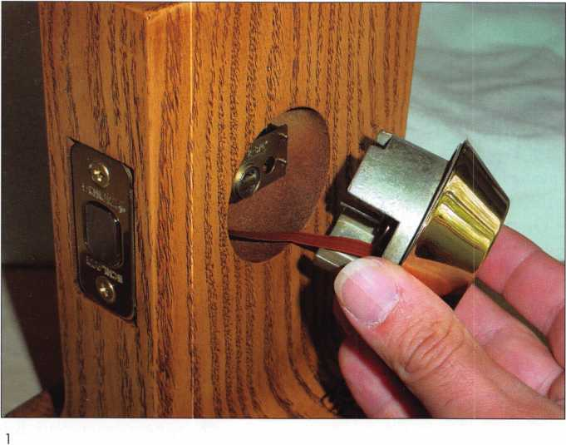

Keynotes • July/August 2002



positioned for insertion through the crossbore hole. The word “TOP” in the casting will identify the proper orientation of the assembly. The tailpiece should be turned to align with the appropri­ate opening in the latch and the ribbon cable should be positioned to insert below the bolt.

With the outside assembly already in place, photograph 2 shows the ribbon cable protruding through to the interior side of the door. I’m holding the inside assembly in my hand with the tailpiece oriented for proper insertion. The flex cable should fit through the opening in the inside assembly just below the tailpiece. The inside assembly is mated to the outside assembly in photograph 3, and the tie screws have been started. After the tie screws have been tightened in pho­tograph 4, the flex cable (with contacts facing up) is inserted into the connector on the circuit board. Carefully loop and tuck the excess flex cable into the space allotted, without crimping or cutting the cable. Next, install a 9-volt alkaline battery in the opening at the top of the inside assembly. Rechargeable batteries should not be used, only alkaline.

Everything is wired up in photograph 5. Em holding the inside cover that has the thumb turn piece. Align the thumb turn with the drive piece of the inside assembly and position the cover over the inside assembly. The cover is in place in photograph 6. Two screws (one at 3 o’clock and one at 9 o’clock, per a clock face) attach the cover to the inside assembly. The lock is then fully assembled. It will not operate with an electronic key until the lock is initialized.

Programming and Operation of the E-Bolt

The E-Bolt locks work with special key management software. The locks do not have to be directly plugged into a cable connected to a computer or similar device in order to program the locks. Schlage uses a special programming key that looks like the electronic operat­ing keys except for the color. The programming key is used to trans­fer data to and from the locks and the computer that has the soft­ware installed.

Photograph 7 shows the mounted E-Bolt lock and the programming box below and to the right of the mount. A red-colored program­ming key is inserted into the keyway of the programming box, while a gray-colored operating (or user) key is in the keyway of the mount­ed E-Bolt. The cable of the programming box will plug into the seri­al port of your computer. Some poorly written software documenta­tion kept me from testing all of the E-Bolts features. I had to call

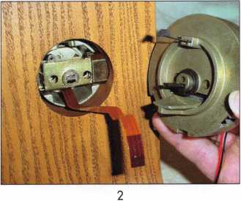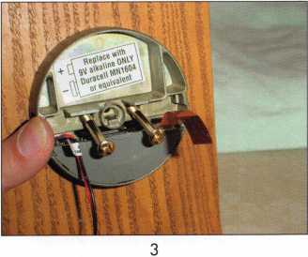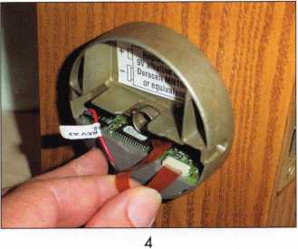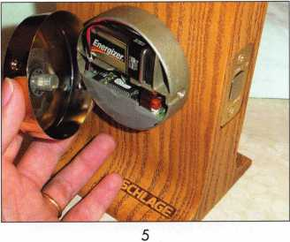

Keynotes • July/August 2002

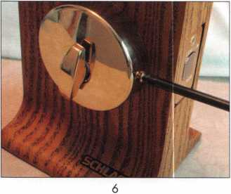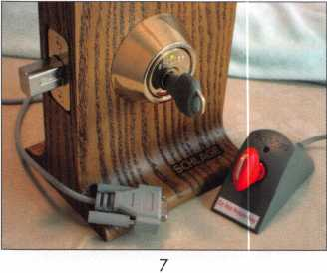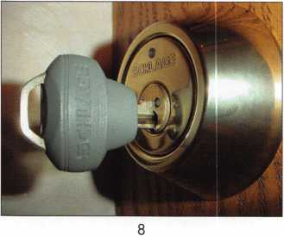

Your computer system requirements for installing the Schlage E-Bolt soft­ware are as follows:

* Windows 95 or higher
* A 486DX processor or higher
* 15 Megabytes of hard drive space
* 8 Megabytes of RAM or more
* A CD-ROM Drive
* An available serial port

Additional hard disk space may be needed to maintain the Key Management Software.

my contact at Schlage to walk me through part of the programming process. Apparently, the software documentation problem preceded the current project manager and he assured me that the instructions were being re-written. His instructions over the telephone got me through the basic initialization and programming process. With his help, the software did seem relatively easy to use. I have every rea­son to believe that the revised instructions will be much easier to understand. The programming key was used to transfer data from the software to the lock and to proceed with the initialization process. I instructed the lock to accept two different electronic keys to lock and unlock it.

Photograph 8 shows a close-up view of a Schlage E-Bolt lock with an electronic key in the keyway. The oversized gray plastic bow of the key obviously contains the electronic components. The lock looks very much like a mechanical deadbolt lock, except for the LED just above the name “SCHLAGE” on the face of the lock. There is also a contact spot on the lock cylinder plug that matches with a wire-like protrusion from the bow of the key. Information from the key to the lock is transferred from there. The red programming key had pre­ceded that gray operating key in that same place. The initialization took place when the programming key uploaded lock and key infor­mation through that contact point. It instructed the lock the identi­ty of the electronic keys that would be allowed to operate it. Although I didn’t program time zones, it could have also restricted the hours at which those keys would work. If programmed to accept an audit, the programming key could have downloaded information from the lock, indicating which electronic keys were used in the lock and at what times.

The E-Bolt is actually electro-mechanical since the electronic key must still be rotated (much like a mechanical key) to throw the lock­ing bolt. Yet there are no tumblers within the electronic lock cylin­der and no need to physically re-key it. The lock instead is repro­grammed to accept or refuse keys. This feature makes it superior to a mechanical lock when it comes to master keying. There are no incidental or accidental keys (which will unlock the lock) that are some variation of individual characteristics of programmed master keys and change keys.

The E-Bolt looks like a pretty interesting lock. Many electronic locks tend to be more temperamental than purely mechanical locks, but they also have greater capabilities. For more information about E-Bolt, contact Schlage or your local Schlage wholesaler. Q

Keynotes • July/August 2002



In an extremely easy-to-use format, our latest catalog contains detailed specifications  
on the best electrical and mechanical products in the industry.

Call 1-800-847-5625, fax: 800-878-6400,  
or visit our website: [www.seclock.com](http://www.seclock.com)



BOSTON, MA LAS VEGAS, NV POMPANO BEACH, FL

NEW!

PRODUCTS

Locksmithing with that Personal Touch:

A Close-up view of the Ford 8-cut, Ignition Removal Kit

Frank Markisello, CRL of Aable Locksmiths, has designed a  
tool kit that will allow you to remove all Ford 8-cut ignitions  
in a matter of minutes — without any damage to the

lock or housing. Just fit each key to the code num-  
bers on each wafer to generate a key to all the

locks on the car. Then replace the same lock,  
fast and easy Or you can use the force tool

(photo #i), and turn the cylinder to the  
ON position in 60 seconds or less.  
There is no damage to the wafers, so  
you can just remove the wafers and fit  
the key then replace them into new  
plug to have the same key for all the  
locks on the car. Photo i shows the  
force tool, which is available by itself.  
Photo 2 shows the complete kit to  
pick the side bar in to remove the  
lock, fit the key and replace the same  
lock back into the housing. Here are  
step-by-step instructions showing how  
to use the tools.

1

ford 8,force tool only

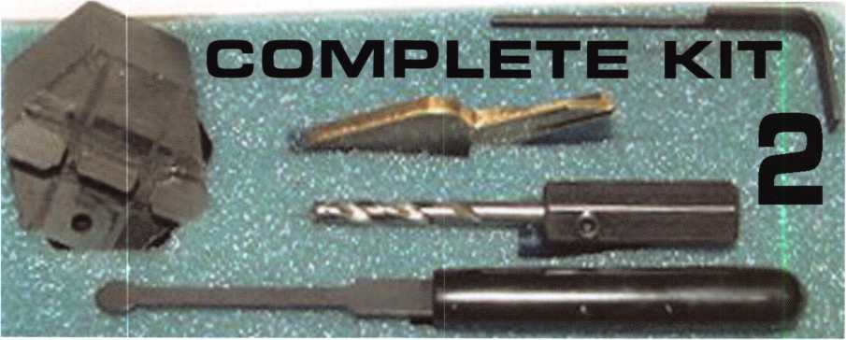

Keynotes • July/August 2002

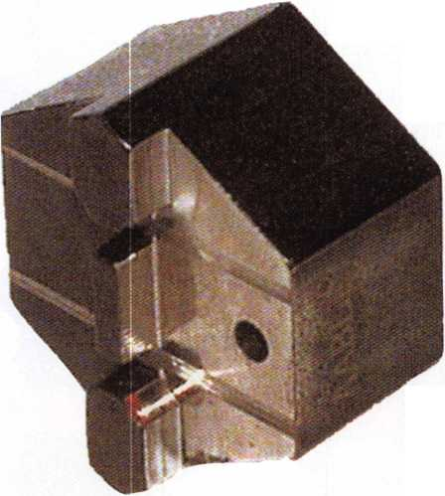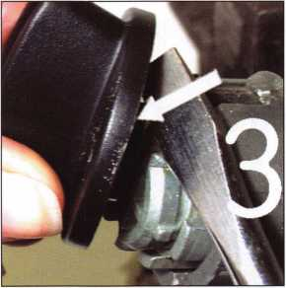

Photo 3: Pry wing nut off with a large flat screwdriver, so you don't damage it.

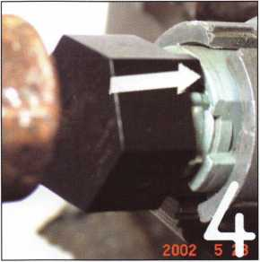

Photo 4: Insert drill block (also force tool) into the keyway with drill hole toward you. Give it a slight tap to seat it.

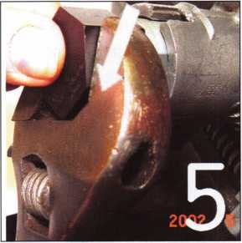

Photo 5: If you just want to start or just remove the lock in less than 60 seconds, use a crescent wrench or socket and turn the cylinder to the ON position for fast removal.

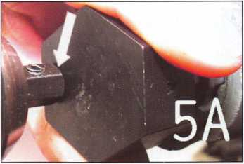

Photo 5a: If you want to use the same lock again, just drill through the drill-guide hole until the arbor touches the face of the force tool.

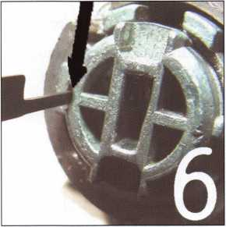

Photo 6: Insert the side bar pressure behind the side bar through the access hole you have made.

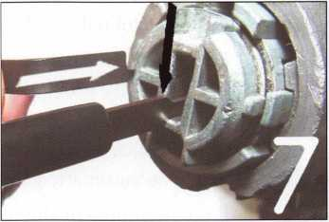

Photo 7: While apply­ing pressure against the side bar pressure tool, take a pick and rock the wafers from the front toward the rear as you feel the side tool slide into the cylinder.

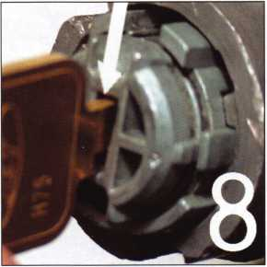

Photo 8: Once the side bar pressure tool drops all the way into the access hole, take the short key and insert it into the keyway.

You can view this tool — and all the other auto tools Frank designs — on his website at: [www.aablelocksmiths.com](http://www.aablelocksmiths.com), or call Frank directly at 718/848-8000.

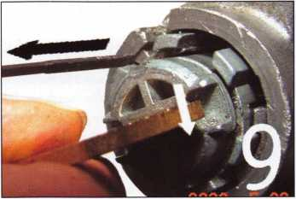

Photo 9: Apply pressure on the key toward the ON position; at the same time, pull the side bar pressure tool out of the access hole, timing it so the side bar does not relock.

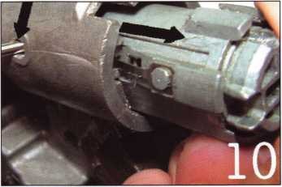

Keynotes •

Photo 10: Push the cylinder retainer pin in through the access hole located on the lock housing. Slide the cylin­der out, fit the key and replace the lock.

July/August 2002



NEW!

PRODUCTS

Access Control: The 65,000 Key Lock?

By Paul F. Chandler CRL

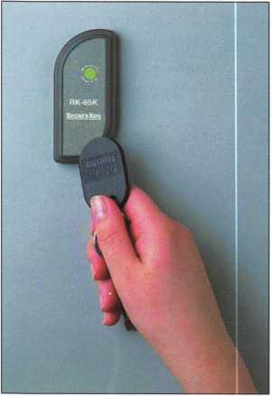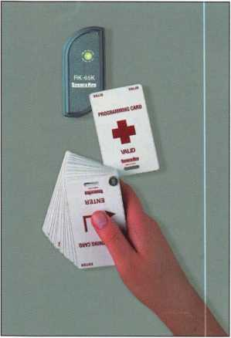

Imagine a lock that has over 65,000 individual change keys, each cut differ-  
ently, yet all working the lock. Imagine that you can quickly and easily deac-  
tivate any one of these keys without disrupting any other key holders.  
Imagine a group of these locks with unlimited, non-hierarchical master key  
possibilities. And imagine that this lock cannot be picked, will not open to  
any unintentional master keys and is so simple to “rekey” that your customer  
can do it himself.

Of course, such a “lock” is impossible to create using conventional pin tum-  
bler, disc tumbler or wafer tumbler paradigms. To obtain features like this,  
you must go electronic. Secura Key has just introduced a new proximity  
access control unit — the RK-65K, that does all of these things, and more.

The RK-65K is small enough to mount directly on a door frame or mullion.  
It is a complete proximity access control reader/controller for up to 65,000  
unique cards or key ring tags. A solid-state relay in the unit can be config-  
ured to unlock a fail-secure lock or strike, a fail-safe magnet or lock, or to  
activate an automatic gate or door.

All programming of the RK-65K is accomplished with a special deck of  
proximity cards. Holding a sequence of cards close to the reader puts the  
unit in the programming mode, adds or deletes cards, sets the latch timer  
and places the RK-65K in a variety of operational modes.

Installing the RK-65K

1. Select a suitable mounting location. The RK-65K can be mounted on metallic and  
   non-metallic surfaces. It is better not to have metal around the sides of the RK-65K,  
   and it cannot read through metal. It can read through most non-metallic materials,  
   so the unit can be mounted behind a pane of glass or inside of a wood, plastic,  
   drywall or masonry space. Drill one 3/4-inch hole for the cable and buzzer. Drill  
   two 1/8-inch holes for the mounting screws. (See Figure 1)
2. Connect the Red wire to +12VDC and connect the black wire to -12VDC.
3. If you have a Request-to-Exit button, connect it to the orange and brown wires.
4. The blue and violet wires are connected to the on-board solid state relay. Out of the  
   box, this circuit will control a fail-secure strike or lock as well as an automatic door  
   or gate operator. If you want to connect a fail-safe electric lock, you can reconfigure  
   the relay in programming. (See Figure 2)
5. Attach the RK-65K to the mounting surface and cover the screw heads with one of  
   the five decorator faceplates.



Keynotes • July/August 2002



Programming the RK-65K

1. After you connect power to the unit, the LED should be flashing alternately red and green. Set the facility code of your cards by holding a sample card near the reader for one second. The RK-65K can learn up to 10 unique facility codes. Fifteen seconds after you set the last facility code, the flashing will stop.
2. Place the unit in the program mode by entering

1+2+3+4+5+ENTER with the program card deck.

The LED should begin flashing amber and will contin­ue flashing until you complete your programming session.

1. Change the "password" from 1 2345 to another 5 digit number.
2. Add one or more cards to the unit by using the digit cards in the program deck, which correspond to the card numbers you wish to add.
3. Set the latch timer for the amount of time you want the door to be unlocked. This can be from 1/4 -sec­ond to 18 hours. You can also program the RK-65K to act like a toggle switch; one card use closes the circuit, the next card use opens the circuit, and so on.
4. Set the solid-state relay for Normally Open or Normally Closed operation.

The first question locksmiths ask when evaluating a product is “How can I break into it?” Like most standalone access control products, the RK-65K is vulnerable to physical attack. If the reader is ripped of the wall and the wiring is accessible, a savvy criminal could “hot wire” the lock. One way to counter this is to install the proximity reader behind glass or some other non-metallic surface. Where this is not feasible, you might want to add the SecuRelay(tm). This intel­ligent relay module removes lock control from the reader and locates it inside the protected space.

When the SecuRelay(tm) is used, nothing an intruder does to the wiring at the reader location can release the lock.

The Secura Key RK-65K provides a simple-to-use sys­tem for clients who want to add and delete users quickly, and without disrupting the lives of other users. Wallet-size cards or convenient key ring tags can be used as electronic “keys.” A single tag can be entered into one or more access control units, creat­ing an unlimited masterkey array.

The RK-65K does not offer all of the features and conveniences of larger, more expensive systems. There is no provision for issuing cards that are limited to certain times or days. There is no auto

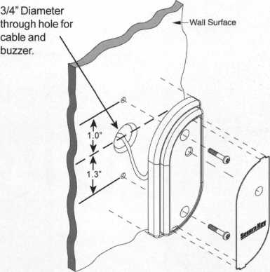

locking/unlocking  
schedule. And the  
unit does not  
record card uses  
in an “audit trail”  
buffer.

Frequently a  
client will start  
out with a simple,  
single-door access  
control product,  
but later will  
expand to a more

complete multi-door system.

The RK-65K makes this migration easy.

A fourth pair of wires in the reader provide an industry-standard Wiegand output. This means that the RK-65K can be rewired to an access control panel and become part of a larger system. In addition to reusing the reader, the access cards already issued can be used with the more advanced system.

An RK-65K with an RK-PDi program card deck and 25 user cards has a List Price under $300. This puts proximity access control well within the reach of many small businesses, non-profit organizations and high-end homes. The RK-65K is a 21st century lock­ing system that you can both sell and install easily Check it out at the Secura Key booth (#1429) near the ALOA booth at the 2002 Security Expo later this month. Q

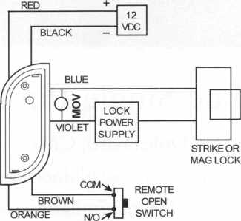

Fig. 2



Keynotes • July/August 2002

s all m

Mbfclftifflgfetl

>w$oofc§ei§ie;se>riie<

.JW»i

fitet«fe»9Hfe«thei

the shear lii

specific pin stack |

__JHL

- -0„-. r._ ^figpins in the first chamber so tfitft frvp shear line (in the

; cylinder and that it is possiblyjpjcnow individually when %&ljave lifted i

The Single Pin Method

By Sal Dulcamara, CML

In part i, I explained some of the basic principles and concepts regarding why lock picking (or manipulation) is possible. In this second installment of the article series,

I’ll now begin to explain specific steps and details of various picking methods. The first method that I will detail has quite a few different names. I have heard it described as the “single pin” method and the “feel” method. As I describe the process, some of you will recognize the basic procedure and relate it to the name that you know it as (if a name was even given). This method will rely on many of the basic principles described in part i (as will other methods to be described in future installments). The specific application of those principles will vary by method.

I’d like to precede my technical instruction by making some very important obser­vations. Like many other skills that we can develop, lock picking will rely on a certain level of natural talent to determine how far we will excel. I’m sure that Michael Jordan (notwithstanding some declining skills at this stage of his career) would soundly beat most of us one on one in basketball, even if we found ourselves wearing the best and most expensive pair of Nikes, and if he decided to play barefoot on broken glass.

Please understand that many of you will require considerably more effort and practice than a select few with a certain instinctive feel for the various processes. If you don’t

**46**

Keynotes • July/August 2002



find that you have immediate and amazing success at lock manipulation,  
don’t presume that you are not destined to learn how to do it.

You will just have to try harder and practice more. Like the  
tortoise and the hare, a determined person (with sufficient  
practice) will often exceed the level of someone with natural  
ability who is too lazy to practice. If you don’t try, you

can’t succeed.

Finally, I’d like to comment on tools. Lock picking is  
a skill that requires the use of tools in order to practice  
it. The level of skill of the technician will always be  
more important than the perceived quality or price of  
the tools that he or she uses. I sometimes get frustrated  
at the peculiar presumption that possessing a set of lock  
picks makes you a skilled lock manipulator. A skilled lock

picker no more owes his success to a set of gold-plated  
lock picking tools than Michael Jordan owed his success at  
basketball to Nike footwear. With very few important excep-  
tions, a homemade set of tools operated by a skilled technician  
will generally outdo an expensive set of professionally made high quali-  
ty tools operated by an unskilled technician.Learning the Single Pin Method  
The single pin method is probably the most scientific and precise method of lock pick-  
ing. It is the most skill-oriented method, and usually takes diligence and practice to become  
proficient in it. After I describe the procedure, I will give some tips and suggestions to  
minimize the likelihood of failure for those with less natural abilities. To use this method  
effectively, you must be able to detect what is going on inside the lock that you wish to  
pick. It will be worthwhile to use your sense of hearing to aid you in your goal. Once you  
get the hang of it, you will sometimes be uncertain whether or not your sensation of events  
within the lock have been sensed by your finger tips or your ears. Although your eyes will  
not be able to see through the lock, it is often beneficial to visualize what is going on inside  
the lock as you manipulate the tumblers. The more you can connect the visualized physical  
activity of the tumblers inside the chambers to your senses of feel and hearing, the more  
natural locking picking will become.

Figure i shows a side cutaway view of a typical pin tumbler lock  
cylinder. There are five pin chambers with top and bottom pins  
in each chamber. Tumbler springs are not illustrated, but pre-  
sume that they would be at the top of each chamber. With  
no key in the lock, the tumbler springs would force the top

and bottom pin stack to the lowest point within each  
chamber. The front cutaway view shown in figure 2 isolates

a single pin chamber to  
reveal the relationship of  
_ the plug within the lock

mi<tjj ';|jB

cylinder’s shell. With no

**Keynotes • July/August 2002**

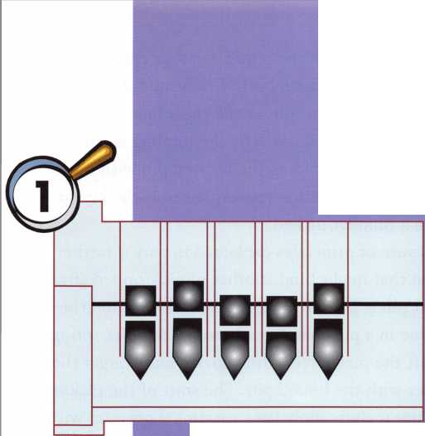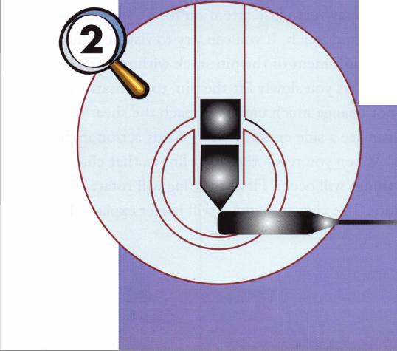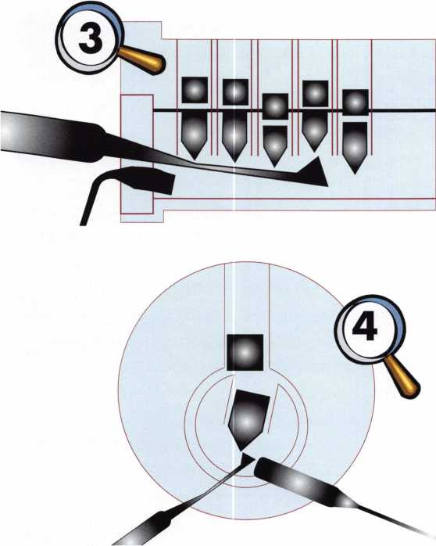

key in the lock, the bottom pin is completely con­tained within the lower chamber (as will be the case with all the remaining bottom pins). The top pin extends downward from the upper chamber into the lower chamber, effectively preventing rotation of the plug. An “L’ shaped tool (called a turning tool or ten­sion wrench) fits into the bottom of the keyway broaching. If the turning tool were used to rotate the plug clockwise, the plug would rotate ever so slightly and then stop. The plug would stop rotating when the top pin became bound between the plug and the shell. The upper part of the top pin (on its right side) would collide with the inside right surface of the upper chamber, while the lower part of the top pin (on its left side) would make contact with the inside left sur­face of the lower chamber. The top pin would be bound between those two surfaces and the plug could rotate no further.

At this point, some of you may be thinking that there are four more chambers where the exact same interaction was occurring. The fact is that something

similar is going on in the remaining four chambers, but not the same. Last month, I indicated that even if I lifted a pin stack to split at the shear line, the stack would be forced back down by the tumbler spring as soon as I stopped holding the bottom pin with my pick. The binding action just explained is the key to keeping a tumbler picked.

Because of principles explained in part i, further rotation that might bind another pin is stopped after the first pin is bound. Since it is fruitless to find the shear line in a pin chamber where the tumbler spring will shift the pins after letting go, we must target the chamber with the bound pin. The start of the picking procedure is thus: apply light rotational pressure with your turning tool and then find the chamber with the bound pin. For our example lock, I will select cham­ber 4 (referenced from the face of the plug or bow to tip) as containing the first top pin that binds. For sin­gle pin picking, I would recommend the use of a dia­mond (sometimes called a half diamond) pick or a hook pick to provide greater isolation of a single pin. By lifting up on each bottom pin, you should be able to determine which pin binds. If you lift the bottom pin in a chamber that is not bound, you will feel the tension from the tumbler spring trying to push the stack back down. When you find the bottom pin in the bound chamber, you will feel the friction of the top pin caught between the chamber walls as you lift upward. If you feel anything more than just light fric­tion, you are applying too much rotational force with your turning tool. The key to successful lock picking is a very light touch.

As you are lifting the bottom pin in the bound chamber, pay very close attention to the sensations of sound and touch. If you can, try to visualize the upward movement of the pin stack within that pin chamber. As you slowly lift the pin, the sensations will not change much until you reach the shear line. You can see a side cutaway view of this action in fig­ure 3. When you reach the shear line in that chamber, two things will occur. First, the plug will rotate slight­ly more. The view in figure 4 will better explain the

Keynotes • July/August 2002

reason for the sensations that I describe. The actual amount of rotation is very small. The second thing is that the bottom pin will resist further upward movement.

The details in figure 4 are intentionally exaggerat­ed to identify the physical characteristics that cause the identifiable sensations that indicate a pin has been picked. When the first pin is picked, the plug will begin to rotate ever so slightly. Those beginners with greater natural ability will often detect the telltale sensations that identify a picked pin right away. Most of the rest of us require more practice and concentra­tion. There will be a subtle feel that the plug has moved. It will have rotated barely a few degrees, if that much. You may hear a subtle clicking sound as the bottom corner of the top pin scrapes across the top surface of the plug at the left end of the bottom pin chamber. If there was only one pin chamber, the plug rotation would be dramatic. Since there are four more pins to deal with, one of the remaining four chambers will contain the next top pin to bind and stop the plug rotation.

As long as light rotation pressure is maintained, the top surface of the plug (just to the left of the fourth pin chamber) blocks the top pin from falling into the lower chamber even though the tumbler spring still applies some downward pressure. After the plug has shifted, the inside surface of the shell (just to the right of the top pin chamber) partially obstructs any further upward movement of the bottom pin.

If you are still lifting upward on the bottom pin after slight plug rotation, you may feel something trying to prevent you from lifting the pin any higher. Lacking such subtle sensitivity, it will be quite easy to force the picked pin upward and un-pick that previously picked chamber. Although my illustration suggests that there is so much overlap that anybody would feel the upward resistance and stop, the unfortunate fact is that the overlap will typically measure just a few thousandths of an inch. Only those with considerable natural ability will feel it on the first try Most of the rest of us will have to practice to train our senses sufficiently.

I don’t want to sound unnecessarily discouraging at this point in regards to learning this picking method. On some of the more precisely manufactured lock cylinders, attempting to pick a 5 (or 6) pin tum­bler lock for a beginner could be quite discouraging.

If you have developed your senses sufficiently, you will start to notice the phenomena that I describe. When I teach lock picking, there is a locksmith’s equivalent of training wheels that I use to increase a beginner’s ability to learn this method. After I finish describing the entire picking process, I will reveal that crutch that may help you to develop the senses needed for single pin picking. Your basic step-by-step procedure will be essentially the same, but you will be able to “feel” everything a little easier.

After picking the pin in the fourth pin chamber, we can lower our pick from the bottom pin. We must, however, maintain rotational force with our turning tool. When we let go of the bottom pin, it will drop to the bottom of the pin chamber because of gravity. We needn’t be concerned as long as the top pin does-

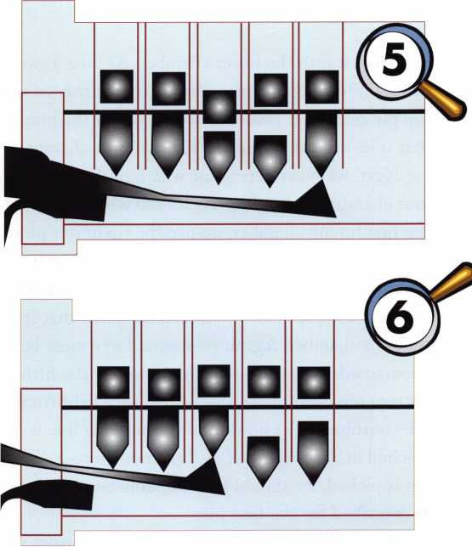

Keynotes • July/August 2002

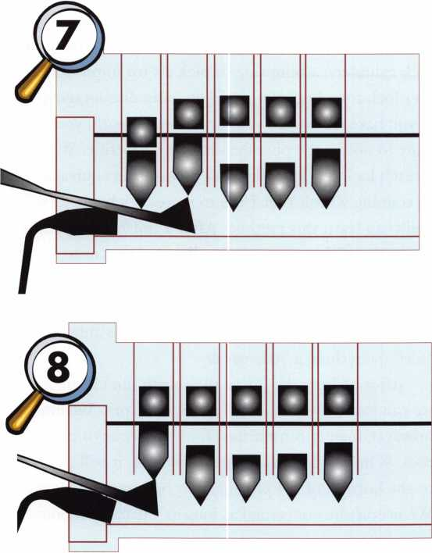

n’t follow it into the lower chamber. As long as we maintain turning pressure, the bottom corner of that top pin rests on a small surface on top of the plug that is just to the left of the lower fourth chamber.

Next, we must determine which of the remaining four chambers is binding. As we did when we found the first bound chamber, we use the tip of our pick to lift up on the remaining four bottom pins. Three should have spring resistance and one should bind.

For our example lock, we have determined that it’s the fifth chamber. Again, rotational force must be maintained, but not too much. As we lift the fifth bottom pin upward, we should feel very light friction. We continue to lift upward until the shear line is reached in that chamber, as shown in figure 5. As each pin is picked, we should feel the same basic sensations as described for the first pin.

When the split between the top and bottom pins reaches the shear line, the plug will rotate a bit fur­

ther clockwise (until the next pin binds and stops the rotation). You may hear a similar clicking sound as the bottom surface of the top pin skips across the top corner of that lower pin chamber. As you maintain rotational force, let go of the fifth bottom pin and seek out the next pin to bind. With three remaining pins, two should have spring pressure and one should have slight friction. For our example, the binding will be in the third chamber. We lift slowly on the third bottom pin until the split between top and bottom pins reaches the shear line, as in figure 6. The plug will again slightly rotate.

Some of you may be noticing some interesting possibilities in figure 6. While the single pin method involves consciously picking specific pins with the tip of the pick, we can’t get around the fact that the neck of the pick is lifting all the pins preceding the specific pin contacted by the tip. Under typical circumstances, the split points between the top and bottom pins in those chambers will not be residing at the shear line, but it is possible. The first and second chambers are very close to that hypothetical condition. If they actu­ally were at the shear line, the conscious motion of picking the third pin and the accidental picking of the second and first pins would cause all five pin chambers to be at the shear line simultaneously. That would cause the plug to rotate more than just slightly — it would unlock the entire lock. Picking single pin is a precise and deliberate picking method. It might prove confusing to the practitioner who consciously picked only three pins but somehow arranged all five pin chambers at their shear lines. We will revisit this topic in a future installment of this article series on quirks and complications of various picking methods. For the time being, we will presume that only the third pin picked, and that we have two more to go in order to open the lock.

The second chamber contains the next pin to bind. The process is continued by lifting the second bottom pin against the resistance of light friction from the chamber walls. When the split point between the top and bottom pins reaches the shear

Keynotes • July/August 2002

line shown in figure 7, the plug again rotates slightly:

At this point, only one pin chamber is forestalling the actual unlocking of the lock cylinder. The tip of the pick should be placed under the first bottom pin and slowly lifted against the friction of the chamber side walls. Lifting should continue until the shear line is reached as shown in figure 8. It is apparent in this illustration that all five top pins are at the shear line. The last four bottom pins are not at the shear line, but they are below it and not blocking the shear line. With no pins left to prevent the plug’s rotation, the plug rotates dramatically in figure 9. The lock is unlocked.

Tips and Training Wheels

We have now reviewed the basic steps. It is no accident that this is sometimes called the “feel” method. Until you develop the feel for the process I just described, you will not succeed with this method consistently. First to the training wheels, and I suggest that all beginners use it. It is a fact that (all other fac­tors being equal) a lock with more tumblers will be more difficult to pick than a lock with fewer tum­blers. Most pin tumbler locks, out of the box, have five or six chambers. I don’t recommend that a begin­ner learn the “single pin” or “feel” method by starting with a five-pin lock. Your best bet is to empty at least two of the pin chambers, and maybe even three. You should start out with a three-pin lock, and only go for a two-pin setup if you cannot detect any of the physi­cal sensations I have described in the instructions previously giv^n.

In the example lock I had a certain sequence of pin chambers that bound. As a consequence, I had to pick the pins in that sequence. Every lock that you confront will have its own sequence identity for pick­ing. There will be one for clockwise rotation and a different one for counterclockwise rotation. Since we can only pick a pin when it binds, we must obey the dictates of the lock. We cannot choose our own alter­nate sequence. When we remove pins from some of the chambers,

we tend to increase  
the distance of  
plug rotation

when a pin  
picks. That  
slightly  
exaggerated  
movement  
and feel will  
help us to  
detect those  
characteristics

when our senses are

not yet finely honed. As  
we develop the feel, we can add  
another pin to make it a four-pin

lock. We will reduce the motion and sound that  
occurs when a pin is picked, but our senses will  
become gradually more attuned to the more subtle  
sensations. When comfortable at four pins, we up it  
to five. Hopefully our senses adapt sooner rather than  
later, as we practice and improve.

It is important not to get ahead of yourself. Do not jump to five pins after picking a four-pin lock only once. There is always some element of luck when picking a lock, even among the very best technicians. Make sure that you could feel the tumblers pick and not just that you picked the lock. It is my personal recommendation that you pick a lock repeatedly both clockwise and counterclockwise before adding an additional pin to your lock. You will find that the time required to pick one direction will be longer than picking the other direction, sometimes dramati­cally longer. There are reasons for that. I’ll explain that in the installments on quirks and complications. Also try both the hook and diamond picks. They use the same basic picking principles, but they each have a slightly different feel. I’m guessing you will develop a preference for one over the other. Keep on practic­ing and watch for part three. Q

Keynotes • July/August 2002

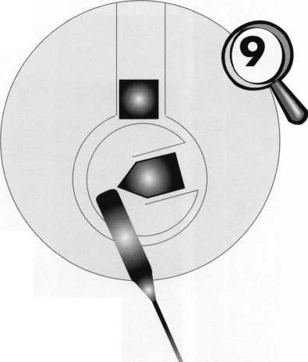

SAFES: A MAJOR DEFEAT

We’re often told to think like burglars. How would you break into something and then devise a way to prevent that method of attack? Seeing how a burglar attempts to open a safe is always of interest. Some of the time, they attack a safe with wild abandon — no idea how to get it open and no real plan, just beat it, drill it, torch it, or pry it and hope it opens. Sometimes they get lucky and pick a safe with no defense against their plan of attack. Prying open a fire safe falls decidedly into the “lucky” category. One of the more common methods of attack is to knock off the dial and punch the spindle off a combination lock. Rarely is it effective. Most lock manufacturers, excluding the low-end manufacturers, build into their locks a relock trigger, which fires when the back is knocked off to keep the lock bolt from retracting.

The safe manufacturer may even add a relock device that will also fire, locking the bolt works of the safe, effectively preventing the safe from opening. When this lid was brought into us, my first thought was, “How did they get the safe opened that way?!” This time, the burglar got lucky with their attack method, and the safe opened. They did have a lot of time available to them since in this case the burglar was a renter. The landlord found his safe broken into after the tenant skipped town.

Looking at photo i, can you guess how the safe was opened? We see the dial is gone, the spindle appears to be punched and a hole is drilled to the hard plate next to the spindle hole. I’ll give you a hint: This is an old style Major Safe round door with hand change wheels. I will tell you this door is not easily repairable because of the method chosen to attack it. This attack method would not work on a newer lid with a LaGard wheel pack. Still no thoughts on how it opened? Let’s see if I can guide you through my educated guess how they proceeded. I’ll also explain the factory-recommended method and a couple of alternative ways to open them.



Keynotes • July/August 2002

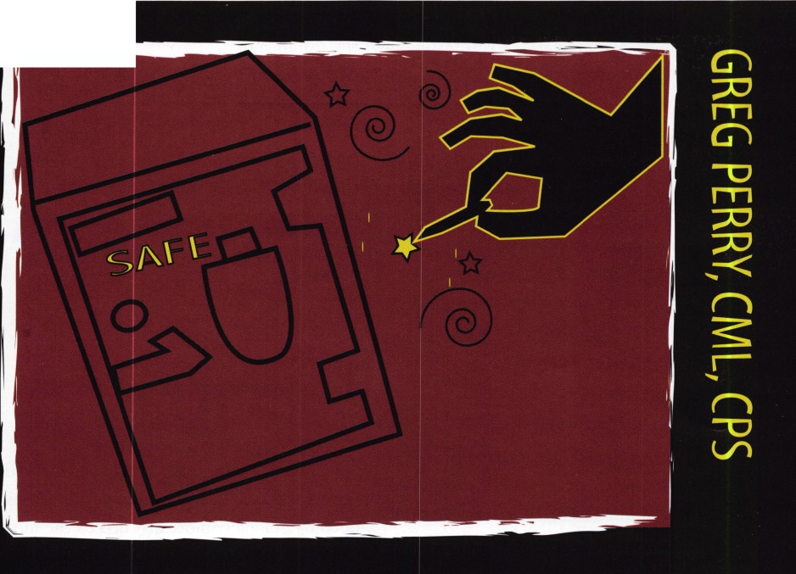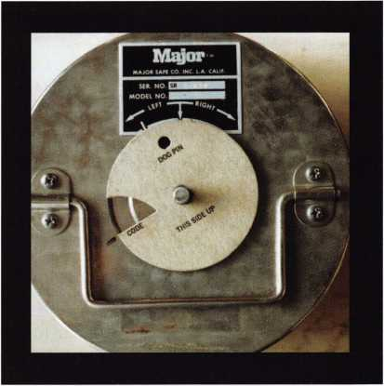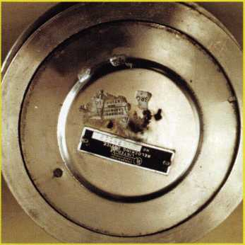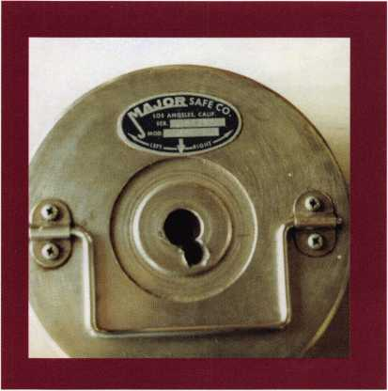

They started by knocking off the dial, maybe by beating on the spindle. The back is pushed out, but not off. This kept the relock from firing. Not getting anywhere, they moved to plan “B.” They randomly chose a place to drill a hole next to the spindle hole. I say “randomly” because Major built these doors and randomly placed the label with the dial index on the door, then drilled and tapped for the bail handle. Since the factory places the label dial index randomly on the door any location selected to drill would be random unless you have the factory drill point.

Photo 1

Oval label without the "SR" prefix indicates old style door. The hole next to the spindle hole stops at the hard plate.

If you need to  
drill one of  
these doors  
and you are  
registered  
with the facto-  
ry, you can call  
them with the  
serial number

and they will give you the template location. Once you have  
this number and the template, you simply set the dial at “o,”  
mark the number given to you on the door next to the dial.  
Remove the dial and place the template on the door over the  
spindle. Align the mark on the template to the mark you  
placed on the door. Using a quarter-inch transfer punch  
through the hole in the template, mark the door. Drill a quar-  
ter-inch hole at this location until you reach the ball bearing.  
Once youVe found the ball bearing, the factory recommends  
increasing the hole size to 3/8-inch. Next use a 5/32-inch punch

to push the

Photo 3

A new style door with a drill template in place. Use this template for a lost combo or broken fly problem. The dog pin is akin to the lever stop in a rectangular body lock.

dog pin out the back cover and reach in with a probe to move  
the fence around to open the safe. Sometimes you can turn the  
spindle right and the bolts will retract. On some doors, IVe  
used a cordless drill on the spindle to help retract the bolts.  
The speed of the drill will sometimes carry the wheel pack  
around to the open position. The template location number  
will align with the center of one of the bolts.

Photo 2

The back of an old style door.

If the label is missing or you are unable to contact the factory  
you may drill a small hole in the neck ring. Insert a wire into  
the hole and slowly rotate the door to find an edge of the bolt.  
Mark this location on the door. Next, lift the wire up rotate  
the door about an inch. Reinsert the wire and rotate the door  
back against the wire. This will allow you to mark the other  
side of the bolt on the door. Mark all three bolts using this  
method. Mark the center of the bolts between your marks.  
One of these centerline marks is the same location the factory  
would provide. Pick one, using the template mark the drill  
point on the door and start drilling. Your odds are one in three

Keynotes • JulyAugust 2002

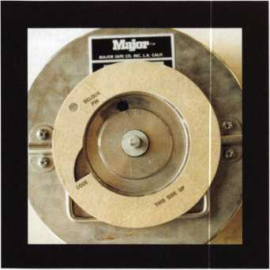

Photo 4

Use this template if the back cover has been knocked off to drill for the relock pin.

Photo 5

The back of a new style door.

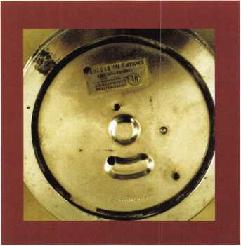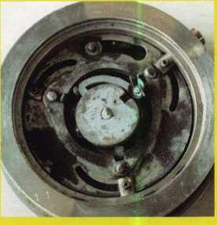

Photo 6

This is the inside of a locked old style door. The fence is blocked by the dog pin.

that you’ve picked the right location. If you reach hard plate, choose one of the other two locations. Once you find the ball bearing, use the punch to push in the dog pin as described above. If your door is a new style you may try a trick developed by Phil Shearer. It was originally published in the July 1988 S&VT magazine on page 23. I’ll try and paraphrase here. The spline groove of the spindle will line up with one of four locations on the dial; o, 25, 50, or 75. Find the right contact point and add 13 to that number (e.g., if your right contact is 20 add 13 to it and set your dial at 33; leave your dial set at 33 and mark your door where the dial reads o, 25, 50, or 75; one of these locations is the factory drill template code). Cock the door to one side, insert a shim and try to find the bolt that lines up with one of the marks. When you find the bolt that lines up with one of the four marks, use it for your template location. If you cannot get a shim to find the bolt, then drill a small hole in the side as described above to locate your bolts.

An alternative method, if you do not know the template location, is to pick a location 7/8-inch out from the dial center and drill a hole, then transfer the wheel pack to the correct location to open the safe. A third method I’ve seen published (which I think originally came from Keith Knott via the “National Safemans Organization”) is to remove a bail mounting plate and drill a scope hole. The hole needs to be slightly inside of the centerline between the two screw holes of the mounting plate. This misses the hard plate; the only downside is if you find a bolt in the way. This burglar used none of the above methods, but he got it open.

Back to this opening; how did he do it? After getting nowhere drilling next to the spindle hole, he moved to

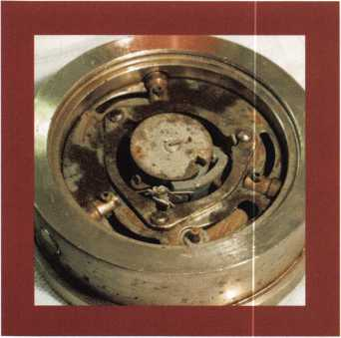

Photo 7

The bolts are retracted and the fence/wheel pack assembly is turned. This is how it looked when I removed the back cover.

1

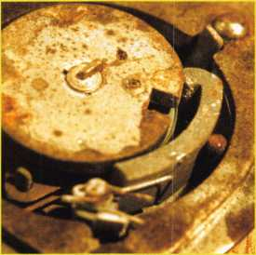

Photo 8

A close up of the fence and dog pin shows the fence is not in the wheel pack but it has rotated.

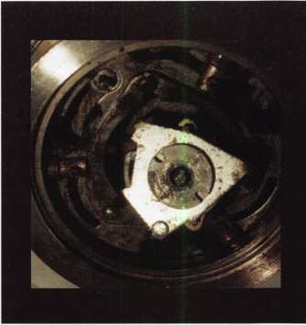

Photo 9

The wheel pack is turned over revealing that the mounting post and spindle have been drilled releasing it from the door. This allowed it to move away from the dog pin allowing the fence to bypass and rotate to open.

**54**

Keynotes • July/August 2002

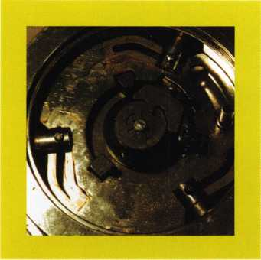

Photo 10

Inside a new style door.

Photo 11

This is the new style wheel pack assembly.

Photo 12

The back side of a new style wheel pack.

The dog pin goes through the cutout on the plate.

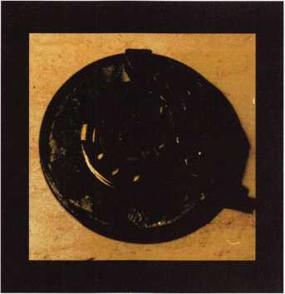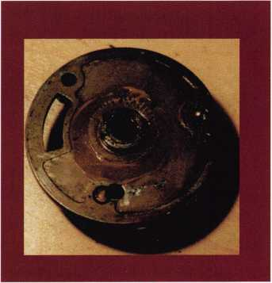

the spindle. Drilling the spindle hole with a 27/64-inch bit removed the wheel post mount. This allowed the  
wheel pack assembly to move over away from the dog pin. My guess is, as the drill bit broke out the wheel post  
it spun the assembly and retracted the bolts. So much for stopping a criminal attack through the spindle hole!  
This door as mentioned earlier cannot be easily repaired. The reason is the lack of threads for the spindle post.  
Repair would involve restoring the internal threads and a new wheel post installed. Since this door design was  
discontinued in 1980, parts may be difficult to find. A better alternative is to sell the customer a new door  
available from American Security Products (AMSEC), who purchased Major Safe Company in 1987. Service of  
this door is similar to most other safe locks. Both styles of doors need to be completely disassembled and all  
the parts cleaned of any dust, old lubrication or any other contaminants. All parts should be inspected for any  
wear or cracks. The older style door needs a very small amount of lubrication on the wheel post, both inside  
and out. The bolts, cam plate and spindle shaft underneath the dial need a little more lubricant. GE Versilube  
G322L is the recommended lubricant for both applications. LaGard does not recommend any lubrication on  
their wheel pack used in the new style door. AMSEC, in their 1988 service manual (and several technicians  
I know), disagree with LaGard and recommend a very small amount of lubrication on the wheel post both  
inside and out; again the GE Versilube is the most recommended product. The cam plate, bolts and spindle  
shaft also need lubrication just like the old style. The biggest difference in service of this door is when chang-  
ing or setting the combination. It’s very important to know the last or ending

number. Unlike most safe locks, since this door has a random drop-in  
location, the last number will be in a different location on each door.

The forbidden zone will therefore be different on each door. Since  
the third number should not be within 20 numbers of the last  
number (the forbidden zone), it’s important to know the last  
number before choosing the combination.

I find attack methods interesting. Most of the time uneducat-  
ed burglars don’t get into quality burglar-resistant safes. They  
simply don’t have the knowledge to overcome the built-in pro-  
tections. Sometimes, they just get lucky and find a spot, which  
allows them to break into the desired safe. Manufacturers need  
to minimize those spots. That may be why Major Safe changed  
their design. The new design has a casting that surrounds the dog  
pin. This prevents the wheel pack assembly from moving to the side,  
effectively preventing this form of attack. I would love to know if the

burglar knew about the weakness in this safe door or if he just got lucky. Q

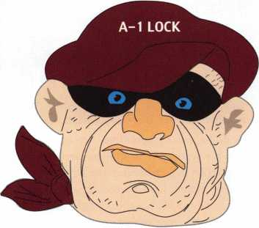

Keynotes • JulyAugust 2002

AUTO:

Inside the 1999 Lexus RX300 SUV

By Jeff Trepanier, RL

There are SUVs, and then there is the luxurious  
Lexus RX300. It’s a beauty from head to tail,  
and with some specific security features that  
require a close look and some special

servicing. I got a hold of this one,

which was turned into a local dealer  
near me after the lease was up on  
it. Every time a leased car gets  
turned into the dealer, they  
want the locks changed, and  
Em all too happy to do it for  
them. Let’s take a look at this  
beauty, step by step.

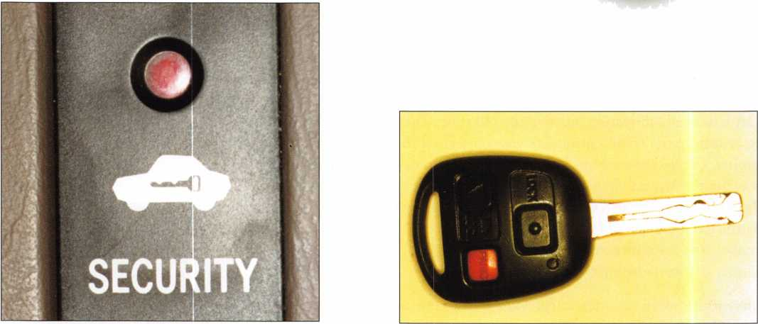

1. A view of the security light. This is an indication that the vehicle you are working on is transponder-equipped. This light is located on the dashboard just left of the steering wheel. Not all models have the security light in the same place, and some models have just a light without the word "security," so check your vehicle carefully or consult your dealer for technical information if you are unsure about the vehicle being transponder-equipped.
2. The high security key with a remote built into the head of the key, along with a panic button, and (of course) the unseen transponder. You should first establish an account and the cooperation of a Lexus dealership before you take on any Lexus work. Servicing most model Lexus vehicles with transponders is not that tough. You don't need any special key machines or fancy tools. You start by ordering keys from your Lexus dealership. Three keys are recommended. The normal key order can be received in two or three days. You can order Lexus keys overnight — for an extra charge.

Keynotes • July/August 2002

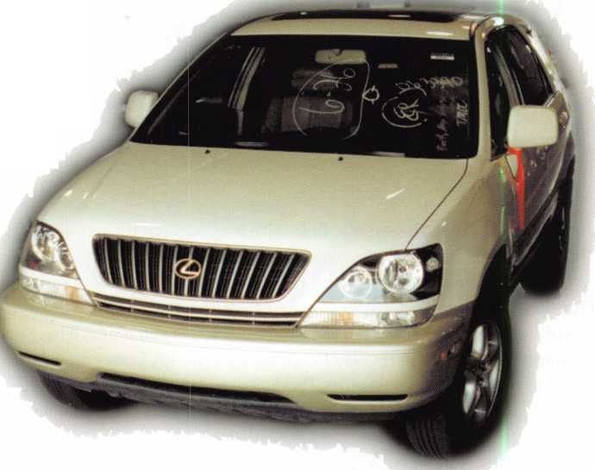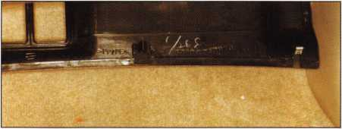

1. The black hush panel pulled down away from underneath  
   the glove box. Gently pull or pry apart the black panel,  
   which is held in place by two clips, and pull toward you to  
   remove. This is the first step in removing the computer.

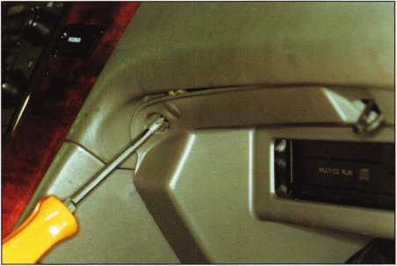

1. A Phillips screw being removed in the upper left hand  
   corner of the glove box. There is one more Phillips screw to  
   be removed in the upper right hand corner of the glove box.  
   After that, remove two 1 Omm bolts at the bottom of the  
   glove box to the left and right.

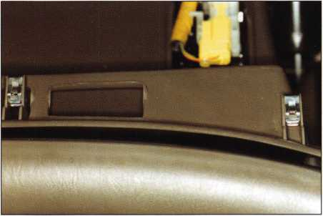

1. Two of the three retainer clips that help hold the top of the glove box assembly in place. The third clip is located to the left of the glove box. Gently pull the top of the glove box until it pulls away. Be careful not to pull too far, as there are wires attached to the glove box.

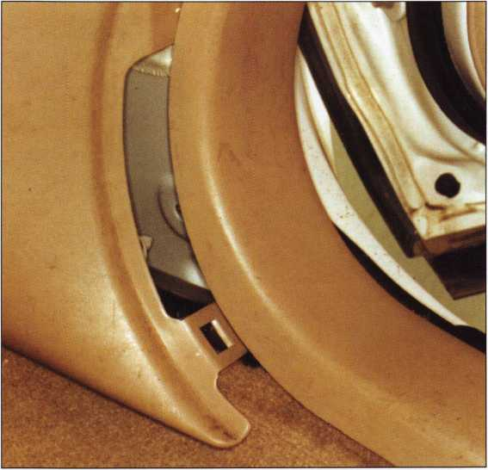

4. The kick panel, partially removed. Next, either by hand or with a 12mm wrench or nut driver, remove the black plastic nut retainer located toward the front of the kick panel. Then gently pull the trim forward and remove the kick panel.

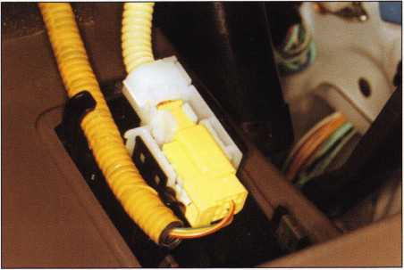

1. The airbag wires on top of the glove box. Gently use a small screw driver at the side and spread the black retainer away from the white block assembly and pop out. Now you can remove the glove box completely.

Keynotes • July/August 2002

**5**

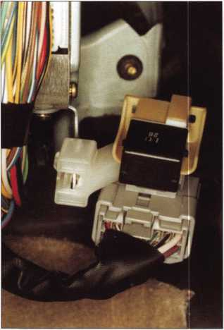

8. A wire block assembly located at the bottom of the computer. To remove this assembly, push in on the tab at the left side to release it from the computer mount­ing bracket.

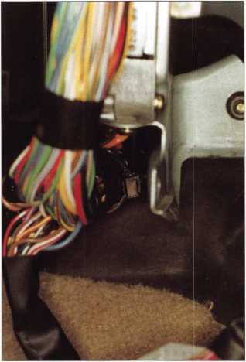

9. A black wire loom attached to the

lower computer mounting bracket and one  
1 Omm bracket nut. Gently pry out the  
black wire loom strap from the mounting  
bracket. Next remove the 1 Omm nut from  
the lower mounting bracket. There is one  
more nut at the top of the computer.

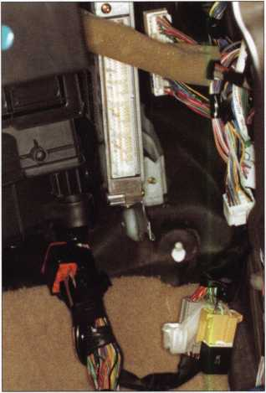

10. The lower computer mounting nut removed and the computer unplugged.

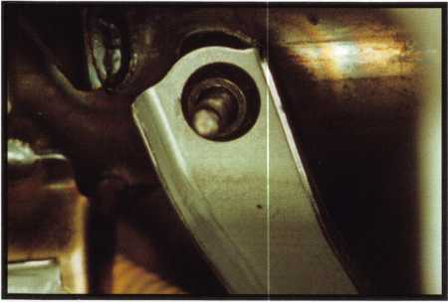

11. A close up of the 1 Omm nut that needs to be removed from the upper computer mounting bracket. This is the final step in the computer removal.

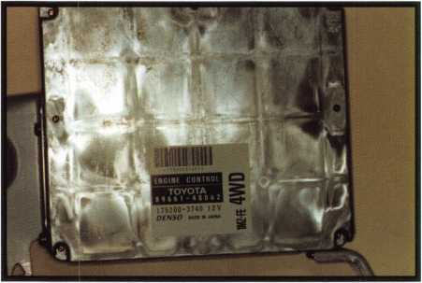

1 2. This is what the main engine computer looks like. All you have to do is remove the brackets and ship the computer out.

Note: Randy Mize were instrumental You can send your 800/654-0637. Q

of Lockmasters and Bill Neff, CML, of Neff’s Safe Lock and Security (Lititz, PA)  
in figuring out how to re-program the Lexus and Toyota computers to accept new keys,  
computers to Lockmasters for reprogramming. For more info., call them toll free at

Keynotes • July/August 2002

Products locksmith Professionals

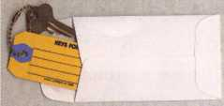

**AD / ID KEY TAGS**

Specifically designed to identify the product you work with  
daily and promote your business with your custom Ad copy.

back side of tag with 4 lines for key identification

KEYS FOR

**Clear Plastic Protective Sleeves** Stock# PPS10

Protect your key tags with  
durable plastic sleeves

**Key Tag Envelopes**

Stock # KTE3 Actual Size: 2W x 4V4" Added security and finishing touch when presenting keys to your customers

* 100 200 500 1000

10.50 17.00 37.50 65.00

* 100 200 500 1000

11.50 19.95 42.00 68.50

**TO ORDER:** Choose QTY., Key Tags with Chains or Rings, TAG COLOR and Provide Imprint Copy (printed black only).

ANDOVER LOCK  
& KEY SERVICE

, M 3221 LAKESIDE HWY.

ANDOVER MA 05242  
(508) 626-1111

actual tag size 2.75” x 1.375

Choose from White, Yellow, Neon Pink or Neon Green with Style A or B fronts

LAKEVIEW

LOCKSMITH

24 Hour Service **(845) 556-LOCK**

Choose from Brass Plated Bead Chains or Chrome Plated Wire Rings

QUANTITIES

1000

2000

3000 5000

**it** KEY TAGS with CHAINS or RINGS 32.00 42.95 83.95 115.00

YOUR CHOICE OF CHAINS OR RINGS - IF NOT SPECIFIED WE SHIP CHAINS

195.00 269.00 395.00

Key Tags Only (no chains or rings) - Deduct 10% from above prices

National Logos - No Charge / Custom Logos - Add $25.00 and supply clean B & W artwork

**TRANSPARENT PLASTIC KEY TAGS Stock # DP-226** Actual Size: 2" x 1.375”

Available colors: Blue,

Amber or Crystal  
•Extra heavy beadchain  
• “Lifetime” unbreakable  
proponate •Insert card is  
printed with your Ad Copy  
• Handy identification space  
on reverse side

*50 49.50 100 82.95

1. .. 112.50 250.... 142.50
2. ..195.50 1000...346.50

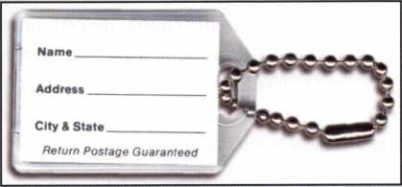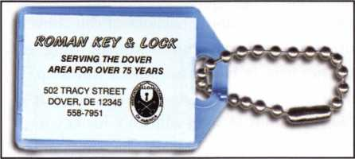

**FULL COLOR PHOTO BUSINESS CARDS**

In an effort to make buying full color more economical we have  
introduced the lowest quantity in the industry just 250 cards, now  
you can have high quality full color cards at unbelievable low  
prices! Our new digital full color press makes this possible.

Choose from the Antique Lock design # FCBC-121 or Available imprint colors: Black, Medium Mountain Creek design #FCBC-10 shown or if you have Blue, Dark Blue, Red, Purple, Golden

your own design send in a sample, we will duplicate it for Yellow, Medium Green, Dark Green,

a one time $25.00 setup charge. Brown, Pink and Orange - if not specified

TA An.pn *. ,. . . ... we print as shown in sample design. *For*

TO ORDER: send in the copy you need, along with your Mo/^/e color Imprint - indicate color of photo and we will fit the copy best to suit the design eac/? nne ancj/or iogo co/or

you choose. Specify card stock. (National Logos - FREE

*Choose from 2 finishes of high quality heavy card stock* Custom Logos - $25.00)

each additional

**\* QTY. 250 500 1000** 1000

**Matte 54.95 82.50 96.50 89,00/M**

High Gloss 63.75 91.50 104.95 98.00/M

**FREE PHOTOS - your cards can be ordered with or without photo**

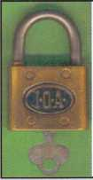

**Tom Carter**

Licensed Master Locksmith

3221 Lakeside Hwy.

Andover, MA 05242

508-626-1111

**ANDOVER**

**LOCK & KEY SERVICE**

*“Andover’s* *#1 Locksmith Since 1947”*

**24 HOUR EMERGENCY SERVICE**

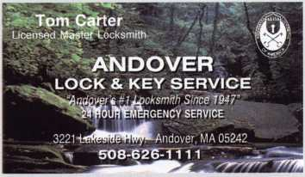

**\*$7.00 SHIPPING CHARGE ADDED PER ORDER**

**SANZO SPECIALTIES, INC. BOX 68 ENDICOTT, NY 13760  
TOLL FREE: 1-800-222-4041 FAX: 607-748-0507**

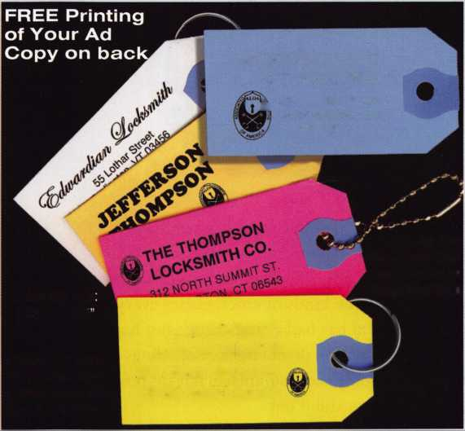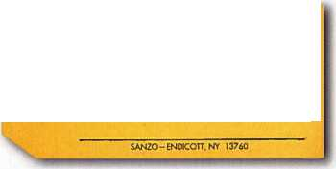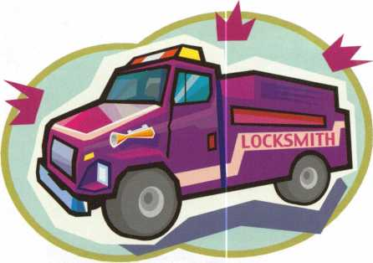

Opening Reflections:

Living as a Public Servant

By C.D. Lipscomb, CML, CPS

This is my story. It is about notable emergency openings that I have done, but it is the same story for literally thousands of locksmiths worldwide that deal with these same kinds of emergencies every day Every one of them has had a similar series of happen­ings in their career. We do emergency openings so often that it becomes commonplace, but on reflec­tion, some of them stand out

“Emergency” is a relative term. Almost always, the person locked out considers it an emergency; I sup­pose I should define what I consider to be an emer­gency. To the locksmith community, an emergency is when a person’s life or health is at immanent risk due to being locked in or out of something. This is opposed to a person being simply locked out of some­thing like a house, or car, which we see as merely an inconvenience. Even inconveniences have to be dealt with properly and with due haste, but emergencies take priority over everything else.

Sometimes, the “emergencies” are humorous and somewhat sensitive. I have removed handcuffs more than once that had gotten way too tight for comfort by the person playing with them. I have taken them off of people who came to the shop, and even have made the trip to someone’s bedroom to free a stam­mering and red-faced person. Being the soul of discre­tion that I am, further details of that will have to be left out of this story. We see a lot in this business, and surprises are harder to come by as time goes on.

There was the late night call by the hesitant-sounding young lady, who asked that I pick her up at a farm­house where she was calling from and take her back to her locked up car. It was more than a mile further down the country road. I did, and when we arrived, there were the keys, all right, sitting on a neatly fold­

ed pair of men’s pants on the front seat. I asked where the owner of the pants was. From the bushes along the side of the dirt road, I heard this voice say, “Here I am. Just open the car, and she will pay you. Then please, just go.” As I said, we locksmiths are the keepers of the secrets, and the souls of discretion. I will never name names, but I have gotten a good story out of that call. I did not consider that to be an emergency, but they sure did. I might have even saved his life by getting them home on time.

Today, when I unlock a car, usually the person involved is remorseful and beating up on themselves.

I tell my customers this little true story to make them feel a little better. I tell them, “Most of my auto lock­outs are ladies. This is simply because of the conven­tions of dress rather than a man or woman thing.

A lady puts her keys in her purse, which winds up left on the seat of the car because the purse is not attached to their body. A man will stick his key into his pants pocket and he rarely leaves his pants in the car. However, at least once, I have seen that happen.” Usually, that gets a laugh from the customer and sud­denly, things are not so bad after all. That makes for a good call.

I open a lot of houses and cars for the local law enforcement and emergency services. This is mostly in those cases where someone hasn’t been seen for some time and people are concerned, or where a child has been locked inside something by accident. Naturally, if they knew that the person was in trouble, they would kick the door in or break a window and not wait for me to get there. However, when they can wait, the authorities often call me instead of making a forced entry so that there will be no damage to the property. Sometimes, they simply cannot get in any

Keynotes • July/August 2002

other way and call me. Some houses are like fortress-  
es and some cars are near impossible to open without  
proper tools and training. Usually, the cars get opened  
quickly with nothing remarkable happening, and most  
of the time, there is no one in the houses I am asked  
to open. I count those as good ones. There have been,  
over the last 20-something years a few that stick in  
my memory for one reason or another.

One notable time was the one where I had to pick  
my way through eight locks just to find out the per-  
son was not there. Then, I had to pick them back to  
a locked condition after one of the neighbors came  
by and said, “Oh, she left with her cousin a couple  
of days ago.” (Where was that neighbor when all this  
started?) Thank goodness, that was one of my better  
days, and I looked rather profes-  
sional for a change. James Bond did-

n’t have anything over me that day.

The locks opened quickly and even  
the fact that a number of people  
and law enforcement personnel  
were standing looking over my  
shoulder didn’t faze me. That is not  
always the case. Often it is difficult  
for me to pick a lock while people  
talk, ask questions, and tell me how  
much faster their brother-in-law  
could do it with a coat hanger or a  
hairpin. Usually, I just say to myself,

“Right!!” and go on about my work.

There was the car that had the small child locked in it at the local department store parking lot. It was a hot day in August, two years ago, and the car was dark colored. His parents had spent 30 minutes trying to get in before asking for help. They asked the service manager at the store’s automotive department to open it for them. More time passed, and the car got hotter. Someone finally called the police, who called me. It was a mad race to get there to the scene. Within four minutes, I pulled into the parking lot and got to the car at the same time as a policeman. Just as we got there, the service manager forced the door open. The baby was in trouble, limp, and well into heat stroke. The officer made the couple take the baby to the emergency room and followed them there. I never heard whether the baby suffered per­

manent damage or not, or whether the officer arrest-  
ed the couple. The policeman was raging angry, and  
with good cause. When asked why they didn’t call for  
help sooner, the man said “because they didn’t have  
no money to spend on no damned locksmith.” I was  
furious. The car was not only fairly new, but it had  
all kinds of vanity accessories on it. They were at the  
store to get more junk to hang on the car. I expect  
they spent more on the flashing lights around the  
license plate than I would have charged, IF I had  
been going to charge them anyway, which I wouldn’t  
have in that case. Those people had nearly let that kid  
die over money. That is why locksmiths don’t charge  
for locked up cars with kids in them. We do it for the  
kid’s sake, not the parents. We do it so that parents

won’t have an excuse to be stupid.  
That episode left a very bad taste in  
my mouth. “Why” is a word I have  
used many times since, about that  
call and those people. That was not  
a good call.

A few times (way too many), I have  
opened a house to find the person  
deceased. The most heart-rending  
one, the one that I have felt the  
worst about, the one I may never  
forget, was one of my customers.

She had some kind of debilitating  
condition that left her crippled and  
paralyzed on one side of her body,

and very weak on the other. When I opened the  
house, we found her where she had fallen between the  
table leg and a chair and was wedged there. She had  
probably lived a couple of days, pinned there, before  
she died. She had not been dead long when we got  
there. That one was very sad. She was a nice lady  
who smiled a lot, and never complained about her  
affliction. If only they had called sooner... If only  
she had not been alone... If only... such sad words.

I will remember that call a long time. That was not a good one.

Once, the police called me to open an elderly lady’s house. Seems a neighbor had come to see the lady, couldn’t get her to the door and couldn’t get in from outside, herself. However, she could hear the lady making noises inside, and called for help. The police

Sometimes, the  
“emergencies” are  
humorous and some-  
what sensitive. I have  
removed handcuffs  
more than once that  
had gotten way too  
tight for comfort by  
the person playing  
with them.



Keynotes • July/August 2002

couldn’t kick their way in, either. When I got there, two officers were waiting for me, and I could hear the lady inside. One of the cops said, “She must have had a stroke, as we can’t understand a word she says.”

The 90-year-old woman sounded strong, but we just couldn’t understand anything she said. I quickly picked the Yale mortise cylinder on the barred wrought-iron gate in front of her door, and we were in.

We found her sitting on the toilet. Seems she had herself a “sit-down” and decided to read the paper while there. After a while, she discovered that her hips and legs had gone to sleep and she couldn’t move. She was smart enough not to throw herself off the commode, as she was quite old and fragile. A broken anything might have been fatal to her. She could yell, but since she had left her false teeth out, she couldn’t make anyone understand her. One of the cops and I picked her up off the pot, and carried her to bed, dirty butt and all. She jabbered incomprehensibly all the way. I did manage to understand a weak “fanks, miff-ter”. That was one that was both touch­ing, and funny. This one was a good one.

A couple of times, I have actually been able to make a difference. Once, I opened a house that “no one was sure if the guy was in there or not, but they didn’t want to break anything to find out.” A search found him between the bed and wall where he had fallen after having a stroke. There was a bloody hand print on the wall where he had vainly tried to get up and had raked his fingers raw while trying. That was a truly sobering sight. He was all right after a few months, but would have died if I had not been there to pick open the lock. That one felt real good.

Another time, an elderly, invalid lady customer of mine was not seen for two days. There was no real indication of trouble. The house was locked up tight and the lights were off. She might have just been

“gone somewhere” but her neighbor was concerned. Thank goodness for concerned neighbors. I opened the house and the cops and I went in. We found her naked on the kitchen floor where she had crawled to, after falling in the bathtub. She had lost enough blood at that point that she had passed out. She had been there so long that she had stopped bleeding and the blood was dry. The floor looked like someone had butchered something there. I don’t know how she lived through all that, but she did, and eventually recovered. She went into a nursing home soon after that, and I haven’t seen her in a while. That was the first time I ever saw the effects of osteoporosis when I saw her paper-thin, broken leg-bone sticking out of her ankle. It was a gruesome sight, but over all, that one was a good one, too.

Most of these calls are to houses where the circum­stances are unknown, and the neighbors and police know if they break something, it could cause a hard­ship on the person living there. Some of the houses are so armored that police can’t get in anyway The law enforcement people also know that if they call,

I will come and not charge. These are the cases where only a suspicion of trouble exists, but there is no real basis for forceful, rapid entry. These are the cases that if I weren’t there to open the doors with no damage so that they could make a quick look, they would not go in at all. Sometimes, that would have meant some­one’s death. That is why I do it — for those I can help. There is truly nothing in this world that feels better than to have a part in saving someone’s life and to know that what you did mattered. Service to others is a rewarding thing, but the rewards are the things you hold in your heart. Few times have I ever even gotten a “thank you” from the people whose houses I opened. They are either not there, dead, or too sick to know who helped them. However, the law enforce­ment people know, and their “thanks,” and the knowl­edge that I may have done some good is enough. Q

**62**

Keynotes • July/August 2002

Only STRATTEC can supply the 2000 Taurus and Sable transponder keys, along with other original Ford, DaimlerChrysler, GM, and Mitsubishi models. Only STRATTEC is America's largest transponder key OE supplier. So only STRATTEC's keys hit the market the same time the new cars do. Alone among the competition, STRATTEC has the technological experience that comes with leadership. Nobody else offers the STRATTEC seminars that keep you up to date with the latest in security technology. Nobody else gives you that kind of support; the originals stand alone, so you don't have to.

599452 - Chrysler RFID Valet Key 89 Groove **690556**

**690222 -** Chrysler RFID Primary Key 84 Groove 690554

**690224** - Chrysler RFID Valet Key 85 Groove 598333

**690226** - Chrysler RFID Key 90 Groove 599902

599450 - Dodge RFID Key 90 Groove 599179

**599455 - Dodge** RFID Key 84 Groove 599114

690504 - Jeep RFID Master Key 84 Groove **598992**

**690223** - Neon RFID Key 84 Groove **599479**

**690552 -** General Motors 75 Groove RFID Key

* General Motors Primary 88 Groove RFID Key
* General Motors Valet 75 Groove RFID Key
* Ford Primary Molded 82 Groove PATS Key
* Ford Primary Molded Encrypted 82 Groove PATS Key
* Mercury Sable Primary Molded Encrypted 82 Groove PATS Key
* Ford Taurus Primary Molded Encrypted 82 Groove PATS Key
* Mitsubishi Primary Molded 90 Groove RFID Key
* Mitsubishi Valet 89 Groove RFID Key

**STRATTEC**

Le°di^e Industry Since 191i

The Originals Stand Alone.

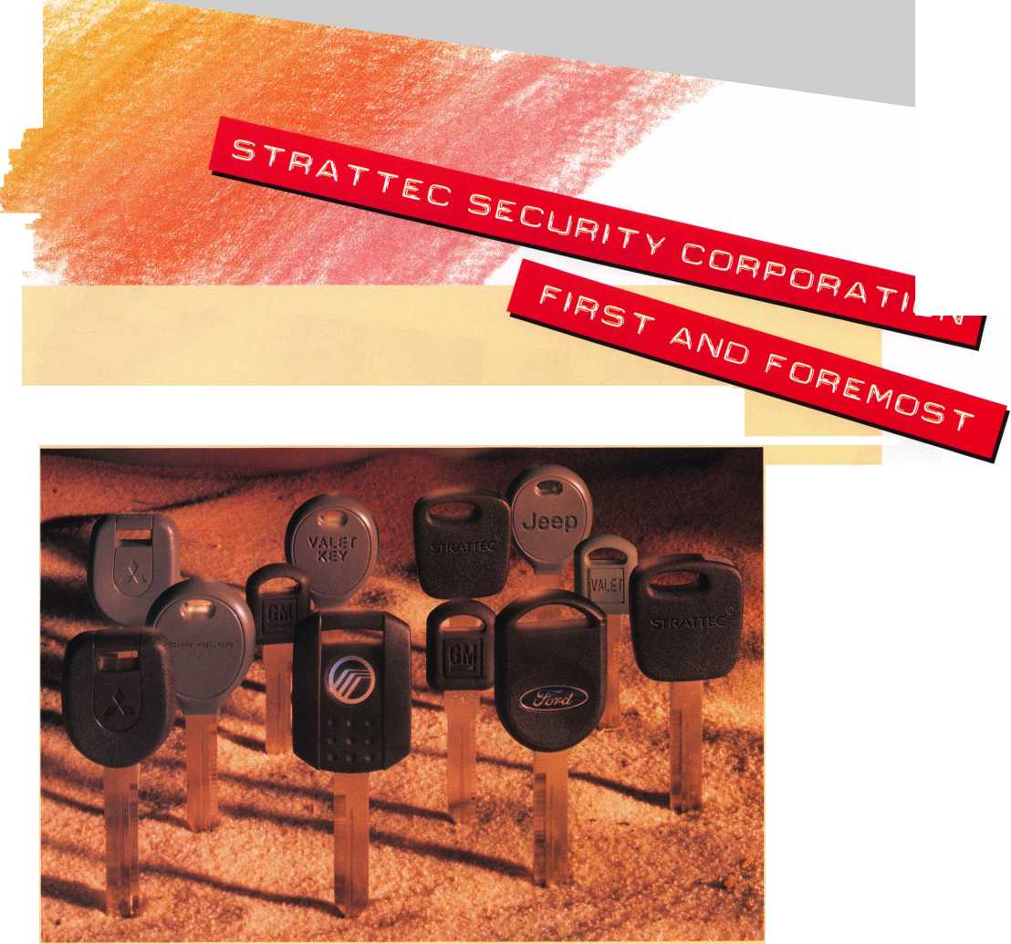

Customer Service:



MAKE

OR

BREAK

Your Business...

By Claire L. Cohen, CML

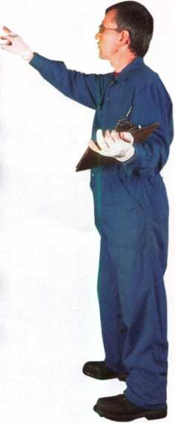

Without customers, what business would you be in?

When people are considering a purchase of merchandise or service, they first think of those with whom it is easiest to do business. People don’t buy products and services from a business. They buy from people! People they like, people they trust and people who treat them right.

Have you ever gone into a store ready to buy, then had to walk around trying to find an employee who would help find what you wanted? When you did find someone to help, was he or she courteous, knowledgeable, and eager to help? After you found an item, did you have to wander around looking for something to take your money? Is this the type of customer serv­ice that makes you want to come back for subsequent purchases? If the storeowner had been there, do you think you would have received the same type of service? Do you think you would have been treated the same if an employee had a commission involved?



Keynotes • July/August 2002

Quality customer service is a critical part of any busi­ness, and is especially important in the security busi­ness. Answering the phone promptly, listening to cus­tomer concerns, treating the customer properly, arriv­ing on time for a service call—are all elements of quality customer service. Many businesses simply do not deliver the type of customer service that keeps customers coming back. And then they wonder why their business continues to decline.

An unhappy customer whom you find out about is bad enough; but at least you have a chance to correct whatever made them unhappy. The business-killing unhappy customer is one that leaves your store or hangs up the telephone, never tells you about the problem, never returns, and then proceeds to tell everyone who will listen about the bad experience they had.

People buy, or do not buy, for their own individualized reasons. Price is further down the list of why to pur­chase or not purchase than you would think. A poten­tial customer may turn around and walk out of your place of business if he or she is not greeted properly (or at all). If people are not dealt with courteously and professionally, most of the time they will not do busi­ness with that firm no matter how low the price. On the other hand, that same person will pay a premium price for goods or services when he or she is treated properly and by someone they deem a professional.

A customer who has been dealt with considerately will find it very difficult to ask for a discount, if you

have provided flawless customer service. If you know that you have given your customer the best service possible, you and your staff should feel very confident about your price.

Another interesting point is that your customer serv­ice staff is a very effective sales force. There is no bet­ter time to close an additional sale than after you have just solved a problem for a client. “Customer service” personnel are viewed differently than “salespeople”. When a person is dealing with someone perceived to have nothing to gain by selling something, the cus­tomer is less on guard and much more receptive to buying additional goods or services.

So how can you be sure that you are handling cus­tomers properly? It boils down to insuring that every­one on the staff is aware of the customer service com­ponent of the business. They must act responsibly, conscientiously, politely, and exhibit pleasant person­alities when dealing with every customer.

Remember: The business-killing unhappy customer leaves your store or hangs up the telephone, never tells you about the problem, never returns, and then proceeds to tell everyone who will listen about the bad experience they had.

Make EVERY CUSTOMER aware that you and your company believe in the highest level of customer serv­ice. Thank each customer for choosing you and your company to provide quality solutions for their resi­dential and commercial security needs. Without cus­tomers, what business would you be in? Q

Keynotes • July/August 2002

**65**



Up Close with the 2002 ALOA Scholarship Recipients

We’ve done it again. For yet another year, the ALOA Scholarship Foundation has dug deep to provide free locksmithing instruction to those aspiring locksmiths who otherwise would have been unable to attend the biggest show of them all - ALOA 2002. The good people you are about to meet are the benefactors of ALOA Scholarship gifts representing thousands upon thousands of dollars.

Kenneth Briggs

I have spent the past  
24 years in the public  
eye as a law enforce-  
ment officer and an  
Emergency Medical

Technician. As an EMT,

I received my Firefighter 1 certifica­tion; I have served to protect the citi­zens in my community on a public level. When my law enforcement career came to an end in 1994, so in 1995, I graduated from a professional locksmithing school in Scanton, PA, and started a locksmithing business out of my garage with one key machine and 800 key blanks. We now have a storefront with 3 locksmiths, plus one CCTV/Alarm/Access Control specialist. In January, I took over as Chairman of the Indianhead Chapter of ALOA, and I will use this training to train our shop people, as well as our people in the ALOA chapter.



Roger Mahnk, Jr.

I will benefit from this

scholarship in many  
ways. When I  
became a locksmith  
after moving to

Arizona a few years ago,

I found something more than a job.

For the first time in my life, I felt I had a career and not just a job! I enjoy the challenges involved in being a locksmith, and learning new aspects of the job every day. I know have much to learn, but I look forward to it.

With the advances in technology, there will always be something new to learn in this field. Having moved my family across the country, I know I can use this scholarship to further my career. With or without it, I feel I will succeed, because I find the challenge of learning new things in locksmithing to be very rewarding. But without this scholarship, it would’ve been quite a while before I could’ve afforded to advance my knowledge in this field.

William Leonard

At 23, I have been in the

locksmith business for

3 years. I work in  
Kalamazoo, MI, and  
my interest is in safes

and safe deposit boxes.

I have knowledge in these areas, but would like to learn as much as I can. I am familiar with other areas of the profession, but I would like to be able to handle any problem that could arise. I feel that by taking classes now, I am dedicating myself to my profession.

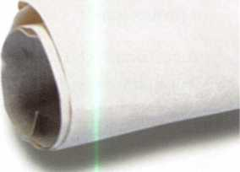

Keynotes • July/August 2002

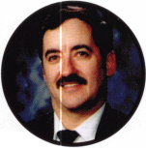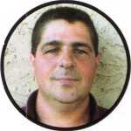

Lloyd Willits, CRL

I am a retired, disabled

veteran. While in the

service, I started my  
own locksmith busi-  
ness part-time after

taking the Foley Belsaw

course in 1991. I learned to love the  
challenge of lock work, as ever lock  
seems to be a different puzzle; but  
moving around with the military didn’t  
allow for much training. After retiring  
in 1999, I went to work for a lock  
shop full time and currently the lead  
technician with the additional respon-  
sibility of training new staff. In this lit-  
tle corner of the country, Kwikset is  
standard, but the change to increased  
security is slowly coming. To service  
this new need and train new staff,

I need to train myself first. I have  
attended ALOA convention before  
and know of no better training format  
for locksmiths. The knowledge gained  
from networking during breaks and  
after classes is worth the price alone,  
let alone the excellent knowledge  
gleaned from the instructors  
during class.

Mary Ann “Niki” Elizabeth  
Aquilano-Hill (“Niki Hill”)

I started locksmith  
school a few months  
ago and have  
received As on all  
my tests. I enjoy the

classes and the pursuit

of a career in this field. I was a solo  
“over the road” truck driver for a year  
and a half. When my husband, John,  
started havjjj^health concerns, I came  
off the roM. Ofcve beerfw^mployed  
for one year how and it has left us  
with no moaef fora^y^schooling. Twill  
be happy to further llf^Bucation in  
the field of locksmithingwt the 2002  
ALOA Convention; I wilftake full  
advantage of the classe^jpffered at this

year’s show. Joining ALOA will be a

top priority when I can afford it. I am  
a very dedicated person, and certain  
that this scholarship will provide me  
the important information I need to

reach my goal.

Olisha Shani Cox,

I am a 26 year old  
employee of my  
father’s locksmith

business in Knightdale,

NC. Being a locksmith is a fulfilling  
childhood dream I have had since I  
was 12 years old. I always watched my  
dad opening and repairing locks.

There is a satisfaction and joy working  
in this industry that few people com-  
prehend. I know I have some  
strengths, and I also know I have  
many more areas where I need to  
grow. ALOA offers so much in the  
area of education; it is a huge waste if  
we do not take advantage of it. I have  
attended the Security Expo before,  
but last year was my first year taking  
classes. The experience blew my mind!  
I was so inspired by the vastness of  
our industry. With this scholarship,

I want to broaden my horizons as a  
locksmith and put the knowledge  
I receive from these ALOA classes  
to use to further my skills, as well  
as to assist in training and  
teaching co-workers.

Mike Rodriguez

I want to broaden my

knowledge of the lock j

and safe profession.

Currently, I am an  
apprentice with one  
year of experience;

I have found a career that I enjoy,  
and one that lets me excel. I am a  
single U.S. Navy veteran with a back-  
ground in mechanics and electronics.  
This scholarship will help me broaden  
my knowledge and professionalism in  
this industry

Jeremy Rodocker, CPL, CPS

The acquaintances and

friendships created at

the conventions and  
classes I attend  
become a network  
of support for me,

my family and my peers. We try  
to improve our skills and knowledge  
through education. I’ve been a full-  
time locksmith for 15 years, and  
attending classes for an even greater  
time. The people I’ve met and  
befriended across the country have  
become a valued resource for me dur-  
ing challenging moments in the field.

I too have been called upon during  
moments of need to offer what I can.  
This reciprocal advantage would not  
be available to each of us if we didn’t  
have some method of meeting and  
exchanging ideas. The ALOA conven-  
tion is an excellent medium for just  
such a dialogue.

Ryan Aman

Although I am  
receiving an  
extensive amount

of on-the-job training,

I believe that it is

important that I take a variety  
of classes to obtain knowledge.  
Unfortunately, I haven’t been able to  
find classes in the area to assist me.

I am applying for this scholarship because although my parents pay for my college courses, neither they nor I are able to afford the cost of ALOA membership, convention classes, and lodging and meals while attending classes. My employer owns a small shop and is unable to pay for training as well. I believe it is important that young people such as I enter the field of locksmithing. So many high school graduates today are discouraged from learning a trade. I know that I want to be a professional locksmith; all I need is the opportunity to learn all the vari­ous aspects of the trade.

Keynotes • July/August 2002

**6**

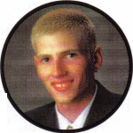

Jesse Piehl

Ten years ago, m  
with whom I am  
working now,  
received an ALO  
scholarship wher  
was just starting

this business. Then three years ago,  
my younger brother took classes  
through a scholarship. After taking  
the classes, I noticed they both had a  
huge amount of confidence in doing  
their work. I now have decided to go  
into this business and I would like to  
have the opportunity to take classes  
and increase my knowledge. Because  
we are a large family (I have five  
brothers and sisters, some in college),  
money is always a concern. For this  
reason, I applied for a scholarship  
to help in my pursuit of higher

education.

Hobert Banks

I have been fortunate  
enough to attend  
ALOA conventions  
in the past. The  
knowledge from the

past convention has proved to  
be very useful. My skills as a locksmith  
have improved tremendously About  
four months ago, my dispatcher start-  
ed sending me out on service calls for  
safe repair and service work. Although  
I had never done safe work, I found  
that I enjoyed it. It is a challenging  
job that requires a great deal of skill.  
With this scholarship, I plan to attend  
as many classes as possible to enhance  
my safe repair and service knowledge.  
Classes in other basic subjects would  
be a great refresher for me as well.

Don Falkos, CRL

I have 18 years experi-

ence as a locksmith.

Most of that time has  
been spent working

in my family’s business

in Aurora, IL. A little

over a year ago, I moved (with his wife  
and son) to Madison, WI. There, I am  
employed by the Housing Division of  
the University of Wisconsin-Madison.

Mark Hinkle

I was fortunate enough

to attend last year’s  
convention as well as  
the 1999 convention.

The knowledge from

these two conventions

has proved to be invaluable. My skills  
as a locksmith have improved tremen-  
dously. Being able to attend this year’s  
convention will allow me the chance  
to continue improving in my profes-  
sion as a locksmith.

Chandler Glover

I am a self-employed  
locksmith in the  
Denver area. I am a  
member of the local  
Rocky Mountain

Locksmith Association

and an ALOA member since 1990.

As I have observed the industry  
changing at a rapid pace, it is evident  
that we cannot survive by being com-  
placent with our present knowledge  
and skills in the security industry.  
Therefore, I would like to improve my  
professional skills and knowledge by  
staying abreast of the latest education  
and technology available.

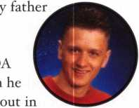

William Smith

I applied for a scholar-

ship this year to gain  
knowledge from the  
experts in the indus-  
try, and to pass it on  
to any and all lock-

smiths willing to learn from my skills,  
plus my years of experience and past  
ALOA classes. I have always taken  
great pride in trying to help others,  
to promote a cohesive bond within the  
locksmith industry. To me, the ALOA  
Scholarship Foundation is a wonderful  
plus in our industry, but with or with-  
out it, nothing would keep me away  
from the wonderful camaraderie of

the ALOA show.

John Miller

I am presently a full-  
time police officer.

I began working in  
the locksmith busi-  
ness six months ago.

In doing so, I have been

working with a locksmith who has  
been in business for over 30 years.

My intention is to work with him,  
and within a five-year period, become  
the owner of the business. I have just  
recently joined ALOA, and become  
aware of the scholarship programs  
offered. My intent is to become a pro-  
fessional in this line of business, and  
I feel that with your assistance, that

can happen.

David Braswell  
I am 24 years old  
and have been a lock-  
smith/security con-

sultant for seven years.

I applied for the ALOA

2002 scholarships to help further  
myself in the security industry. I plan  
to continue in the PRP until I reach  
the level of CML.

ALOA Scholarship recipient, Shim Alpert.



Keynotes • July/August 2002

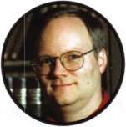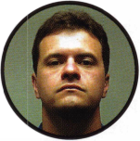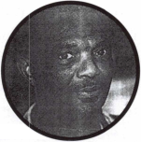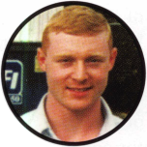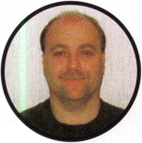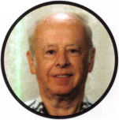

2002 Training Classes

Bryan Rayburn

I am a 26-year old lock-

smith, and have been  
in the business for 10  
years. It’s challenging  
work that always  
keeps you thinking.

That’s why I like it so much.

That’s why I applied for

the scholarship.

Norby King, RL

For several years, I’ve  
been a member of  
ALOA and my lock-

smith needs were sup-  
ported by my full-tim(

day job. After I was laid off, I had  
to revise my plan of becoming a full-  
time locksmith in 2003 (when I had  
hoped to have my CPL). Beyond our  
control, we had a severe medical con-  
dition that came up with my spouse.  
Although she is now in remission, she  
is not currently working. With the  
help of an unemployment check, lock-  
smith friends who give me their extra  
work (when they have it) and a cre-  
ative accountant, I’m able to get bills  
paid. (They did not get laid off.)

My plans for the future are still in  
locksmithing and I had hoped to go  
to the show in Chicago. Now the ACE  
scholarship is the only way I can go.  
Believe me when I say getting older

is not for sissies.

Eric Anderson

I have heard only  
positive feedback on  
your organization and  
am looking forward tc

some of the educational

endeavors ALOA has to offer. I have  
only recently become a locksmith with  
the University of Wisconsin-Madison  
(two years), where they are training  
me. I don’t want to be a liability for  
them, so learning more on my own is  
needed. Q



* Fundamentals of Locksmithing NEW!
* Non-Destructive Lock Entry NEW!
* Safe Deposit Locks
* Safe Lock Manipulation
* X-07/X-08/X-09 Master Class NEW!
* Combination Lock Technology 1
* GSA Security Container Servicing,

Opening, and Repair Certification NEW!

* Inspection and Re-Certification of

GSA Containers and Vault Doors NEW!

Call or visit our web site for the class  
schedule and descriptions.

**MBA\***

**USA, INC.** Mk

Education & Equipment for  
Security Specialists

email: [mbatools@aol.com](mailto:mbatools@aol.com) • web: [www.mbausa.com](http://www.mbausa.com)

Toll Free 1-888-MBA-5495 • Fax (859) 887-9491

KeylessRide

The Locksmiths' Source for Keyless Entry Remotes

* Genuine Factory Units No Aftermarket 100% OEM
* Largest Selection Thousands of Remotes on Stock
* GM, Ford, Chrysler, Toyota, Nissan, Honda, Mazda, Mitsubishi, Audi, BMW, Jaguar, Volvo, etc.
* Save 50% Over Dealership Prices
* Technical Support via Telephone and Internet

Call us toll free: **1.877.619.3136 [www.keylessride.com](http://www.keylessride.com)**

BOOTH #504 AT THE ALOA CONVENTION

Visit us at Rosemont and Get the Year's Best Prices!

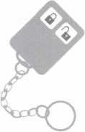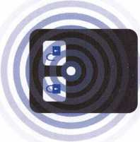

Keynotes • July/August 2002

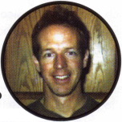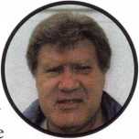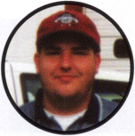

THE SAGA OF "YOUCANSAVE.COM" AND THE FEDERAL LOCK PICK "NON-MAILABILITY" ACT

THE PROBLEM

In recent months, many ALOA members have been bombarded with unso­licited emails advertising, "Kwick Lock Pick - never call a locksmith again" and providing a link to <http://store.yahoo.com/youcansave/kwickpick.html>.

ALOA has received over 200 complaints regarding this nuisance.

THE LAW

Selling lockpicks and car unlocking tools via interstate mailing or delivery service to anyone other than a bona fide locksmith, repossessor, lock man­ufacturer or distributor, motor vehicle manufacturer or dealer has been a violation of federal law (39 (JSC 30 (33002a) since November 1988. The problem is that it is a "non-mailability law" in other words, you can adver­tise these tools all you want. However, the moment you put a lockpicking tool into the mail to someone other than a "bona-fide" locksmith, that's when you are violating the law. But according to the U.S. Postal Inspector, sending items via FedEx, UPS, Airborne Express, etc. doesn't constitute "mailing" to them (the law says otherwise, but that's how they intend to interpret it). ONLY if the item is mailed through the U.S. Postal Service (and unfortunately, most of the companies DO NOT use regular mail) can you make a complaint. You are only allowed to make a complaint once the item has been mailed and sent via U.S. Postal Service, and then only when the violation is discovered.

THE SOLUTION

Tim McMullen, ALOA's Government Affairs Manager ordered a Kwick Pick and had it sent to a P.O. Box (forcing it to be sent regular mail). Once he got it, he made a formal complaint (he's an attorney, not a "bona fide locksmith") to the U.S. Postal Inspector in California where youcansave.com is based.

THE RESPONSE

A response came back saying we should complain to the FBI. Tim sent a letter to the FBI. A letter came back saying we should complain to the U.S. Postal Service. At convention two years ago, we did a letter writing cam­paign from the show floor to the Postmaster General about this problem of non-enforcement. A response came back saying the FBI enforces the law, not the Postal Service.

HOW YOU CAN HELP

ALOA still files a complaint with the U.S. Postal Inspector and the FBI, and sends a copy to youcansave.com. We encourage you to pursue the matter by having a non-locksmith purchase a Kwick Pick and have it mailed to a P.O. Box. Then file a complaint to the U.S. Postal Inspector and send a copy to Youcansave.com:

Postal Inspection Service United States Postal Service Attn: Inspector Freeman P.O. Box 2000 Pasadena, CA 91 102-2000

Stephen Newman Youcansave.com 30631 San Antonio St.

Hayward, CA 94544

Only through our collective voices, can we get this problem resolved!

ARIZONA ENFORCES ADVERTISING LAW AGAINST UNLICENSED CONTRACTORS

Last year, Arizona passed House Bill 2371 which requires that all unli­censed persons advertising that they perform construction trade contracting services must use the following words in their ads, "not a licensed contrac­tor" even if they fall under one of the exclusions to the law. Even though many locksmiths are exempt from the Registrar of Contractor's licensing requirements when their projects require no building permit and are less than $750 for the total contract price ("handyman exemption"), they are not exempt from this new advertising law. Recently, the Registrar of Contractors has been combing the local Yellow Pages looking for locksmith ads that offer services of "replacing" or "installing" security devices. Many ALOA members have received notices from the Registrar that they must add this language into their advertising. Failure to follow the new laws may subject persons advertising that they perform contracting services to fines up to $10,000 per violation pursuant to the Arizona Consumer Fraud Act.

What does this mean for you? You have three options: add "not a licensed contractor" to your advertising; take out of your advertising any mention that you replace or install hardware; get a license. You may apply for a "restricted license" which is a specialty license that confines the scope of allowable contracting work to a specialized area of construction which the Registrar grants on a case-by-case basis.

When applying for a restricted license classification (C-5), you need to submit: a detailed statement of the type and scope of contracting work that the applicant proposes to perform (See definition of "locksmithing services" below), and any brochures, catalogs, photographs, diagrams or other materials that will further clarify the scope of work the applicant proposes to perform. The Registrar shall determine the classification of the restricted license and notify the applicant of that classification and the scope of operations. The cost for this restricted license usually starts at $750. If you include electronic security devises in your detailed statement regarding your scope of work, you may have to get a dual restricted license classification (K-5).

There currently is a low-voltage communications systems (C-12) that you may already be required to have depending on the scope of work that you do.

Keynotes • July/August 2002

For more information on a restricted license contact: Alan Felber; Registrar of Contractors; 800 W. Washington, 6th Floor; Phoenix, AZ 85007; 888- 271-9286; 602-542-7852 (fax). For a Press Release about the new enforcement, go to: [www.rc.state.az.us/nr_advt02.html](http://www.rc.state.az.us/nr_advt02.html).

From the ALOA Model Law:

"Locksmith Services" means servicing or installing:

1. Repairing, rebuilding, rekeying, repinning, servicing, adjusting or installing locks, mechanical or electronic security devices, access control, CCTV, safes, vaults or safe deposit boxes;
2. Operating a mechanical or electrical security device, safe or vault by a means other than those intended by the manufacturer of such locking devices, safes or vaults.

UPDATE ON THE "MOTOR VEHICLE OWNERS' RIGHT TO REPAIR ACT"

ILLINOIS HB3663

Provides that a person who applies for licensure as a locksmith agency between September 1, 2002 and December 31, 2002 shall be exempt from the examination requirement. To House Committee on Rules.

ILLINOIS HB4879

Amends the Private Detective, Private Alarm, Private Security, and Locksmith Act of 1993. Changes the procedure for processing employees of security related companies, including locksmiths. The State Police will now make the background check information available to employers within three (3) days. If there is no conviction found, the employee may start to work immediately while the paperwork is processed for the employee's Permanent Employee Registration Card (PERC). Provides that a person is qualified to receive a license as a private alarm contractor without meeting all the regular requirements for licensure if specified criteria are met (3 day grandfather window). Passed BOTH Houses.

Increasing technology in cars, is allowing car manufacturers, and not con­sumers, to determine where and when motor vehicles are serviced. By not making available vital information and tools necessary to repair today's high-tech cars to locksmith and other service providers. Manufacturers force consumers to return to dealerships for service. At a time, price and place of the Manufactures Representative convenience, without regard to the need of the consumers.

The Motor Vehicle Owner's Right to Repair Act of 2001 (H.R. 2735 and S.2617) seeks to remedy this situation by ensuring the consumer or his agent has the right to the information necessary to repair his or her vehicle at a time and place of their choosing. The legislation does this without requiring car manufacturers to divulge proprietary information or trade secrets.

ALOA Government Affairs Manager, Tim McMullen met with the Vice President of Govt. Affairs for the Automotive Aftermarket Industry Association (AAIA) to lend our support for the bill. They are co-sponsoring the bill along with the Automotive Service Association (ASA) based in Dallas. They expressed appreciation and support for our efforts to help them pass this legislation. Most importantly, they absolutely agree that the codes locksmiths need and covered under this bill.

They would like to get a hearing on the bill as soon as possible. The legis­lation is in the Subcommittee on Commerce, Trade, and Consumer Protection in the House Committee on Energy and Commerce. Please go to [www.aloa.org/leg](http://www.aloa.org/leg) to find out how to contact the Subcommittee Chair, Cliff Stearns (R-FL) and the Commerce Committee Chair, WJ. "Billy" Tauzin (R-LA) and request that a hearing be held on this important piece of legislation.

Watch for the latest on this bill at the Legislative Booth at the ALOA Security Expo, July 25-28, 2002 in Rosemont, Illinois.

STATE LEGISLATIVE UPDATE GEORGIA HB1082

Minor word change, no impact on low-voltage contractors. To House Committee on Industry.

Copies of all these bills can be found at  
[www.aloa.org/news/legislation.cfm](http://www.aloa.org/news/legislation.cfm)

MARYLAND SB 125

Continues the licensing and regulation of security systems technicians until 2016. From Senate Committee on Education, Health and Environmental Affairs: Enacted.

MINNESOTA HB2787

Requires that employees of electronic security system companies undergo criminal history background checks. Passed House.

NEW YORK SB 1859

Provides a possible tax credit in cities of one million or more for security To Senate Committee on Rules.

NEW YORK AB10435

Mandates automobile manufacturers' to release vehicle repair information to vehicle owners allowing such owners to choose among competing repair facilities for the convenient. Introduced and sent to Assembly Committee on Transportation.

NORTH CAROLINA HI552

Changes the locksmith licensure effective date from July 1, 2002 to January 1, 2003. Introduced and sent to House Committee on State Government.

OHIO HB452

Alarm licensing bill that includes access control and CCTV. Sent to sub­committee in the Committee on Commerce and Labor. Chair has requested no new hearings for the rest of the year.

PENNSYLVANIA HB2075

Regulates the licensure of electrical and alarm system contractors. To House Committee on Professional Licensure.

TENNESSEE SB2087

Renews the Alarm Systems Contractors Act until 2006. Enacted.

CHECK OUT ALOA'S WEBSITE AT <http://www.aloa.org/news/legcom.cfm>

FOR THE LATEST HAPPENINGS IN YOUR STATE



Keynotes • July/August 2002

EMPLOYMENT

STOP LOOKING!!!!!

EXPERIENCED TECHNICIANS WANTED Lock into your future now!

If you are experienced, intelligent, and desire a secure future, come join our team. We are a full service commercial/residential security service (locks, keys, safes, CCTV, access control, door relat­ed hardware). We offer: sign on bonus, top wages, company vehicle, 401k, paid vacation, paid holi­days, new uniforms, cross training, and job satisfac­tion. We are looking for the best tech's, who are ready to be treated and compensated as profession­als.

Bass Security Services, Inc.

Ph#216-755-1200 ex.#128

Fax#216-755-1220

E-MAIL / [rmesnick@bass-security.com](mailto:rmesnick@bass-security.com)

KWIK KEY OF SOUTH FLORIDA

is looking for experienced commercial locksmiths. Work in Sunny Florida. Salary starts @ $620 per week. Call 305/770- 2490, and ask for Mr. Fred Zimmerman.

EXPERIENCED LOCKSMITH WANTED

base and is expanding. Qualified individuals will have exten­sive experience in locksmithing safes and door hardware. Electronic hardware experience is a plus. Great benefits. Salary DOE. Please contact us and/or fax resume to: James Rochester • 6207 Industrial Road • Las Vegas, NV 89118 702/614-3939 (phone) • 702/614-8052 (fax)

EXPERIENCED LOCKSMITHS

Growing, established 23-year company is seeking lead lock­smiths. Experienced required in commercial locksmithing, includ­ing safe work and electronic access/CCTV, panic hardware, master key systems. Work in and around the nation's Capitol. Excellent opportunity for individual dedicated to the trade and customer service. Company-provided vehicle, tools, uniforms. Salary commensurate with experience. Inside position also available. Paid holidays, vacations, health insurance, 401 (k). Please fax resume to 301/424-3080, or call 888/424-LOCK (5625), ext. 14.

BUSINESS FOR SALE

NEED A CHANGE IN THE WEATHER?

A well-established lock and safe business is for sale in sunny Orlando, FL! Owner is retiring (after a smooth takeover transi­tion). 20 years at present location with a long-term lease, two fully-stocked service vans, inventory and equipment worth well over $1 20K with a long list of commercial and residential accounts grossing over $200K. Asking $190K. Serious inquiries call 407/277-5177, ask for John.

■Hi

*mm*

Las Vegas-based company that deals with all phases of surveil­lance, access control and locksmithing is looking for a highly qualified and motivated individual to perform locksmith duties. Vegas Valley Locking Systems, Inc., has an established customer

ESTABLISHED, 30-YEAR " AWARD WINNING " lock and safe business in rural eastern Connecticut for sale. Brisk retail store, new service vehicle, safe

Classified Advertising Policy

Classified advertising space is provided free of charge to ALOA members, and fora fee of $.60 per word, $15 minimum for non-members. Classified ads may be used to advertise  
used merchandise and overstocked items for sale, "wanted to buy" items, business opportunities, employment opportunities/positions wanted and the like. Members or non-members wishing  
to advertise services or new merchandise for sale may purchase a "Commercial Classified Ad," for a fee of $1.30 per word, with a minimum of $40. Each ad will run for two issues. For blind  
boxes there is a $5 charge to members and non-members. All ads must be submitted in writing to the ALOA office by the fifteenth of the month, two months prior to issue date. Send to  
Keynotes Classifieds, 3003 Live Oak St., Dallas TX 75204-6186. ALOA reserves the right to refuse any classified advertisement that it deems inappropriate according to the stated purpose

of the classified advertising section.

Keynotes • July/August 2002



rigging truck and over $250,000 in equipment and inventory. This is a five-day work week business that nets the husband and wife team a nice six-figure income plus benefits. Commercial and residential only - no autos. Selling every­thing at a steal price of $200,000. The hard work is already done ; just take over and run. Hundreds of solid, long-estab­lished accounts, only locksmith in large area. Fax us at 860/423-5604 with your name and address and your inter­est. We will send you an information packet about the busi­ness, complete with photos. If you have equity, we can help with local financing.

FOR SALE:

Mobile lock shop equipped with $4000. Write or call Anthony Rossi, 45055 East Florida Ave., Hemet, CA, 92544. Phone 909/927-6858.

WORK WANTED

NORTHERN NEW JERSEY/NEW YORK CITY AREA

Institutional Locksmith looking for a position with a quality company. Familiar with Medeco as well as other cylindars and door hardware.

Do not wish to relocate. Call James at 973/742/4979 or 973/819-1047

SECURITY PRO FOR HIRE

CML, CPS seeks a challenging and personally rewarding position as a Locksmith at the supervisor or management level. Would prefer institution or college in the Midwest or central United States, however all locations would be considered. 30+ years in the field and well versed in all aspects of sales, training and management. Please respond to the editor of ALOA, (800)532-2562, ext. 19.

WANTED TO BUY/SELL

FOR SALE:

Overstock: one llco pin kit #796-008X, $150; three Von Duprin 9927F US28 w/o trim, $300 each; eight Von Duprin 9927TP 3' 313, $450; 22 Von Duprin 88EO No trim, $200 each. Plus, used merchandise: llco model 2178U universal code machine, depth guide .015, .18, .020, .023, spacing guide . 150 and . 156. Cutter 20 MC, 14 MC + 1, $400. All items are plus shipping. Key machines: Sugar Model SA 400, First key — $400; Medeco manual cuts "00" commercial keys — $1500; Medeco pneumatic complete with air com­pressor cuts "00" commercial keys — $2000.

E-mail: [jcrenderer@aol.com](mailto:jcrenderer@aol.com), or call 305/944-0469.

FOR SALE:

Locksmith tools, code books, hardware, key blanks. Framon, Curtis, Aero, Schlage, LSDA. For complete list, contact Gary at P.O. Box 52, Conover, Wl, 54519, phone 330/418-1689 or e-mail: [gary@cybertekweb.com](mailto:gary@cybertekweb.com), view complete list on web at [www.cybertekweb.com/tools](http://www.cybertekweb.com/tools).

**TURn ID**

WHOLESALE SERVICE

In-Stock... **SAFES** FREE Freight Program Fax: 800-391-4553

800**-**848-9790

**AMSEC** FireKing Gaidall HAYMAN MEILINK **\flCTOR**

r

Ro werMa te®

MOTORIZED STAIRCLIMBING HANDTRUCKS

Power Tailgate Lift Power Dock Leveller

Order'S Yours: Todayi

Many models to choose from:

**PowerMate M-1** 1500 lb. Capacity **40”+ Lift** **to** Tailgate

Built-in 4 Wheel

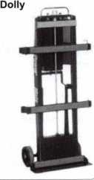

■\

Power safes, ATMs, vault doors, etc. up/down stairs and on/off vehicles safely and quickly at the push of a button. Because PowerMate® does 100% of the lifting, there is no strain on your back or legs.

More secure handling results in less risk of damage to your productsand/orclient’sstairs,wallsandfloors, saving money!

V

1*-*800*-*697-6283

[www.lpinternational.com](http://www.lpinternational.com)

Keynotes • July/August 2002

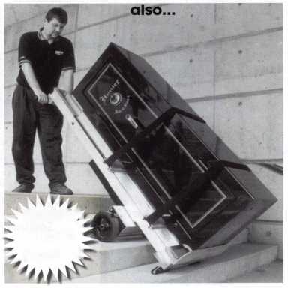

Distributor

ADI Inc

Phone 631-692-1000 Fax 631-692-3011

Accredited Lock Supply Co.

Phone 201-865-5015 Fax 201-865-0030 [www.acclock.com](http://www.acclock.com)

Ace Lock & Security Supply

Phone 908-688-7666 Fax 908-688-2442 [www.acelock.com](http://www.acelock.com)

Action Hardware Inc.

Phone 800-662-6695 Fax 800-930-2329

Andrews Wholesale Lock Supply

Phone 717-272-7422 Fax 717-274-8659

Boyle & Chase Inc.

Phone 800-325-2530 Fax 800-205-3500 [www.boyleandchase.com](http://www.boyleandchase.com)

Clark Security Products

Phone 800-854-2088 Fax 619-974-5284 [www.clarksecurity.com](http://www.clarksecurity.com)

Cook's Building Specialties

Phone 505-883-5701 Fax 505-883-5704

Dire's Lock & Key Company

Phone 303-294-0176 Fax 303-294-0198

Direct Security Supply, Inc.

Phone 800-252-5757 Fax 800-452-8600

Doyle Security Products

Phone 800-333-6953 Fax 612-521-0166 [www.doylesecurity.com](http://www.doylesecurity.com)

Dugmore and Duncan, Inc.

Phone 888-384-6673 Fax 888-329-3846

E. L. Reinhardt Co., Inc.

Phone 800-328-1311 Fax 651-481-0166 [www.elreinhardt.com](http://www.elreinhardt.com)

Ewert Wholesale Hardware

Phone 800-451-0200 Fax 708-597-0881

Fairway Supply, Inc.

Phone 214-350-0021 Fax 214-352-4299 [www.fairwaysupply.com](http://www.fairwaysupply.com)

Foley-Belsaw Company

Phone 800-821-3452 Fax 816-483-5010 [www.belsaw.com](http://www.belsaw.com)

Fried Brothers Inc.

Phone 800-523-2924 Fax 215-592-1255 [www.fbisecurity.com](http://www.fbisecurity.com)

H L Flake Co.

Phone 800-231-4105 Fax 713-926-3399 [www.hlflake.com](http://www.hlflake.com)

H.S. & S. Wholesale Distrib.

Phone 313-342-6777 Fax 313-342-7580

Hans Johnsen Company

Phone 214-879-1550 Fax 214-879-1530

Hardware Agencies, Ltd.

Phone 416-462-1921

Howard Keys

Phone 704-509-4944 Fax 704-509-6248 [www.howardkeys.com](http://www.howardkeys.com)

IDN Incorporated

Phone 817-421-5470 Fax 817-421-5468

Intermountain Lock & Supply

Phone 800-453-5386 Fax 801-485-7205 [www.intermountainlock.com](http://www.intermountainlock.com)

Jo Van Distributors

Phone 416-752-2238 Fax 416-752-7282

Lockmasters, Inc.

Phone 859-885-6041 Fax 859-885-7093 [www.lockmasters.com](http://www.lockmasters.com)

Locks Company

Phone 800-288-0801 Fax 305-949-3619

M. Zion Company

Phone 212-349-8677 Fax 212-964-0495

Massglass &

Door Service

Phone 888-742-8837 Fax 818-991-5742 [www.massglass.com](http://www.massglass.com)

McDonald Dash Locksmith Supp.

Phone 800-238-7541 Fax 901-366-0005

[www.mcdonalddash.com](http://www.mcdonalddash.com)

McManus Locksmith Supply/ Inc.

Phone 704-333-9112 Fax 704-332-8664

Monaco Lock Co.

Phone 800-526-6094 Fax 800-845-5625

[www.monacolock.com](http://www.monacolock.com)

Omaha Wholesale Hardware

Phone 800-238-4566 Fax 402-444-1664

[www.omahawh.com](http://www.omahawh.com)

Phoenix Safe International LLC

Phone 765-483-0954 Fax 765-483-0962

[www.phoenixsafeusa.com](http://www.phoenixsafeusa.com)

SecureRite.Com

Phone 800-241-3930 Fax 858-974-5269

[www.SecureRite.Corn](http://www.SecureRite.Corn)

Sentry Security Fasteners

Phone 309-693-2800 Fax 800-693-2872

Somerset Security Products

Phone 800-881-5206 Fax 800-206-9949

Southern Lock and Supply Co.

Phone 727-541-5536 Fax 727-544-8278 southernlock.com

Stone & Berg Wholesale

Phone 800-225-7405 Fax 800-535-5625

Taylor Security & Lock

Phone 301-948-7670 Fax 301-948-1029 [www.taylorsecurity.com](http://www.taylorsecurity.com)

The Locksmith Store Inc.

Phone 847-364-5111 Fax 847-364-5125 [www.locksmithstore.com](http://www.locksmithstore.com)

Timemaster Inc

Phone 888-798-8465 Fax 800-798-8463 [www.time-master.com](http://www.time-master.com)

Top Notch Distributors, Inc.

Phone 800-233-4210 Fax 800-854-4146 [www.4topnotch.com](http://www.4topnotch.com)

U.S. Lock Corp.

Phone 800-925-5000 Fax 800-338-5625 [www.uslock.com](http://www.uslock.com)

Webster Safe & Lock Co., Inc.

Phone 901-332-2911 Fax 901-332-2878 webstersinc.com

Manufacturer

A & B Safe Corporation

Phone 800-253-1267 Fax 856-863-1208 [www.a-bsafecorp.com](http://www.a-bsafecorp.com)

ABUS Lock Company

Phone 800-352-2287 Fax 602-595-3499 [www.abus.com](http://www.abus.com)

Abloy Door Security

Phone 800-465-5761 Fax 514-335-0430 [www.abloy.com](http://www.abloy.com)

Adams Rite Mfg. Company

Phone 800-872-3267 Fax 800-232-7329 [www.adamsrite.com](http://www.adamsrite.com)

Adesco Safe Mfg. Company

Phone 800-821-6803 Fax 562-408-6427 [www.adesco.com](http://www.adesco.com)

Adrian Steel Company

Phone 800-677-2726 Fax 517-265-5834 [www.adriansteel.com](http://www.adriansteel.com)

Alarm Lock Systems Inc.

Phone 800-252-5625 Fax 516-789-3383 [www.alarmlock.com](http://www.alarmlock.com)

All Five Tool Company, Inc.

Phone 860-583-1691 Fax 860-583-4516 [www.all5tool.com](http://www.all5tool.com)

American Lock Company

Phone 708-534-2000 Fax 708-534-0531

American Security Products

Phone 909-685-9680X1083 Fax 909-685-9685 [www.amsecusa.com](http://www.amsecusa.com)

BWD Automotive

Phone 334-872-6524 Fax 334-874-6011 [www.bwdautomotive.com](http://www.bwdautomotive.com)

Baldwin Hardware

Phone 610-796-4012 Fax 610-796-4493

Buddy Products

Phone 800-886-8688 Fax 312-733-8356 [www.buddyontheweb.com](http://www.buddyontheweb.com)

COMPX

Security Products

Phone 864-297-6655 Fax 864-297-9987 [www.nclnet.com](http://www.nclnet.com)

Curtis Industries,

A Barnes Distr.

Phone 800-555-5397 Fax 800-867-6020 [www.curtisindustries.com](http://www.curtisindustries.com)



Keynotes • July/August 2002

|  |  |  |
| --- | --- | --- |
| a | s s o c i a 1 | \ e |
|  | members |  |

|  |  |  |  |  |
| --- | --- | --- | --- | --- |
| DETEX Corporation | Jet Hardware Mfg., Co. | MARKS, U.S.A. | STRATTEC Security | Taymor Industries, Inc. |
| Phone 800-729-3839 | Phone 71 8-257-9600 | Phone 516-225-5400 | Corp. | Phone 800-388-9887 |
| Fax 830-620-671 1 | Fax 718-257-0973 | Fax 516-225-6136 | Phone 414-247-3415 | Fax 800-288-8133 |
|  |  | [www.marksusa.com](http://www.marksusa.com) | Fax 414-247-3692 |  |
| DORMA Architectural | KABA |  |  | Trine Access |
| Hardware | High Security Locks | MARRAY ENTERPRISES | Sargent & | Technology |
| Phone 717-336-3881 | Phone 860-621-3601 | Phone 408-970-0213 | Greenleaf, Inc. | Phone 71 8-829-2332 |
| Fax 717-336-3500 | Fax 860-621-9727 | Fax 408-970-8767 | Phone 859-885-9411 | Fax 718-829-6405 |
| [www.dorma-usa.com](http://www.dorma-usa.com) | [www.kabausa.com](http://www.kabausa.com) | [www.marray.com](http://www.marray.com) | Fax 859-885-3063 | [www.trineonline.com](http://www.trineonline.com) |
|  |  |  | [www.sglocks.com](http://www.sglocks.com) |  |
| Don-Jo | KEY-BAK/West Coast | MCS Communication |  | Videx Inc. |
| Manufacturing, Inc. | Chain Mfg. | Systems | Sargent | Phone 541-758-0521 |
| Phone 978-422-3213 | Phone 909-923-7800 | Phone 514-444-2040 | Manufacturing Co. | Fax 541-752-5285 |
| Fax 978-422-3467 | Fax 909-923-0024 | Fax 514-444-2029 | Phone 203-562-2151 | [www.videx.com](http://www.videx.com) |
| [www.don-jo.com](http://www.don-jo.com) | [www.keybak.com](http://www.keybak.com) | [www.mcscommunication.com](http://www.mcscommunication.com) | Fax 203-776-5992 |  |
|  |  |  |  | W-LOK Corporation |
| Door Controls | Keri Systems Inc | MMD, Inc. | Schlage Lock Co. | Phone 616-355-4015 |
| International | Phone 408-451-2520 | Phone 865-428-3611 | Phone 719-264-5300 | Fax 616-355-4295 |
| Phone 800-742-3634 | Fax 408-441-0309 | Fax 865-453-4136 | Fax 719-264-5382 | [www.wlokcorp.com](http://www.wlokcorp.com) |
| Fax 800-742-0410 | [www.kerisys.com](http://www.kerisys.com) |  | [www.schlagelock.com](http://www.schlagelock.com) |  |
| [www.doorcontrols.com](http://www.doorcontrols.com) |  | MUL-T-LOCK USA, Inc. |  | Yale Security |
|  | Knaack | Phone 800-562-3511 | Schwab Corp. | Group, Inc. |
| ESP Lock Products Inc. | Manufacturing Co. | Fax 973-778-4007 | Phone 765-447-9470 | Phone 800-438-1951 |
| Phone 978-562-3481 | Phone 800-456-7865 | [www.mul-t-lock.com](http://www.mul-t-lock.com) | Fax 765-447-8278 | Fax 800-338-0965 |
| Fax 978-562-9859 | Fax 815-459-9097 |  | [www.schwabcorp.com](http://www.schwabcorp.com) |  |
|  | [www.weatherguard.com](http://www.weatherguard.com) | Master Lock Company |  | | Service Organization | |
| FireKing Security |  | Phone 414-444-2800 | Securitron Magnalock |  |
| Products | LAB Security | Fax 414-444-0322 | Corp. | Allstate Insurance |
| Phone 800-457-2424 | Phone 800-243-8242 | [www.masterlock.com](http://www.masterlock.com) | Phone 775-355-5626 | Company |
| Fax 800-896-6606 | Fax 860-583-7838 |  | Fax 775-355-5636 | Phone 847-402-8196 |
| [www.fi](http://www.fi) reki ng .com | [www.labpins.com](http://www.labpins.com) | Medeco Security Locks | [www.securitron.com](http://www.securitron.com) | Fax 847-326-7509 |
|  |  | Phone 540-380-5000 |  | [www.allstate.com](http://www.allstate.com) |
| HES, Inc. | LCN Closers/Div. of | Fax 540-380-5010 | Security Door Controls |  |
| Phone 623-582-4626 | Ingersoll | [www.medeco.com](http://www.medeco.com) | Phone 805-494-0622 | Emergency Road |
| Fax 623-582-4641 | Phone 815-875-3311 |  | Fax 805-494-8861 | Service Inc. |
| [www.hesinnovations.com](http://www.hesinnovations.com) | Fax 815-879-1497 | NKL Industries Inc. | [www.sdcsecurity.com](http://www.sdcsecurity.com) | Phone 888-839-5386 |
|  | [www.lcnclosers.com](http://www.lcnclosers.com) | Phone 800-528-9900 |  | Fax 678-277-8105 |
| HPC, Inc. |  | Fax 757-485-0271 | Security Solutions |  |
| Phone 847-671-6280 | La Gard Inc. | [www.nklindustries.com/prod-](http://www.nklindustries.com/prod-) | Phone 405-376-1600 | Professional Business |
| Fax 847-671-6343 | Phone 310-325-5670 | ucts_NK | Fax 405-376-6870 | Products |
| [www.hpcworld.com](http://www.hpcworld.com) | Fax 310-325-5615 |  |  | Phone 800-258-6219 |
|  | [www.lagard.com](http://www.lagard.com) | Pro Steel | Sentry Group | Fax 813-888-5393 |
| Hongtai Lock Co. Ltd. |  | Phone 801-373-2385 | Phone 716-381-4900 |  |
| Phone 137-238-1414 | Locksmith Ledger | Fax 801-373-2399 | Fax 716-381-8559 | The National Locksmith |
| Fax 208-793-3856 | International | [www.pro-steel.net](http://www.pro-steel.net) | [www.sentrysafe.com](http://www.sentrysafe.com) | Phone 630-837-2044 |
|  | Phone 770-886-0800 |  |  | Fax 630-837-1210 |
| INTELLIKEY Corp. | Fax 770-889-7703 | ROFU International | Sully Tools Inc. | [www.thenationallocksmith.com](http://www.thenationallocksmith.com) |
| Phone 800-226-0703 | lledger.com | Corp. | Phone 703-689-3416 |  |
| Fax 321-724-0811 |  | Phone 800-255-7638 | Fax 703-787-0869 |  |
| [www.intellikey.com](http://www.intellikey.com) | Lucky Line | Fax 253-922-1728 | [www.sullytools.com](http://www.sullytools.com) |  |
|  | Products, Inc. | [www.rofu.com](http://www.rofu.com) |  |  |
| llco Unican | Phone 858-549-6699 |  | SunSafes |  |
| Phone 252-446-3321 | Fax 858-549-3241 | Rutherford Controls | Manufacturing Co. |  |
| Fax 252-446-4702 |  | Int'l. Co. | Phone 823-194-59300 |  |
| [www.kaba-ilco.com](http://www.kaba-ilco.com) | M.A.G. Security | Phone 757-427-1230 | Fax 823-194-59400 |  |
|  | Phone 714-891-5100 | Fax 757-427-9549 | [www.eaglesafes.com](http://www.eaglesafes.com) |  |
|  | Fax 714-892-6845 | [www.rutherfordcontrols.com](http://www.rutherfordcontrols.com) |  |  |
|  | [www.magsecurity.com](http://www.magsecurity.com) |  |  |  |

Keynotes • July/August 2002

**back page**

About the Authors

Dale Bowman, CRL, is a product manager for Medeco.

Paul F. Chandler, CRL manages the electronic security products division of I.D.N. -Acme. Paul earned his journey-  
man electrician license in Massachusetts in 1983, and passed the PRP in 1987. He has experience in CCTV, alarms  
access control systems, high security locks and safes. Paul has written for several trade magazines and was the  
Keynotes Author of the Year for 1998. Paul's classes on access control and basic electricity have been enjoyed by  
locksmiths throughout the southwest.

Claire Cohen, the second woman to become a CML, has been in locksmithing since 1977 and has been writing arti-  
cles for Keynotes since 1987. She is also a contributing editor for Keynotes, and was just named the 2001 Keynotes  
Author of the Year - again, the second woman to achieve that honor.

Jim DeSimone is editor of Keynotes.

Sal Dulcamaro, CML, has been in the security industry for over 27 years. He is the president of All Pro Security,  
Inc. in Michigan and has been an ALOA member for 20 years. A past president of the Locksmith Security Association  
of Michigan, Sal currently serves as web editor of the association's on-line newsletter. He was named Keynotes "Author  
of the Year" in both 1996 and 1997. He is also a contributing editor for Keynotes. Find Sal on the Internet at:

<<http://www.home.earthlink.net/-lockwriter>>.

Mark Fuller, CRL, owns and operates Weston Key Sytems in

Houston, TX.

Clifford D. "C.D." Lipscomb, CML, CPS, has been work-  
ing in the physical security industry since 1974 as an insti-  
tutional locksmith and currently as owner of a full-service  
locksmith business in Corsicana, TX. An ALOA member  
since 1990, C.D. is an ALOA ACE certified instructor and  
has taught for many locksmith associations, including the  
Texas Locksmith Association and the Greater Dallas  
Locksmith Association. He also has has held various volun-  
teer offices with GDLA and TLA.

Frank Markisello Jr., CRL, owns and operates Aable  
Locksmith in Ozone Park, NY.

Jamie Martin serves as a product manager for  
Kaba Mas.

Greg Perry, CML, CPS has been in the locksmith indus-  
try for 20 years. He's spent half of that time as a field tech-  
nician for Security Engineering in Ridgecrest, CA. Greg is  
also a past president of the Desert Counties Chapter of the  
California Locksmiths Association. You can e-mail him at  
[glmperry@iwvisp.com](mailto:glmperry@iwvisp.com).

Jeff Trepanier, RL, owns and operates Interstate Lock  
Masters in Racine, Wl. He has been published in several  
trade magazines and is widely recognized as an automotive  
locksmithing guru.

|  |  |
| --- | --- |
| r |  |
| Ad Index |  |
| HES Inside Front Cover | |
| Kaba llco | 1 |
| Dynalock | 7 |
| A&B | 9 |
| Intralock | 13 |
| Aable Locksmiths | 29 |
| Strattec | 63 |
| Keyless Ride | 69 |
| MBA | 69 |
| Turn 10 | 73 |
| LP International | 73 |
| Yale Inside Back Cover | |
| Hickok Back Cover | |
| L | J |

Keynotes • July/August 2002

**Unlocking Ford/Mazda Transponder Prof its...Wsrl**

**You're n^ver on your own..**

**Toll FreeTech Support**

**1-800-^42-5080**

"I've lost my Taurus keys..

mr

can you make a new set?

How much of your money  
have you sent to the  
local Ford dealer?

/

✓

ww

8008LA New Generation STAR

Use the Ford factory tool to  
program transponder keys for  
ALL Ford/Mazda vehicles.

Keep the money in your pocket!

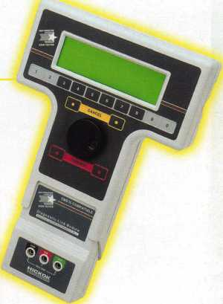

NGS

Complete  
Ford/Mazda  
transponder  
coverage

PLUS the

ability to  
clear ALL  
Diagnostic

Service Codes

Say "YES" to  
$100 phone calls



HICKOK

INCORPORATED

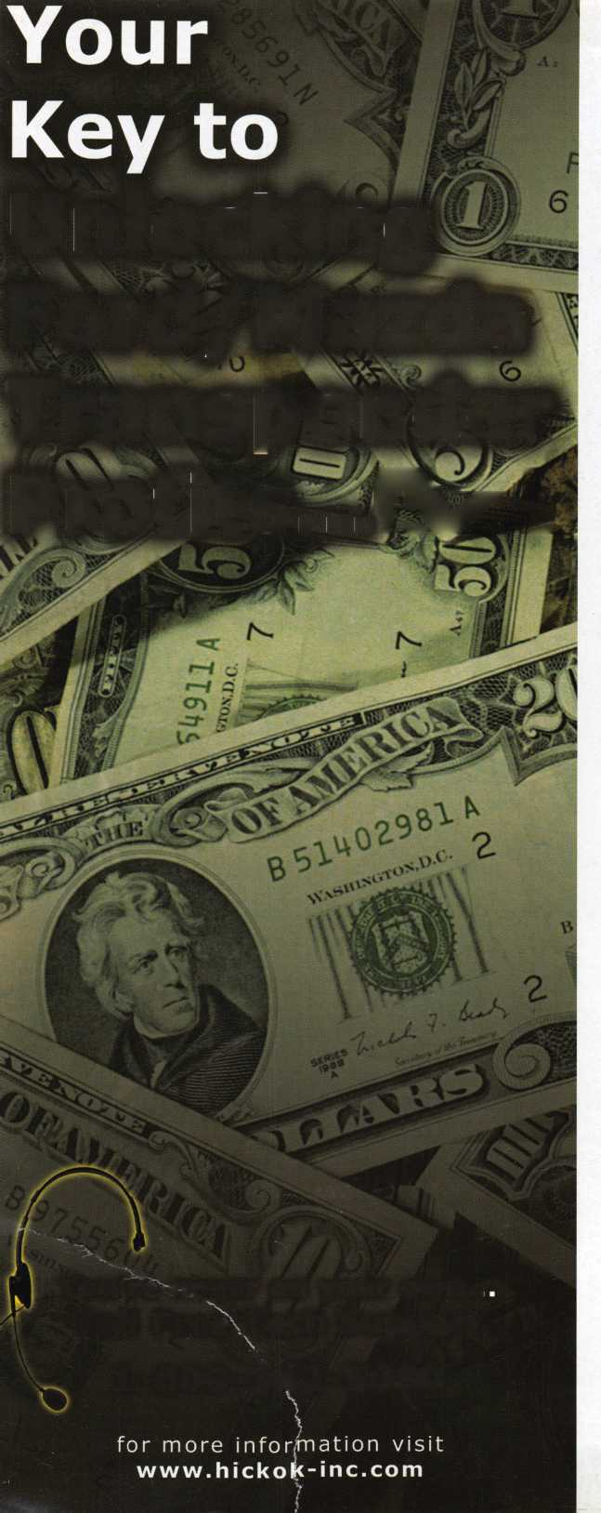

Sure, old Spike here will do the job. But you're going to have to feed him and walk him.  
SecureX,™our new patent pending controlled exit device with delayed egress, will stop  
anyone in their tracks without taking a bite out of their backside. It's the kind of product  
you've come to expect from Yale, one of the most respected names in the industry.  
So you have a decision to make. Contact us at 888-828-8349, or visit our website at

[www.yalelocks](http://www.yalelocks)

com to find out more. Or go buy 50 lbs. of dry dog food

Delayed Egress Exit Device

